User Manual: Raw Materials

| jUNE-20 |

**Document Overview**

**Documentation Goals**

This documentation is intended to provide instruction for all ***Materials/Raw Goods*** functions*.* It details the use of ***Material Transactions, Issuing Materials to Jobs, Entering Physical Inventory Counts, Affecting Mass Price Changes, Processing Raw Good Reports***, and maintaining the ***Raw Goods Master Files***.

**Documentation Disclaimers**

* Teach a user how to utilize the Raw Materials system.
* Provide instructions for overseeing raw material transactions and determining inventory levels.

**Table of Contents**

**Overview of Advantzware Specific Keys and Icons** 6

Function Keys 6

Advanced Software Standard Function Keys 7

Program Icons 8

**Raw Materials Overview** 9

**Update Materials Transactions [MU]** 10

Overview 10

RM Enter/Modify Receipts [MU1] 11

Overview 11

Receipts 11

Issue Materials to Jobs [MU2] 15

Overview 15

Issues 15

Browse TIP Tags 18

RM Enter/Modify Transfers [MU3] 19

Transfers 19

RM Enter/Modify Adjustment [MU4] 22

Adjustment 22

Print Raw Material Edit List [MU5] 25

Post to Raw Material Files [MU6] 27

Delete Zero Quantity RM Bins [MU7] 29

RM Load Tag Creation [MU8] 29

**Raw Material Inventory Control and Warehouse Transactions** 31

**Count Raw Goods Inventory [MC]** 32

Overview 32

Cycle Count Code Report [MC1] 32

Physical Count Processing [MC2] 34

Overview 34

Counts 35

Post Physical Counts [MC3] 38

Initialize Physical Counts [MC4] 39

Analyze and Post Physical Counts [MC5] 40

**Global RM Price Change [MG]** 43

Select/Deselect Material Types 43

**Query Raw Goods [MQ]** 44

Overview 44

Raw Materials Transaction by Item 44

Raw Materials Transaction by Job Number 44

RM History [MQ1] 44

RM Allocated by Job [MQ2] 46

RM History 46

**Reports for Raw Goods [MR]** 47

Overview 47

Raw Materials Cost List [MR1] 47

Overview 47

Reordering Advice [MR2] 50

Overview 50

Inventory by Bin/Tag [MR3] 52

Inventory by Item Name [MR4] 55

Transaction History [MR5] 58

Vendor Price List [MR6] 61

Material Receipts History [MR7] 63

Inks by Machine [MR8] 66

Roll Stock Lot/Tag Report [MR9] 68

Roll Stock Consumed Report [MR)] 70

Transaction by TON/MSF [MR!] 73

Ink/Glue Consumption [MR@] 76

Roll Stock Cost [MR#] 79

Job Material/Machine Report [MR$] 81

Customer Material Usage [MR%] 85

**File Maintenance for Raw Goods [MF]** 88

Overview 88

Folding Carton Materials [MF1] 89

Overview 89

Browse Items 90

View Item 91

Add/Update Item 92

BOM 95

Update BOM 96

Inventory 97

Update Inventory 98

Inventory: On Hand Inquiry 101

Inventory: On Order Inquiry 102

Inventory: Committed Inquiry 103

Inventory: Backordered Inquiry 104

Inventory: Available Inquiry 104

Vend Cost: Browse 105

Vend Cost: Vendor Cost 107

Add/Update Vendor Cost 108

Vend Cost: Vendor Cost: Cost Levels 110

Update/Add Cost Levels 111

Update/Add Multiple Vendor Cost Levels 112

Vend Cost: Restrictions 114

Update Restrictions 115

POs 117

Jobs 118

Bins 119

History 120

Corrugated/Foam Materials [MF2] 122

Overview 122

Browse Items 122

View Item 123

Add/Update Item 124

BOM 128

Update BOM 129

Inventory 130

Update Inventory 131

Inventory: On Hand Inquiry 134

Inventory: On Order Inquiry 135

Inventory: Committed Inquiry 136

Inventory: Backordered Inquiry 136

Inventory: Available Inquiry 137

Vend Cost: Browse 138

Vend Cost: Vendor Cost 140

Add/Update Vendor Cost 141

Vend Cost: Vendor Cost: Cost Levels 143

Update/Add Cost Levels 144

Update/Add Multiple Vendor Cost Levels 145

Vend Cost: Restrictions 147

Update Restrictions 148

POs 150

Jobs 151

Bins 152

Spec 153

Add Spec 154

History 155

Raw Materials Categories [MF3] 157

Browse Category 157

View Category 158

Add/Update Category 159

Material Cost Types [MF4] 160

Overview 160

Browse Types 161

View Type 162

Add/Update Type 163

Raw Materials Control [MF5] 165

R/M Control 165

Update Control 165

# **Overview of Advantzware Specific Keys and Icons**

## Function Keys

|  |  |
| --- | --- |
| BRWS | The browser, which is a list of records in this file. This is functionally equivalent to the Find option of our standard package. |
| VIEW | View record provides the ability to ADD, CHANGE, DELETE, and UPDATE an individual record. |
| SORT BY | The selections at the bottom of the browser, which will sort the list alphabetic order. |
|  |  |
| Update | Update the current record. |
| Reset | Reset the current record. |
| Add | Add a record. |
| Copy | This will copy the existing record. |
| Delete | Delete the current record displayed on the screen. |
| Cancel | Cancel the information that was entered. |
| Save | Save the record. |
|  |  |
|  | Takes the user to the first current record. |
|  | Moves backward one record. |
|  | Moves forward one record. |
|  | Takes the user to the last current record. |
|  |  |
| F1 | Miscellaneous Fields |
| F3 | Search |
| F3 | List |
| F4 | Notes |
| F6 | Browse |
| F7 | Viewer |
| F12 | Exit |

## Advanced Software Standard Function Keys

|  |  |
| --- | --- |
| Next | Shows the next sequential record. |
| Prev | Shows the previous record. |
| Add | Add a record. |
| Change | Change the current record displayed on the screen. |
| Delete | Delete the current record displayed on the screen. |
| Find | Find a record by searching by description. |
| “1”, “2” | Number 1 or 2 to go the first or second page of this record. |
| Esc | Escape from the current transaction without updating. |
| Q | Quit from the current transaction without updating. |
| F1 | Save |
| F3 | Help information is available on every data field. Simply place the cursor on a field and press F3 to display documentation regarding this particular field. |
| F3 | To insert additional data in a data field without erasing the information currently displayed. |
| F4 | Notes – General |
| F1 | Field Lookup is available on every data field which is maintained in a separate file. Place the cursor on a field and press ***“F1”*** to search for the code by description or to advance a screen of records by pressing the next key. Place the cursor next to the desired record and press enter to transfer the record to the data entry screen. See ***“Page Up”*** / ***“Page Down”*** keys below as an alternative |
| F7 | Delete |
| F8 | Notes – File Specific |
| Enter | Advances the cursor to the next field |
| Page Up | Will skim forward through each record in a data file in sequential order |
| Page Down | Will skim backward through each record in a data file in sequential order |
|  |  |

## Program Icons

|  |  |  |
| --- | --- | --- |
|  | Job Notes |  |
|  | Customer Attachments | Attach files (such as Word/Excel/Images) for this specific customer order. |
|  | Change Move/Set Column Mode |  |
|  | Print Acknowledgement |  |
|  | Export to Excel |  |
|  | Add |  |
|  | Attachments | Attachments for this Estimate. Will transfer to all future repeat orders for this estimate. |
|  | Notes |  |
|  | Spec Notes | Notes for specific finished goods items. |
|  | Utility Application |  |
|  | Help |  |
|  | UDF Viewer |  |
|  | Commissions |  |
|  | Exit |  |
|  |  |  |
|  |  |  |

# **Raw Materials Overview**

Raw Materials inventory file is used as input for standard cost for the estimating module and for actual cost for production and inventory control. Both standard cost and actual cost items may be used in estimating. The Item Code field is the key as to whether the item's cost is at standard or at actual. If the Item Code field is an ***"R"***, then the item is Real Raw material that we stock on hand. Real raw materials utilize the average or last cost fields for estimating as dictated by the raw materials control file.

If the Item Code field is an ***"E"***, then the item is an estimated material which we do not stock but use for cost calculations. The cost for estimated standard cost material is determined by a price matrix on screen two which provides cost levels based on quantity breaks.

The amount of material required for each estimate quantity, is calculated with the aid of the Material Type field. Our system has a formula for each material type so that the total material required is computed by the unit of measure. Valid Material Types are as Follows:

|  |  |  |  |
| --- | --- | --- | --- |
| B | Board | M | Miscellaneous |
| C | Corrugated Packing | R | Die Rule |
| D | Pallet | T | Tape |
| G | Glue | S | Stitch |
| I | Ink | V | Varnish |
| L | Laminate | W | Window Film |

There are three unit of measures: Consumption/Stocking UOM and Purchasing UOM must be defined for stocked Raw Material and Estimated/Standard UOM must be defined for estimated material types. The consumption unit of measure is the item's quantity that is stocked and is used for inventory and production posting for reducing the on-hand quantity of inventory. The purchasing unit of measure is how you buy the item.

If the Consumption UOM and Purchasing UOM are different, a conversion will automatically occur when receipts are entered through purchasing. The estimated unit of measure is used in Cost Estimating to calculate the material cost for non-stocked items via a cost matrix. Valid UOM's are as Follows:

|  |  |  |  |
| --- | --- | --- | --- |
| EA | LB | MLI | MSI |
| Etc. | LF | MSF | TON |

For actual stocked material, many fields are user defined so that each customer can and create a system tailored for their own reporting needs. The product category field, material cost type field, production code and a purchasing report field provide numerous management reporting.

Other features include inventory status reports, cycle counting, reorder advise reporting and inventory control down to the roll tag number. Alpha-numeric look ups by item number provide user friendly access to the item's information. The lookup displays a full screen of materials sorted by the characters you enter. If we searched for SBS, all SBS items would be listed in alphabetic order.

Reorder advise reports are available for materials which your company would like to maintain safety stock levels. Minimum, maximum and economic reorder levels help guide purchasing decisions. To better control inventory, cycle counting provides inventory tags for counting and adjusting actual quantities. The tags print out by cycle count code, thereby allowing inventory checks weekly for a small group of items.

Raw Materials are integrated with the customer order processing, purchasing, production control and job costing. Allocations for raw materials may be generated for each job order, however if a material on the estimate has an item Code equal to ***"E"***, then an actual material item must be substituted. When a purchase order is printed and posted, the quantity on order is automatically updated.

When inventory receipts are posted, the quantity on order will be reduced and the quantity on hand increased, the last cost recorded, and a new weighted average cost is recalculated. Production posting or issues to a job deletes on hand will be increased and the cost to the job cost work in the process file will be transferred.

# **Update Materials Transactions [MU]**

## Overview

Raw materials must be received into a particular warehouse before the item can be consumed in the production process. Raw goods inventory may be added, deleted, transferred and adjusted for each warehouse location. In addition, the item may be tracked per pallet/tag number and by bin within a warehouse. i.e. many pallet/tags may be located in one bin location within a particular warehouse and multiple bins may be tracked per warehouse. An audit trail is kept by the system for review prior to posting.

Please Note: Warehouse transactions either reduce or increase the existing quantities defined in the item file.

Receipts for Raw Materials will increase the on-hand quantity for the item and simultaneously reduce the quantity on order from Purchasing.

Issues for Raw Materials will decrease the quantity on hand for the item and simultaneously decrease the quantity committed to that job. Issues will also credit the Raw Material asset account defined in the material cost debit the work in process (W.I.P.) inventory account defined in the product line for the item. Lastly the Issue will debit or credit the Purchase Price variance account for the difference between estimated cost and the actual cost. For more information, see Job Costing.

Transfers for Raw Materials simply move the material from one location to another so that better inventory control is maintained.

Adjustments for Raw Materials provides the ability to increase or decrease the quantity and/or cost of the material on hand.

The Edit List provides a pre posting worksheet to catch data entry errors.

Posting the Warehouse transactions actually updates all files entered for the Warehouse transactions.

Zero quantity Bins & Tags may be purged from the system to provide cleaner Reports and Inquiries and to save disk space.

## RM Enter/Modify Receipts [MU1]

### Overview

Receipts may be entered with the total quantity or a quantity for each tag/pallet number. If integrated with PO, enter the PO number and the information will transfer for modification. Receipts for Raw Materials will increase the on-hand quantity for the item and simultaneously reduce the quantity on order from Purchasing.

### Receipts

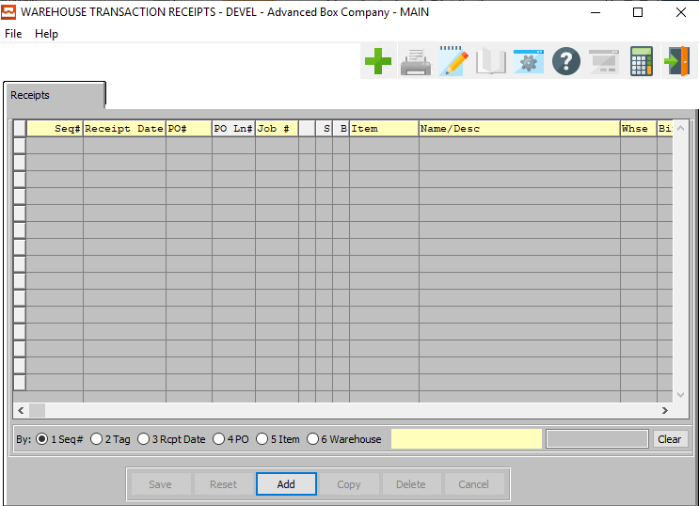

#### ADD

To add a new Receipt, simply click the ***“Green + Icon”*** button at the top of the Warehouse Transaction Receipt screen.

Alternatively, click the ***“Add”*** button at the bottom of the screen.

### Add Receipt

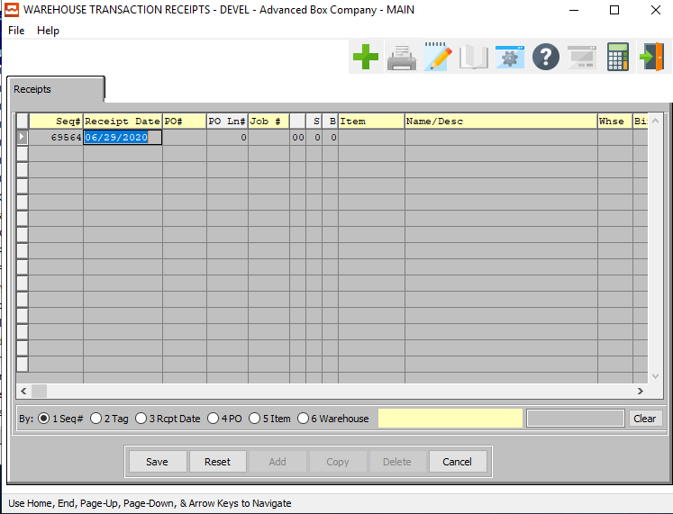

#### SAVE

Click the ***“Save”*** button to save all changes to the current Receipt.

#### RESET

Click the ***“Reset”*** button to reset all fields to their original state.

#### CANCEL

Click the ***“Cancel”*** button to cancel all changes to the Receipt without saving.

### Add Receipt Field Definitions

#### Sequence Number

The Sequence Number is automatically given by the system. It is not modifiable by the user.

#### Receipt Date

Enter a valid receipt date.

#### PO Number

Enter a valid Purchase Order number.

#### Job Number

Enter job number for which material was issued.

#### Job Number: 00

Enter the subsequent job number for which material was issued.

#### S / B

Enter the sheet form number and blank number which the material cost will be applied.

#### Item

Enter a valid item and item number.

#### Name/Description

The item name and description will automatically import from the item file as soon as the user enters or chooses a valid item number.

#### Warehouse

Enter a valid Warehouse code from the Warehouse file. Optionally, Press the ***“F1”*** key to search through, or the ***“Page Up” / “Page Down”*** keys to scroll through the Warehouse file. Press the ***“Enter”*** key to accept the warehouse displayed on the screen.

#### Bin

Enter valid Bin from Bin file. Optionally, Press the ***“F1”*** key to search through, or the ***“Page Up” / “Page Down”*** keys to scroll through the Bin file. Press the ***“Enter”*** key to accept the bin displayed on the screen.

#### Tag Number

Tag number is optional. Your company has the option to receive the total quantity or the quantity per tag. The tag number or pallet number may be entered to control inventory by roll, pallet, or lot number. If tag numbers are defined, then inventory must be committed, issued, and shipped utilizing the tag number.

#### Quantity

Enter transaction quantity in the consumption unit of measure.

#### Price UOM

The sell price unit of measure defaults to M for per thousand, however this may be modified. Each unit of measure will yield a different total selling price.

Valid Units of Measure are:

|  |  |
| --- | --- |
| C | Per Hundred |
| CS | Per Case |
| EA | Per Each |
| L | Per Lot |
| M | Per Thousand |

#### Cost

Enter the cost for the consumption UOM for this tag number or item number.

#### Cost UOM

Valid units of measure (UOM) may be found by pressing the ***“F1”*** key or the ***“Page Up” / “Page Down”*** keys. The consumption UOM is the stocking or consumption quantity posted during the production control process. The purchase UOM may be different which will cause a conversion of quantity during purchasing receipts.

#### User ID

The username of the user that created or last updated this receipt.

#### Entered By

The username of the last user who entered information for this receipt.

#### Entered Date/Time

The original date and time that this receipt was entered.

## Issue Materials to Jobs [MU2]

### Overview

Issues for Raw Materials will decrease the quantity on hand for the item and simultaneously decrease the quantity committed to that job. Issues will also credit the Raw Material asset account defined in the material cost debit the work in process (W.I.P.) inventory account defined in the product line for the item. Lastly the Issue will debit or credit the Purchase Price variance account for the difference between estimated cost and the actual cost. For more information, see Job Costing.

### Issues

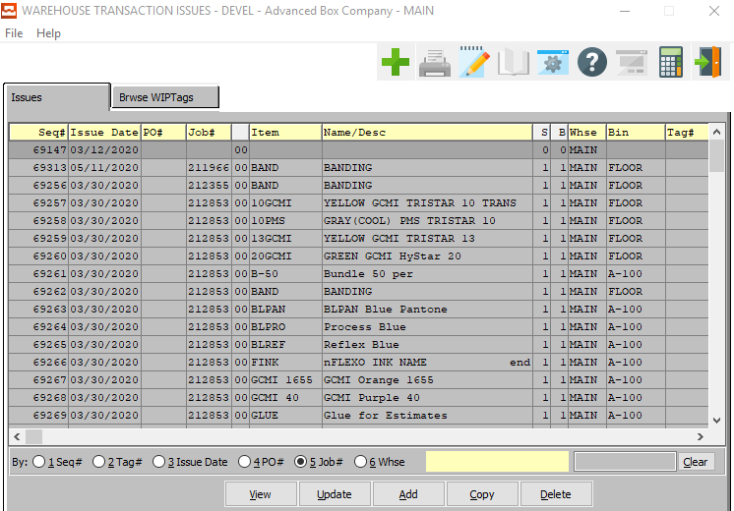

#### UPDATE

To change the currently selected Issue, simply click the ***“Update***” button at the bottom of the screen.

#### ADD

To add a new Issue, simply click the ***“Green + Icon”*** button at the top of the Warehouse Transactions Issues screen.

Alternatively, click the ***“Add”*** button at the bottom of the screen.

#### COPY

Click the ***“Copy”*** button to copy information from the currently selected Issue.

#### DELETE

To delete the currently selected Issue, simply press the ***"D"*** key. Alternatively, click the ***“Delete”*** button at the bottom of the screen.

### Add Warehouse Transaction Issue

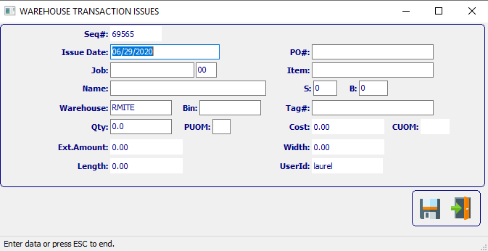

#### SAVE

Click the ***“Floppy Disc Icon”*** to save all changes to the Issue screen.

#### EXIT

Click the ***“Exit Door Icon”*** to exit the Issue popup screen.

### Add Warehouse Transaction Issue Field Definitions

#### Sequence Number

The Sequence Number is automatically given by the system. It is not modifiable by the user.

#### Issue Date

Enter date material was issued to the job. This defaults to system date.

#### Job Number

Enter job number for which material was issued.

#### Job Number: 00

Enter the subsequent job number for which material was issued.

#### Name

Enter a name or a short description for this Issue.

#### Warehouse

Enter a valid warehouse code from the warehouse file. Press ***“F1”*** or ***“Page Up” / “Page Down”*** to search.

#### Bin

Enter a valid bin from the bin file. Press ***“F1”*** or ***“Page Up” / “Page Down”*** to search.

#### Quantity

Enter transaction quantity in the consumption unit of measure, not the estimated or purchased unit of measure.

#### Price UOM

The sell price unit of measure defaults to M for per thousand, however this may be modified. Each unit of measure will yield a different total selling price.

Valid Units of Measure are:

|  |  |
| --- | --- |
| C | Per Hundred |
| CS | Per Case |
| EA | Per Each |
| L | Per Lot |
| M | Per Thousand |

#### PO Number

Enter a valid purchase order number. Alternatively, press the ***“F1”*** key to choose a number from a list of valid purchase orders.

#### Item

Enter Raw Material item number or press the ***“F1”*** button to search for a valid material number from a list of raw materials.

#### S / B

Enter the sheet form number and blank number which the material cost will be applied.

#### Tag Number

Enter a tag/pallet number. This is optional; however it provides lot control and inventory control.

#### Cost

Enter the cost for the consumption UOM for this tag number or item number.

#### Cost UOM

Valid units of measure (UOM) may be found by pressing the ***“F1”*** key or the ***“Page Up” / “Page Down”*** keys. The consumption UOM is the stocking or consumption quantity posted during the production control process. The purchase UOM may be different which will cause a conversion of quantity during purchasing receipts.

#### User ID

The username of the user that first created this Issue. This cannot be modified.

### Browse TIP Tags

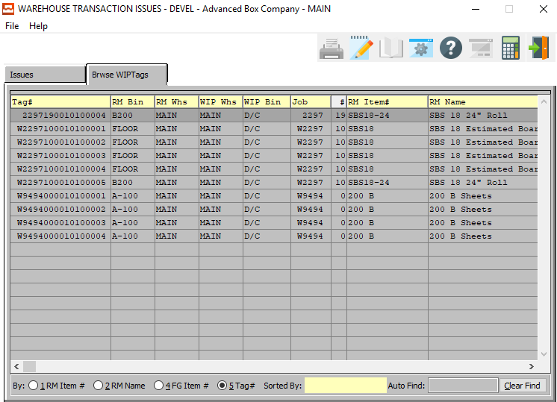

## RM Enter/Modify Transfers [MU3]

Transfers for Raw Materials simply move the material from one location to another so that better inventory control is maintained.

### Transfers

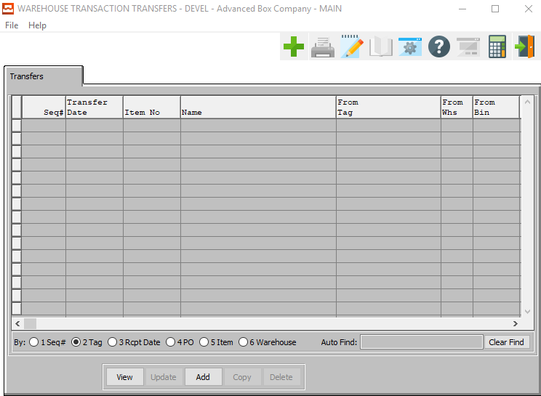

#### VIEW

Click the ***“View”*** button to view detailed information about the currently selected Transfer.

#### ADD

To add a new Transfer, simply click the ***“Green + Icon”*** button at the top of the Warehouse Transaction Transfers screen.

Alternatively, click the ***“Add”*** button at the bottom of the screen.

### Add Transfer

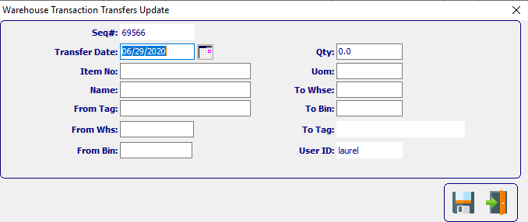

#### SAVE

Click the ***“Floppy Disc Icon”*** to save all changes to the Transfer screen.

#### EXIT

Click the ***“Exit Door Icon”*** to exit the Transfer popup screen.

### Add Transfer Field Definitions

#### Sequence Number

The Sequence Number is automatically given by the system. It is not modifiable by the user.

#### Transfer Date

Enter the date material transferred. Defaults to system date but may be changed.

#### Item Number

Enter valid item number from Raw Material file. Press ***“F1”*** to search.

#### Name

The Item name will transfer from the item file as soon as the user enters or chooses a valid item number.

#### From Tag / To Tag

Enter a beginning and ending tag/pallet number. This is optional; however, it provides lot control and inventory control.

#### From Warehouse / To Warehouse

Enter valid beginning and ending Warehouse code from Warehouse file. Press ***“F1”*** or ***“Page Up” / “Page Down”*** to search.

#### From Bin / To Bin

Enter valid beginning and ending Bin number from Bin file. Press ***“F1”*** or ***“Page Up” / “Page Down”*** to search.

#### Quantity

Enter transaction quantity in the consumption unit of measure.

#### UOM

The sell price unit of measure defaults to M for per thousand, however this may be modified. Each unit of measure will yield a different total selling price.

Valid Units of Measure are:

|  |  |
| --- | --- |
| C | Per Hundred |
| CS | Per Case |
| EA | Per Each |
| L | Per Lot |
| M | Per Thousand |

#### User ID

The username or the user that originally created this Transfer. This cannot be modified.

## RM Enter/Modify Adjustment [MU4]

Adjustments for Raw Materials provides the ability to increase or decrease the quantity and/or cost of the material on hand.

### Adjustment

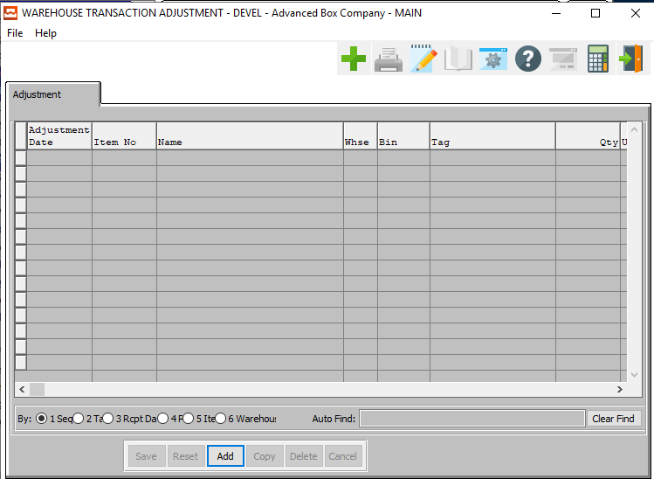

#### ADD

To add a new Adjustment, simply click the ***“Green + Icon”*** button at the top of the Warehouse Transaction Adjustment screen.

Alternatively, click the ***“Add”*** button at the bottom of the screen.

### Add Adjustment

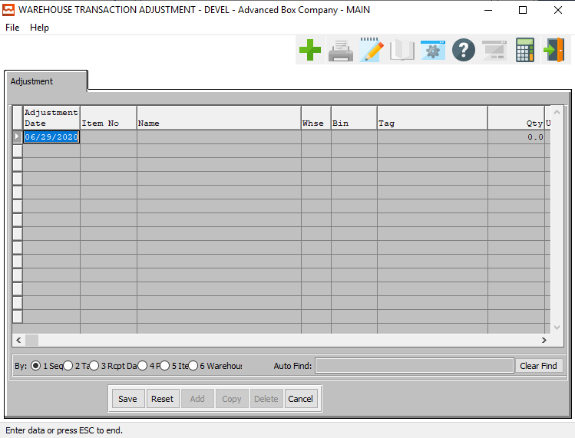

#### SAVE

Click the ***“Save”*** button to save all changes to the current Adjustment.

#### RESET

Click the ***“Reset”*** button to reset all fields to their original state.

#### CANCEL

Click the ***“Cancel”*** button to cancel all changes to the Adjustment without saving.

### Add Adjustment Field Definitions

#### Adjustment Date

Enter date of when material was adjusted.

#### Item Number

Enter valid item number from Raw Material file. Press ***“F1”*** to search.

#### Name

The Item name will transfer from the item file as soon as the user enters or chooses a valid item number.

#### Warehouse

Enter valid Warehouse from Warehouse file. Press ***“F1”*** or ***“Page Up” / “Page Down”*** to search.

#### Bin

Enter valid Bin from Bin file. Press ***“F1”*** or ***“Page Up” / “Page Down”*** to search.

#### Tag

Enter tag number or (ticket number). Not required.

#### Quantity

Enter transaction quantity in the consumption unit of measure.

#### UOM (Quantity)

The sell price unit of measure defaults to M for per thousand, however this may be modified. Each unit of measure will yield a different total selling price.

Valid Units of Measure are:

|  |  |
| --- | --- |
| C | Per Hundred |
| CS | Per Case |
| EA | Per Each |
| L | Per Lot |
| M | Per Thousand |

#### Unit Cost

The cost for this Unit of Measure defaults from Raw Material, but may be modified.

#### UOM (Cost)

The sell price unit of measure defaults to M for per thousand, however this may be modified. Each unit of measure will yield a different total selling price.

Valid Units of Measure are:

|  |  |
| --- | --- |
| C | Per Hundred |
| CS | Per Case |
| EA | Per Each |
| L | Per Lot |
| M | Per Thousand |

#### Reason

The user may choose a reason for this Adjustment from a dropdown list of valid reasons.

Please Note: Reasons may be defined by a user in the File Maintenance section. If the user does not see a valid reason in the drop down menu, they may create a new reason.

#### User ID

The username of the user that originally created this Adjustment.

## Print Raw Material Edit List [MU5]

The Edit List provides a pre-posting worksheet to catch data entry errors.

### Selection Parameters

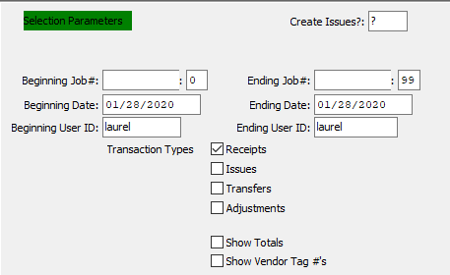

#### Create Issues?

To create issues for all files as they are edited, enter a ***“Y”*** in this field. If the user chooses to skip this step, enter an ***“N”*** in this field.

#### Beginning Job # / Ending Job #

Enter the beginning and ending Job Number to run the report for.

#### Beginning Job #: 00 / Ending Job #: 00

Enter the beginning and ending Subsequent Job Number to run the report for.

#### Beginning Date / Ending Date

Enter the beginning and ending Date to run the report for.

#### Beginning User ID / Ending User ID

Enter the beginning and ending User ID to run the report for.

#### Transaction Type: Receipts – Toggle Box

To include Receipt transactions in the Edit List, make sure that the Receipts toggle box is checked.

#### Transaction Type: Issues – Toggle Box

To include Issue transactions in the Edit List, make sure that the Issues toggle box is checked.

#### Transaction Type: Transfers – Toggle Box

To include Transfer transactions in the Edit List, make sure that the Transfers toggle box is checked.

#### Transaction Type: Adjustments – Toggle Box

To include Adjustment transactions in the Edit List, make sure that the Adjustments toggle box is checked.

#### Show Totals – Toggle Box

To show totals on the Edit List report, make sure that the Show Totals toggle box is checked.

#### Show Vendor Tag #’s – Toggle Box

To show Vendor Tag numbers on the Edit List report, make sure that the Show Vendor Tag #’s toggle box is checked.

### Output Destination

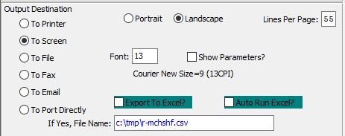

#### Destination Choice

To choose the destination where the document should be printed, please make sure that desired output destination choice bubble is toggled.

#### Layout Choice

To choose the preferred layout of Landscape vs. Portrait, please make sure the desired option choice bubbled is toggled.

#### Lines Per Page

Lines per page on the report when printing.

#### Font

Enter the font number to use with this report (Font 11 is default).

#### Show Parameters? – Toggle Box

To show parameters, make sure that the toggle box is ‘ticked’ with a checkmark.

#### Export to Excel? – Toggle Box

To export the printed file to an excel document, make sure that the Export to Excel toggle box is checked.

#### Auto Run Excel? – Toggle Box

To automatically open the new excel document, make sure that the Auto Run Excel toggle box is checked.

#### If Yes, File Name

If exporting the file to Excel, enter the desired file name.

## Post to Raw Material Files [MU6]

Posting the Warehouse transactions actually updates all files entered for the Warehouse transactions.

### Selection Parameters

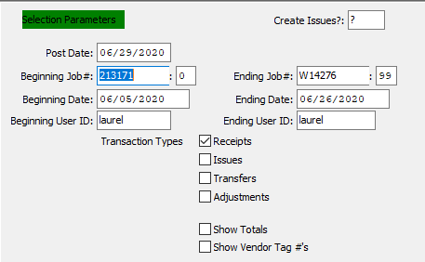

#### Create Issues?

To create issues for all files as they are posted, enter a ***“Y”*** in this field. If the user chooses to skip this step, enter an ***“N”*** in this field.

#### Post Date

Enter date for posting.

#### Beginning Job # / Ending Job #

Enter the beginning and ending Job Number to run the report for.

#### Beginning Job #: 00 / Ending Job #: 00

Enter the beginning and ending Subsequent Job Number to run the report for.

#### Beginning Date / Ending Date

Enter the beginning and ending Date to run the report for.

#### Beginning User ID / Ending User ID

Enter the beginning and ending User ID to run the report for.

#### Transaction Type: Receipts – Toggle Box

To post Receipt transactions, make sure that the Receipts toggle box is checked.

#### Transaction Type: Issues – Toggle Box

To post Issue transactions, make sure that the Issues toggle box is checked.

#### Transaction Type: Transfers – Toggle Box

To post Transfer transactions, make sure that the Transfers toggle box is checked.

#### Transaction Type: Adjustments – Toggle Box

To post Adjustment transactions, make sure that the Adjustments toggle box is checked.

#### Show Totals – Toggle Box

To show totals on the report, make sure that the Show Totals toggle box is checked.

#### Show Vendor Tag #’s – Toggle Box

To show Vendor Tag numbers on the report, make sure that the Show Vendor Tag #’s toggle box is checked.

### Output Destination

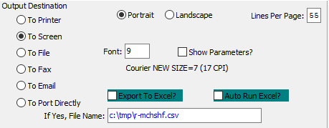

#### Destination Choice

To choose the destination where the document should be printed, please make sure that desired output destination choice bubble is toggled.

#### Layout Choice

To choose the preferred layout of Landscape vs. Portrait, please make sure the desired option choice bubbled is toggled.

#### Lines Per Page

Lines per page on the report when printing.

#### Font

Enter the font number to use with this report (Font 11 is default).

#### Show Parameters? – Toggle Box

To show parameters, make sure that the toggle box is ‘ticked’ with a checkmark.

#### Export to Excel? – Toggle Box

To export the printed file to an excel document, make sure that the Export to Excel toggle box is checked.

#### Auto Run Excel? – Toggle Box

To automatically open the new excel document, make sure that the Auto Run Excel toggle box is checked.

#### If Yes, File Name

If exporting the file to Excel, enter the desired file name.

## Delete Zero Quantity RM Bins [MU7]

Zero quantity Bins & Tags may be purged from the system to provide cleaner Reports and Inquiries and to save disk space.

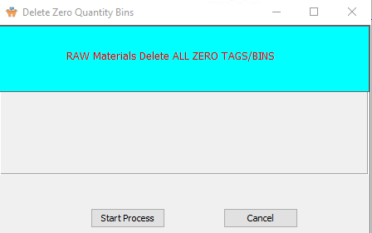

#### START PROCESS

Click the ***“Start Process”*** button to begin the process of deleted all empty Raw Material bins from the system.

#### CANCEL

Click the ***“Cancel”*** button to exit the Delete Zero Quantity screen.

## RM Load Tag Creation [MU8]

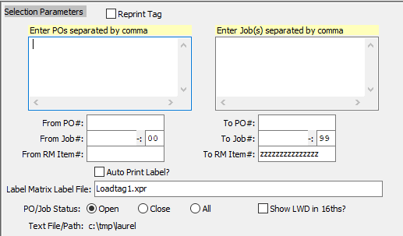

### Selection Parameters

#### Reprint Tag – Toggle Box

To reprint a previously printed load tag, make sure that the Reprint Load Tag toggle box is checked.

#### Enter POs Separated by Comma

If the user wishes to create load tags for purchase orders that are not in a sequence, they may enter whichever PO numbers they wish here, separated with a comma between each.

#### Enter Job(s) Separated by Comma

If the user wishes to create load tags for jobs that are not in a sequence, they may enter whichever Job numbers they wish here, separated with a comma between each.

#### From PO # / To PO #

If the user wishes to create load tags for purchase orders that are in order, they may enter the beginning and ending Purchase Order Number to create Load Tags for.

#### From Job # / To Job #

If the user wishes to create load tags for jobs that are in order, they may enter the beginning and ending Job Numbers to create Load Tags for.

#### From Job#: 00 / To Job #: 00

Enter the beginning and ending Purchase Order Number to create Load Tags for.

#### From RM Item # / To RM Item #

Enter the beginning and ending Purchase Order Number to create Load Tags for.

#### Auto Print Label? – Toggle Box

To automatically print labels upon creation, make sure that the Auto Print Label toggle box is checked.

#### Label Matrix Label File

The user may enter the name of Label Matrix label file they wish to create. Alternatively, they may press the ***“F1”*** key to choose a file using the Windows Explorer window.

#### PO/Job Status (Choice)

To choose the preferred status option of Open vs. Closed (Or All), please make sure the desired option choice bubble is toggled.

#### Show LWD in 16ths? – Toggle Box

To show the LWD in sixteenths, make sure that this toggle box is checked.

# **Raw Material Inventory Control and Warehouse Transactions**

Let’s explain how raw material control works. Since estimated materials (item code = ***“E”***) have no inventory control, this discussion will only address Real material (item code = ***“R”***) When creating jobs, the materials required are transferred from the estimate.

Any time the user presses the ***“StandardCreate”*** key in the job file, the materials transfer again. The quantity of board required shown as MRP in the job file is controlled by the S-8-JOB QTY field. Options include the following:

|  |
| --- |
| Net Sheets Only |
| Net Sheets Plus Waste |
| Net Sheet Plus Waste & Overrun Quantity Based on the Customer Order’s Overrun Percentage |

Adding purchase orders for Real material such as a stocked sheets or rolls, which do not require a job number, will increase the items on order quantity. If the job number is entered on the PO, then raw material receipts for the board “could” simultaneously create a material issue to the job if the S-8-Autoissue logical value is set to ***“Yes”***.

If no job# is defined on the purchase order, then the user must add both the receipt as well as the material issue as separate steps. Therefore, stock sheets or rolls purchased for inventory and used on multiple jobs must have a separate issue added for each job.

When allocating material to a job via the ***“F”-“3”*** option, the quantity committed for the item will increase by the unit of measure for the real material allocated. I.e. if the estimated board SBS-18 on the job requires 1000 sheets, but we allocated material such as SBS18-30 is consumed by the MSF, Ton, Lineal foot or sheet, the system will automatically convert from the estimated unit of measure to the items consumption unit of measure.

For jobs such as sets, tandem and combination, materials must be issued by Form or Sheet number to properly update the correct sheet size. Once Materials are issued to a job, the job status code will change to ***“W”*** (Work in Process), which is required before a job can be closed.

Issues of materials will decrease the quantity on hand for the exact quantity issued. The quantity committed will also decrease up to the original quantity committed.

Therefore if 1000 Sheets are committed, but 1200 issued, only 1000 will be decommitted. If only 900 sheets are issued, then 900 will be decommitted with the remaining balanced decommitted when the job is closed making the committed zero.

# **Count Raw Goods Inventory [MC]**

## Overview

Physical Counting of Raw materials may be processed as often as required. More critical items such as board should be counted every month, whereas glue or pallets may be counted semi-annually. Whatever your company’s inventory control methodology, the physical count processing provides a more routine and accurate method to control inventory.

To facilitate this process, each item is given a CYCLE COUNT Code in the raw material file so that similar items should be given the same cycle count code so that the cycle count worksheet prints only that group of items. Once the worksheet is printed and the actual inventory noted on the worksheet, the data entry process of posting the actual count must be entered. Once entered, an edit list should be printed then finally, the transactions should be posted, and the cycle count register printed.

The important issue regarding this program is that the quantity posted replaces the previous quantity on hand for each bin and tag number. This varies from warehouse transactions which either add or reduce from the original on hand quantity. Once added, physical counts to raw goods inventory may be added, deleted or changed for each warehouse, bin and tag number.

## Cycle Count Code Report [MC1]

The Cycle Count Code Report assists in the physical counting of the raw materials. Each item is given a cycle count code in the Raw Materials File so that similar items should be given the same cycle count code so that the cycle count worksheet prints only that group of items.

### Selection Parameters

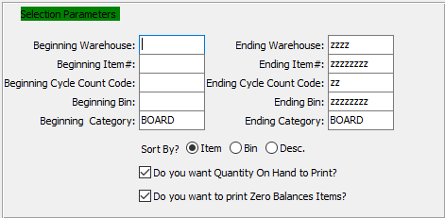

#### Beginning Warehouse / Ending Warehouse

Enter the beginning and ending warehouse for this report.

#### Beginning Item # / Ending Item #

Enter the first and last item numbers for this report.

#### Beginning Cycle Count Code / Ending Cycle Count Code

Enter starting and ending cycle count code for this report.

#### Beginning Bin / Ending Bin

Enter the first and last bin for this report.

#### Beginning Category / Ending Category

Enter the first and last category for this report.

#### Sort By? (Choice)

To choose the preferred sorting method of Item vs. Bin vs. Description, please make sure the desired option choice bubble is toggled.

#### Do You Want Quantity on Hand to Print? – Toggle Box

To print Quantity On-Hand on the report, make sure that this toggle box is checked.

#### Do You Want to Print Zero Balances Items? – Toggle Box

To Print any items that have no quantities on the report, make sure that this toggle box is checked.

### Output Destination

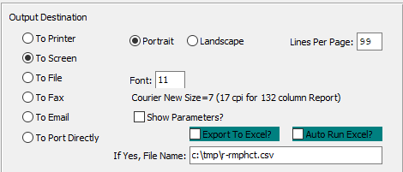

#### Destination Choice

To choose the destination where the document should be printed, please make sure that desired output destination choice bubble is toggled.

#### Layout Choice

To choose the preferred layout of Landscape vs. Portrait, please make sure the desired option choice bubbled is toggled.

#### Show Parameters? – Toggle Box

To show parameters, make sure that the toggle box is ‘ticked’ with a checkmark.

#### Export to Excel? – Toggle Box

To export the printed file to an excel document, make sure that the Export to Excel toggle box is checked.

#### Auto Run Excel? – Toggle Box

To automatically open the new excel document, make sure that the Auto Run Excel toggle box is checked.

#### If Yes, File Name

If exporting the file to Excel, enter the desired file name.

## Physical Count Processing [MC2]

### Overview

Physical Counting of Raw materials may be processed as often as required. More critical items such as board should be counted every month, whereas glue or pallets may be counted semi-annually. Whatever your company’s inventory control methodology, the physical count processing provides a more routine and accurate method to control inventory.

To facilitate this process, each item is given a CYCLE COUNT Code in the raw material file so that similar items should be given the same cycle count code so that the cycle count worksheet prints only that group of items. Once the worksheet is printed and the actual inventory noted on the worksheet, the data entry process of posting the actual count must be entered. Once entered, an edit list should be printed then finally, the transactions should be posted, and the cycle count register printed.

The important issue regarding this program is that the quantity posted replaces the previous quantity on hand for each bin and tag number. This varies from warehouse transactions which either add or reduce from the original on hand quantity. Once added, physical counts to raw goods inventory may be added, deleted or changed for each warehouse, bin and tag number.

### Counts

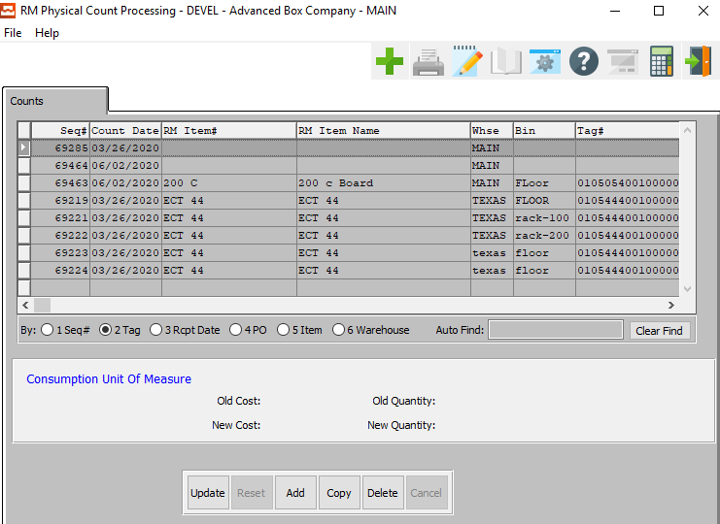

#### UPDATE

To change the currently selected Count, simply click the ***“Update***” button at the bottom of the screen.

#### ADD

To add a new Count, simply click the ***“Green + Icon”*** button at the top of the Physical Count Processing screen.

Alternatively, click the ***“Add”*** button at the bottom of the screen.

#### COPY

Click the ***“Copy”*** button to copy information from the currently selected Count.

#### DELETE

To delete the currently selected Count, simply press the ***"D"*** key. Alternatively, click the ***“Delete”*** button at the bottom of the screen.

### Add Count

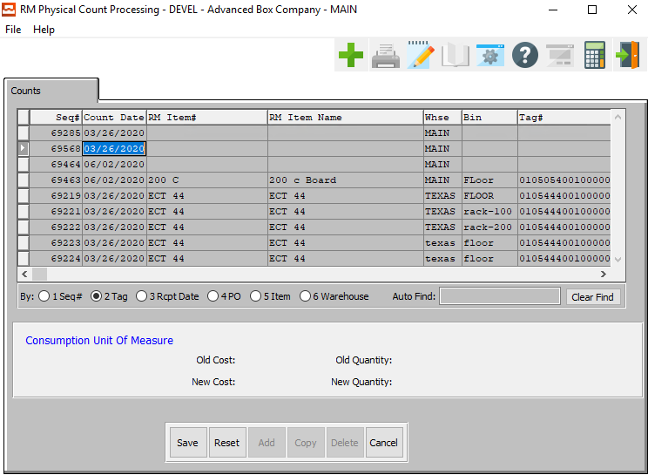

#### SAVE

Click the ***“Save”*** button to save all changes to the current Count.

#### RESET

Click the ***“Reset”*** button to reset all fields to their original state.

#### CANCEL

Click the ***“Cancel”*** button to cancel all changes to the Count without saving.

### Add Count Field Definitions

#### Sequence #

The Sequence Number is automatically given by the system. It is not modifiable by the user.

#### Count Date

Enter date item was received, defaults to system date.

#### RM Item #

The Raw Material item name will transfer from the item file soon as the user enters or chooses a valid Raw Material item number.

#### RM Item Name

The item name will transfer from the item file soon as the user enters or chooses a valid item number.

#### Warehouse

Enter valid Warehouse from Warehouse file. Press ***“F1”*** or ***“Page Up” / “Page Down”*** to search.

#### Bin

Enter valid Bin from Bin file. Press ***“F1”*** or ***“Page Up” / “Page Down”*** to search.

#### Tag #

Enter tag number or (ticket number).

#### Quantity Counted

Enter transaction quantity in the consumption unit of measure.

#### UOM

The sell price unit of measure defaults to M for per thousand, however this may be modified. Each unit of measure will yield a different total selling price.

Valid Units of Measure are:

|  |  |
| --- | --- |
| C | Per Hundred |
| CS | Per Case |
| EA | Per Each |
| L | Per Lot |
| M | Per Thousand |

## Post Physical Counts [MC3]

### Selection Parameters

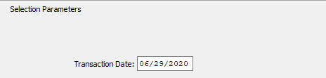

#### Transaction Date

Enter date for posting. After you have entered a date, the system will prompt you for which device to print the report to with the screen shown above.

### Output Destination

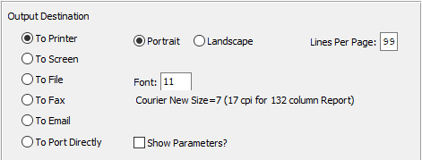

#### Destination Choice

To choose the destination where the document should be printed, please make sure that desired output destination choice bubble is toggled.

#### Layout Choice

To choose the preferred layout of Landscape vs. Portrait, please make sure the desired option choice bubbled is toggled.

#### Lines Per Page

Lines per page on the report when printing.

#### Font

Enter the font number to use with this report (Font 11 is default).

#### Show Parameters? – Toggle Box

To show parameters, make sure that the toggle box is ‘ticked’ with a checkmark.

#### Export to Excel? – Toggle Box

To export the printed file to an excel document, make sure that the Export to Excel toggle box is checked.

#### Auto Run Excel? – Toggle Box

To automatically open the new excel document, make sure that the Auto Run Excel toggle box is checked.

## Initialize Physical Counts [MC4]

### Selection Parameters

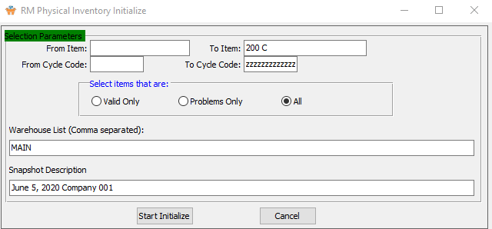

#### From Item / To Item

Enter the beginning and ending Item to physically count inventory for.

#### From Cycle Code / To Cycle Code

Enter the beginning and ending Cycle Code to physically count inventory for.

#### Select Items that Are (Choice)

To choose the preferred item option of Valid Only vs. Problems Only (Or All), please make sure the desired option choice bubble is toggled.

#### Warehouse List

The user may enter multiple warehouses manually, as long as each warehouse code is separated by a comma. Alternatively, the user may press the ***“F1”*** button to bring up a list of all available warehouses.

The user may choose multiple warehouses from this list by using the ***“Control – Click”*** method. Choosing multiple locations this way will automatically separate those chosen by the needed commas.

This list can be sorted by Warehouse Location or Warehouse Description. Alternatively, the user may search for what they wish to use in order to narrow down their selection.

#### Snapshot Description

Enter a description for this particular Snapshot. This description is how the user may later choose which Snapshot to use in the Analyze and Post Physical Counts report (MC5).

## Analyze and Post Physical Counts [MC5]

### Selection Parameters



#### Snapshot

The user may choose which Snapshot they wish to use from the dropdown list of available choices.

### Posting Options

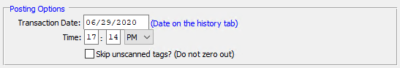

#### Transaction Date

Enter the transaction date for the physical count. This defaults to the system date, but may be modified by the user.

#### Time

Enter the transaction time for the physical count. This defaults to the system time, but may be modified by the user.

#### Skip Unscanned Tags? – Toggle Box

To skip any tags that have not been scanned, make sure that the Skip Unscanned Tags toggle box is checked.

### Item Selections

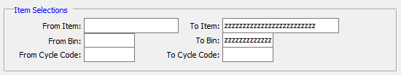

#### From Item / To Item

Enter the beginning and ending Item to physically count inventory for.

#### From Bin / To Bin

Enter the beginning and ending Bin to physically count inventory for.

#### From Cycle Code / To Cycle Code

Enter the beginning and ending Cycle Code to physically count inventory for.

### Warehouse List



The user may enter multiple warehouses manually, as long as each warehouse code is separated by a comma. Alternatively, the user may press the ***“F1”*** button to bring up a list of all available warehouses.

The user may choose multiple warehouses from this list by using the ***“Control – Click”*** method. Choosing multiple locations this way will automatically separate those chosen by the needed commas.

This list can be sorted by Warehouse Location or Warehouse Description. Alternatively, the user may search for what they wish to use in order to narrow down their selection.

### Choose Full Report or Just Exceptions

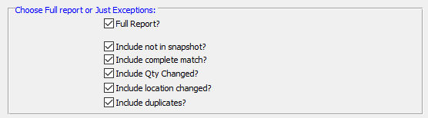

#### Full Report? – Toggle Box

To print a full report, make sure that the Full Report toggle box is checked.

#### Include Not in Snapshot? – Toggle Box

To include items that are not in snapshots, make sure that this toggle box is checked.

#### Include Complete Match? – Toggle Box

To include complete matches for all selection parameters, make sure that this toggle box is checked.

#### Include Qty Changed? – Toggle Box

To include items where the quantity is changed, make sure that this toggle box is checked.

#### Include Location Changed? – Toggle Box

To include items where the location has changed, make sure that this toggle box is checked.

#### Include Duplicates – Toggle Box

To include duplicated items, make sure that the Include Duplicates toggle box is checked.

### Output Destination

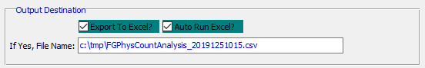

#### Export to Excel? – Toggle Box

To export the printed file to an excel document, make sure that the Export to Excel toggle box is checked.

#### Auto Run Excel? – Toggle Box

To automatically open the new excel document, make sure that the Auto Run Excel toggle box is checked.

#### If Yes, File Name

If exporting the file to Excel, enter the desired file name.

# **Global RM Price Change [MG]**

The Global Price Change screen allows automatic adjusting the cost of estimated (item code = E) materials. Select special material types for the Global Price Change feature.

### Selection Parameters

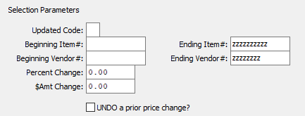

#### Updated Code

Enter the update code.

#### Beginning Item # / Ending Item #

Enter the first and last item number for the price change.

#### Beginning Vendor # / Ending Vendor #

Enter the first and last vendor number for the price change.

#### Percent Change

Enter the percentage of the price adjustment.

#### Dollar Amount Change

Enter the dollar amount of the price adjustment.

#### UNDO a Prior Price Change? – Toggle Box

To undo a prior price change, make sure that this toggle box is checked.

### Select/Deselect Material Types

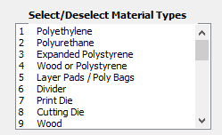

The user may choose multiple Material Types from this list by using the ***“Control – Click”*** method. A selected Material Type will by highlighted within the list, and only highlighted Material Types will be used by the system.

# **Query Raw Goods [MQ]**

## Overview

### Raw Materials Transaction by Item

Alpha-numeric lookups by item number and item description provide easy access to the item number. The inquiry displays current inventory levels by warehouse for on hand, on order, issued, available and reorder level. Totals for all warehouses are also available.

### Raw Materials Transaction by Job Number

Alpha-numeric lookups by job number and job description provide easy access to the job. The inquiry displays current inventory levels by warehouse for on hand, on order, issued, available and reorder level. Totals for all warehouses are also available.

## RM History [MQ1]

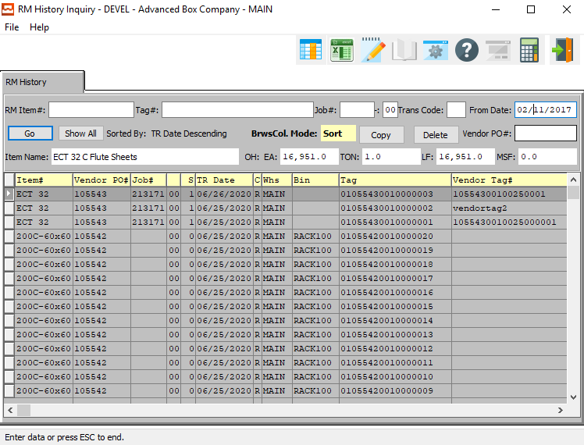

#### COPY

Click the ***“Copy”*** button to copy information from the currently selected Raw Material History.

#### DELETE

To delete the currently selected Raw Material History, simply press the ***"D"*** key. Alternatively, click the ***“Delete”*** button at the top of the screen.

#### RM Item #

Enter an item number.

#### Tag #

Enter a tag number to search for. Alternatively, press the ***“F1”*** key to choose a number from a list of available tag numbers.

#### Job #

Enter a job number to search for. Alternatively, press the ***“F1”*** key to choose a number from a list of available job numbers.

#### Job #: 00

Enter a subsequent job number to search for.

#### Trans Code

Enter a transaction code.

#### From Date

Enter a starting date.

#### Vendor PO #

Enter a Vendor PO number to search for. Alternatively, press the ***“F1”*** key to choose a number from a list of available PO numbers.

#### Item Name

The item name will transfer from the item file as soon as the user enters or chooses a valid item number.

## RM Allocated by Job [MQ2]

### RM History

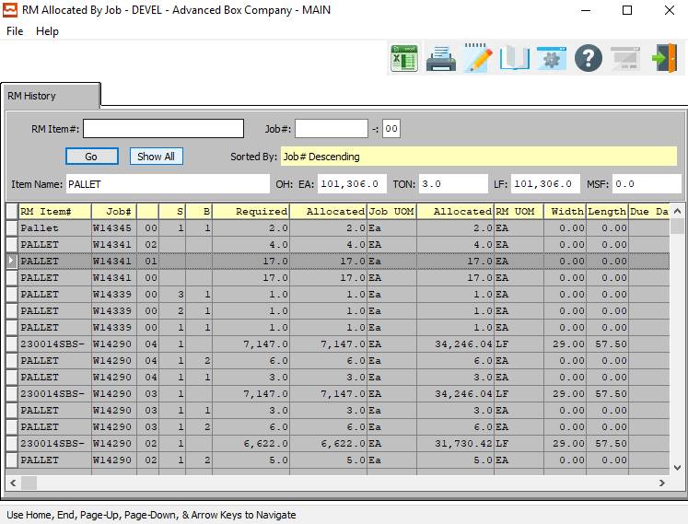

#### RM Item #

Enter an item number.

#### Job #

Enter a job number.

#### Job #: 00

Enter the job number extension.

#### Item Name

The item name will transfer from the item file as soon as the user enters or chooses a valid item number.

# **Reports for Raw Goods [MR]**

## Overview

For the Cost List, raw materials inventory reporting may be sorted by material type and range of product categories for each warehouse. Each material type report may be printed in summary or detail and sorted by either estimated material or actual material or both. To access the material list reports, press the raw materials ***“R”***, report option, then select ***“1”*** to list material cost report options.@@

Print Reordering Advice - Raw materials may be assigned a reorder level quantity in their inventory files. The reordering advise report will print items below the reorder quantity. In addition, the quantity available may exclude or include the quantity on order. This report may be printed by range of items, by warehouse location and product category.

The Inventory by Bin/Tag, Item Name screens provide lists of inventories by bin, tag, and item.

## Raw Materials Cost List [MR1]

### Overview

Raw materials inventory reporting may be sorted by material type and range of product categories for each warehouse. Each material type report may be printed in summary or detail and sorted by either estimated material or actual material or both. To access the material list reports, press the raw materials “***R”***, report option, then select “***1”*** to list material cost report options.

The raw materials cost report essentially provides a cost matrix for each item with the cost that will be used during estimating. The report may be output computer screen, printer, fax, email or directly text file or to an excel format.

The print selection allows limited the report by product category, material type and vendor. Material types include the following:

|  |  |  |  |  |  |  |  |
| --- | --- | --- | --- | --- | --- | --- | --- |
| B | Board | F | Film | I | Inks | P | Paper |
| C | Cases | G | Glue | M | Miscellaneous | W | Window |

The report also provides an option to include inventory that is stocked raw material or just material used for estimating. Finally, a summary and detail version is available.

### Selection Parameters

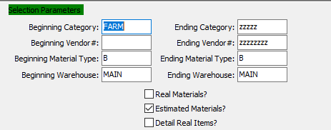

#### Beginning Category / Ending Category

Enter a beginning and ending Category to run the report for.

#### Beginning Vendor # / Ending Vendor #

Enter a beginning and ending Vendor Number to run the report for.

#### Beginning Material Type / Ending Material Type

Enter a beginning and ending Material Type to run the report for.

#### Beginning Warehouse / Ending Warehouse

Enter a beginning and ending Warehouse to run the report for.

#### Real Materials? – Toggle Box

To show real materials on the cost list report, make sure that the Real Materials toggle box is checked.

#### Estimated Materials? – Toggle Box

To show estimated materials on the cost list report, make sure that the Estimated Materials toggle box is checked.

#### Detail Real Items? – Toggle Box

To show a detailed report of the real items, make sure that the Detail Real Items toggle box is checked.

### Available and Selected Columns

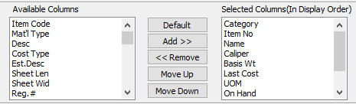

#### Available Columns

The user may choose which columns they wish to have on the report printout. As the user selects their choices, they will appear on the ‘*Selected Columns’* list.

#### Selected Columns (In Display Order)

The columns that the user has chosen from the ‘*Available Columns’* list. The order that these columns are displayed in here is the order in which they will print on the report.

#### Default

Click the ***“Default****”* button to sort the ‘*Selected Columns’* list by the default system parameters.

#### Add >>

Click on the selected item from the ‘*Available Columns’* list to highlight it, then click the ***“Add”*** button to add the selected column to the ‘*Selected Columns’* list.

#### << Remove

Click on the selected item from the ‘*Selected Columns’* list to highlight it, then click the ***“Remove”*** button to remove the selected column to the ‘*Selected Columns’* list.

#### Move Up

Within the ‘*Selected Columns’* list, the user may choose the order they wish the selected columns to print in. In order to change the order of the columns, the user can click on a selection to highlight it. By then clicking the ***“Move Up***” button, the user can change its position on the report.

#### Move Down

Within the ‘*Selected Columns’* list, the user may choose the order they wish the selected columns to print in. In order to change the order of the columns, the user can click on a selection to highlight it. By then clicking the ***“Move Down***” button, the user can change its position on the report.

### Output Destination

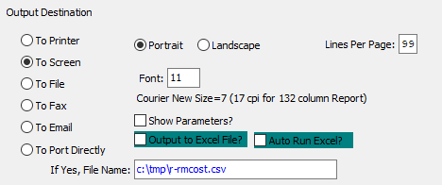

#### Destination Choice

To choose the destination where the document should be printed, please make sure that desired output destination choice bubble is toggled.

#### Layout Choice

To choose the preferred layout of Landscape vs. Portrait, please make sure the desired option choice bubbled is toggled.

#### Lines Per Page

Lines per page on the report when printing.

#### Font

Enter the font number to use with this report (Font 11 is default).

#### Show Parameters? – Toggle Box

To show parameters, make sure that the toggle box is ‘ticked’ with a checkmark.

#### Export to Excel? – Toggle Box

To export the printed file to an excel document, make sure that the Export to Excel toggle box is checked.

#### Auto Run Excel? – Toggle Box

To automatically open the new excel document, make sure that the Auto Run Excel toggle box is checked.

#### If Yes, File Name

If exporting the file to Excel, enter the desired file name.

## Reordering Advice [MR2]

### Overview

Raw materials may be assigned a reorder level quantity in their inventory files. The reordering advise report will print items below the reorder quantity. In addition, the quantity available may exclude or include the quantity on order. This report may be printed by range of items, by warehouse location and product category.

The Reorder Advice Report is an exception report that pinpoints material that is below the reorder lever. The report has the option to include quantity on order. Hence the quantity on hand plus on order minus quantity committed equals the quantity available.

If the quantity available is below the reorder level, then the item appears on the reorder advice report. Essentially, only items that need to be purchased are on the report. The purchasing agent should print this daily.

The print selection allows limited the report by date, item code, warehouse and product category. The report may be output directly to a computer screen, printer, fax, email or to a text file or to an excel format.

### Selection Parameters

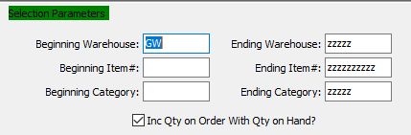

#### Beginning Warehouse / Ending Warehouse

Enter the beginning and ending Warehouse to run the Reordering Advice report for.

#### Beginning Item # / Ending Item #

Enter the beginning and ending Item Number to run the Reordering Advice report for.

#### Beginning Category / Ending Category

Enter the beginning and ending Category to run the Reordering Advice report for.

#### Include Quantity on Order with Quantity on Hand? – Toggle Box

To include the quantity on order along with the quantity on hand on the reordering advice report, make sure that this toggle box is checked.

### Available and Selected Columns

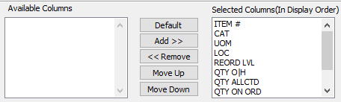

#### Available Columns

The user may choose which columns they wish to have on the report printout. As the user selects their choices, they will appear on the ‘*Selected Columns’* list.

#### Selected Columns (In Display Order)

The columns that the user has chosen from the ‘*Available Columns’* list. The order that these columns are displayed in here is the order in which they will print on the report.

#### Default

Click the ***“Default****”* button to sort the ‘*Selected Columns’* list by the default system parameters.

#### Add >>

Click on the selected item from the ‘*Available Columns’* list to highlight it, then click the ***“Add”*** button to add the selected column to the ‘*Selected Columns’* list.

#### << Remove

Click on the selected item from the ‘*Selected Columns’* list to highlight it, then click the ***“Remove”*** button to remove the selected column to the ‘*Selected Columns’* list.

#### Move Up

Within the ‘*Selected Columns’* list, the user may choose the order they wish the selected columns to print in. In order to change the order of the columns, the user can click on a selection to highlight it. By then clicking the ***“Move Up***” button, the user can change its position on the report.

#### Move Down

Within the ‘*Selected Columns’* list, the user may choose the order they wish the selected columns to print in. In order to change the order of the columns, the user can click on a selection to highlight it. By then clicking the ***“Move Down***” button, the user can change its position on the report.

### Output Destination

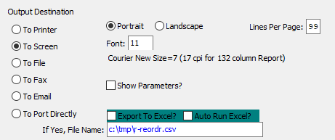

#### Destination Choice

To choose the destination where the document should be printed, please make sure that desired output destination choice bubble is toggled.

#### Layout Choice

To choose the preferred layout of Landscape vs. Portrait, please make sure the desired option choice

#### Show Parameters? – Toggle Box

To show parameters, make sure that the toggle box is ‘ticked’ with a checkmark.

#### Export to Excel? – Toggle Box

To export the printed file to an excel document, make sure that the Export to Excel toggle box is checked.

#### Auto Run Excel? – Toggle Box

To automatically open the new excel document, make sure that the Auto Run Excel toggle box is checked.

## Inventory by Bin/Tag [MR3]

The raw materials report by bin and tag has many options, but this is very useful for a month end value for all raw goods. This report may be run as of a specific date, whereby the value of inventory at that date will be calculated and printed. This is a great tool for any accountant or auditor. The report may be output directly to a text file or to an excel format.

The print selection allows limited the report by date, item code, warehouse, product category, material type and receipt date. Material types include the following:

|  |  |  |  |  |  |  |  |
| --- | --- | --- | --- | --- | --- | --- | --- |
| B | Board | F | Film | I | Inks | P | Paper |
| C | Cases | G | Glue | M | Miscellaneous | W | Window |

Likewise, the report provides an option to subtotal as well as grand total the number of rolls, quantity on hand and value.

The report also provides an option to include inventory with no hand quantity which works as an inventory list.

### Selection Parameters

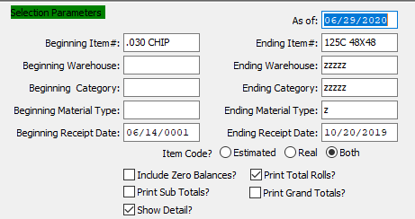

#### As Of

For Jobs Closed After - (As of) Enter the as of date.

#### Beginning Item # / Ending Item #

Enter the beginning and ending Item Number to run the report for.

#### Beginning Warehouse / Ending Warehouse

Enter the beginning and ending Warehouse to run the report for.

#### Beginning Category / Ending Category

Enter the beginning and ending Category to run the report for.

#### Beginning Material Type / Ending Material Type

Enter the beginning and ending Material Type to run the report for.

#### Beginning Receipt Date / Ending Receipt Date

Enter the beginning and ending Receipt Date to run the report for.

#### Item Code? (Choice)

To choose the preferred item code type of Estimated vs. Real (Or Both), please make sure the desired option choice bubble is toggled.

#### Include Zero Balances? – Toggle Box

To inventory with zero balances, make sure that the Include Zero Balances toggle box is checked.

#### Print Sub Totals? – Toggle Box

To print subtotals on the report, make sure that the Print Sub Totals toggle box is checked.

#### Show Detail? – Toggle Box

To show a detailed report of each item, make sure that the Show Detail toggle box is checked.

#### Print Total Rolls? – Toggle Box

To print total rolls, make sure that the Print Total Rolls toggle box is checked.

#### Print Guard Totals? – Toggle Box

To print Guard totals on the report, make sure that the Print Guard Totals toggle box is checked.

### Available and Selected Columns

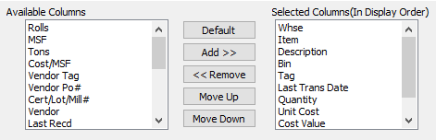

#### Available Columns

The user may choose which columns they wish to have on the report printout. As the user selects their choices, they will appear on the ‘*Selected Columns’* list.

#### Selected Columns (In Display Order)

The columns that the user has chosen from the ‘*Available Columns’* list. The order that these columns are displayed in here is the order in which they will print on the report.

#### Default

Click the ***“Default****”* button to sort the ‘*Selected Columns’* list by the default system parameters.

#### Add >>

Click on the selected item from the ‘*Available Columns’* list to highlight it, then click the ***“Add”*** button to add the selected column to the ‘*Selected Columns’* list.

#### << Remove

Click on the selected item from the ‘*Selected Columns’* list to highlight it, then click the ***“Remove”*** button to remove the selected column to the ‘*Selected Columns’* list.

#### Move Up

Within the ‘*Selected Columns’* list, the user may choose the order they wish the selected columns to print in. In order to change the order of the columns, the user can click on a selection to highlight it. By then clicking the ***“Move Up***” button, the user can change its position on the report.

#### Move Down

Within the ‘*Selected Columns’* list, the user may choose the order they wish the selected columns to print in. In order to change the order of the columns, the user can click on a selection to highlight it. By then clicking the ***“Move Down***” button, the user can change its position on the report.

### Output Destination

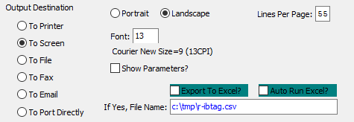

#### Destination Choice

To choose the destination where the document should be printed, please make sure that desired output destination choice bubble is toggled.

#### Layout Choice

To choose the preferred layout of Landscape vs. Portrait, please make sure the desired option choice bubbled is toggled.

#### Lines Per Page

Lines per page on the report when printing.

#### Font

Enter the font number to use with this report (Font 11 is default).

#### Show Parameters? – Toggle Box

To show parameters, make sure that the toggle box is ‘ticked’ with a checkmark.

#### Export to Excel? – Toggle Box

To export the printed file to an excel document, make sure that the Export to Excel toggle box is checked.

#### Auto Run Excel? – Toggle Box

To automatically open the new excel document, make sure that the Auto Run Excel toggle box is checked.

#### If Yes, File Name

If exporting the file to Excel, enter the desired file name.

## Inventory by Item Name [MR4]

The raw materials report by bin and tag has many options, but this is very useful for a month end value for all raw goods. This report may be run as of a specific date, whereby the value of inventory at that date will be calculated and printed. This is a great tool for any accountant or auditor. The report may be output to screen, printer, fax, email or directly to a text file or to an excel format.

The print selection allows limited the report by date, item code, product category and material type. Material types include the following:

|  |  |  |  |  |  |  |  |
| --- | --- | --- | --- | --- | --- | --- | --- |
| B | Board | F | Film | I | Inks | P | Paper |
| C | Cases | G | Glue | M | Miscellaneous | W | Window |

Likewise, the report provides an option to include quantity on order when calculating the total quantity available. The report also provides an option to include inventory with no hand quantity which works as an inventory list.

### Selection Parameters

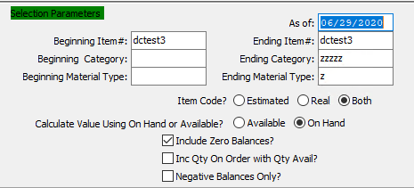

#### As Of

For Jobs Closed After - (As of) Enter the as of date.

#### Beginning Item # / Ending Item #

Enter the beginning and ending Item Number to run the report for.

#### Beginning Category / Ending Category

Enter the beginning and ending Category to run the report for.

#### Beginning Material Type / Ending Material Type

Enter the beginning and ending Material Type to run the report for.

#### Item Code? (Choice)

To choose the preferred item code type of Estimated vs. Real (Or Both), please make sure the desired option choice bubble is toggled.

#### Calculate Value Using On-Hand or Available? (Choice)

To choose the preferred calculating value option of Available vs. On-Hand, please make sure the desired option choice bubble is toggled.

#### Include Zero Balances? – Toggle Box

To include items with zero balances, make sure that the Include Zero Balances toggle box is checked.

#### Include Quantity On-Order with Quantity Available? – Toggle Box

To include quantities on order along with quantities that are available, make sure that this toggle box is checked.

#### Negative Balances Only? – Toggle Box

To only print inventory that have negative balances, make sure that the Negative Balances Only toggle box is checked.

### Available and Selected Columns

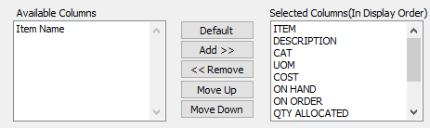

#### Available Columns

The user may choose which columns they wish to have on the report printout. As the user selects their choices, they will appear on the ‘*Selected Columns’* list.

#### Selected Columns (In Display Order)

The columns that the user has chosen from the ‘*Available Columns’* list. The order that these columns are displayed in here is the order in which they will print on the report.

#### Default

Click the ***“Default****”* button to sort the ‘*Selected Columns’* list by the default system parameters.

#### Add >>

Click on the selected item from the ‘*Available Columns’* list to highlight it, then click the ***“Add”*** button to add the selected column to the ‘*Selected Columns’* list.

#### << Remove

Click on the selected item from the ‘*Selected Columns’* list to highlight it, then click the ***“Remove”*** button to remove the selected column to the ‘*Selected Columns’* list.

#### Move Up

Within the ‘*Selected Columns’* list, the user may choose the order they wish the selected columns to print in. In order to change the order of the columns, the user can click on a selection to highlight it. By then clicking the ***“Move Up***” button, the user can change its position on the report.

#### Move Down

Within the ‘*Selected Columns’* list, the user may choose the order they wish the selected columns to print in. In order to change the order of the columns, the user can click on a selection to highlight it. By then clicking the ***“Move Down***” button, the user can change its position on the report.

### Output Destination

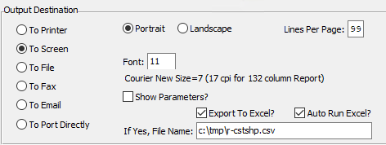

#### Destination Choice

To choose the destination where the document should be printed, please make sure that desired output destination choice bubble is toggled.

#### Layout Choice

To choose the preferred layout of Landscape vs. Portrait, please make sure the desired option choice bubbled is toggled.

#### Lines Per Page

Lines per page on the report when printing.

#### Font

Enter the font number to use with this report (Font 11 is default).

#### Show Parameters? – Toggle Box

To show parameters, make sure that the toggle box is ‘ticked’ with a checkmark.

#### Export to Excel? – Toggle Box

To export the printed file to an excel document, make sure that the Export to Excel toggle box is checked.

#### Auto Run Excel? – Toggle Box

To automatically open the new excel document, make sure that the Auto Run Excel toggle box is checked.

#### If Yes, File Name

If exporting the file to Excel, enter the desired file name.

## Transaction History [MR5]

The raw materials transaction history report shows actual transactions that have occurred. This is very useful for a month end value for all raw goods. This report may be run as of a specific date, whereby this is a great tool for any accountant or auditor. The report may be output to screen, printer, fax, email or directly to a text file or to an excel format.

The print selection allows limited the report by date, item code, product category, warehouse, job number and material type. Each transaction type is subtotaled by date showing total value for any date range.

### Selection Parameters

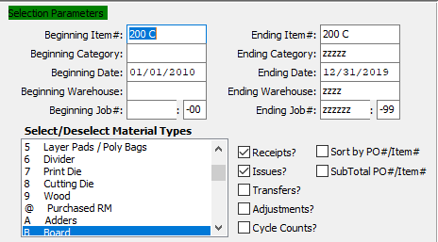

#### Beginning Item # / Ending Item #

Enter the beginning and ending Item Number to run the report for.

#### Beginning Category / Ending Category

Enter the beginning and ending Category to run the report for.

#### Beginning Date / Ending Date

Enter the beginning and ending Date to run the report for.

#### Beginning Warehouse / Ending Warehouse

Enter the beginning and ending Warehouse to run the report for.

#### Beginning Job # / Ending Job #

Enter the beginning and ending Job Number to run the report for.

#### Beginning Job #: 00 / Ending Job #: 00

Enter the beginning and ending Subsequent Job Number to run the report for.

#### Receipts? – Toggle Box

To include receipt transactions, make sure that the Receipts toggle box is checked.

#### Issues? – Toggle Box

To include issue transactions, make sure that the Issues toggle box is checked.

#### Transfers? – Toggle Box

To include transfer transactions, make sure that the Transfers toggle box is checked.

#### Adjustments? – Toggle Box

To include adjustment transactions, make sure that the Adjustments toggle box is checked.

#### Cycle Counts? – Toggle Box

To include cycle counts, make sure that the Cycle Counts toggle box is checked.

#### Sort by PO # / Item # – Toggle Box

To sort by purchase order, and then by item number, make sure that this toggle box is checked.

#### Subtotal PO # / Item # – Toggle Box

To subtotal each purchase order and item, make sure that this toggle box is checked.

### Select/Deselect Material Types

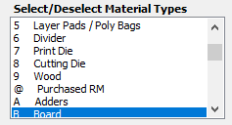

The user may choose multiple Material Types from this list by using the ***“Control – Click”*** method. A selected Material Type will by highlighted within the list, and only highlighted Material Types will be used by the system.

### Available and Selected Columns

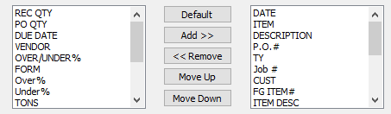

#### Available Columns

The user may choose which columns they wish to have on the report printout. As the user selects their choices, they will appear on the ‘*Selected Columns’* list.

#### Selected Columns (In Display Order)

The columns that the user has chosen from the ‘*Available Columns’* list. The order that these columns are displayed in here is the order in which they will print on the report.

#### Default

Click the ***“Default****”* button to sort the ‘*Selected Columns’* list by the default system parameters.

#### Add >>

Click on the selected item from the ‘*Available Columns’* list to highlight it, then click the ***“Add”*** button to add the selected column to the ‘*Selected Columns’* list.

#### << Remove

Click on the selected item from the ‘*Selected Columns’* list to highlight it, then click the ***“Remove”*** button to remove the selected column to the ‘*Selected Columns’* list.

#### Move Up

Within the ‘*Selected Columns’* list, the user may choose the order they wish the selected columns to print in. In order to change the order of the columns, the user can click on a selection to highlight it. By then clicking the ***“Move Up***” button, the user can change its position on the report.

#### Move Down

Within the ‘*Selected Columns’* list, the user may choose the order they wish the selected columns to print in. In order to change the order of the columns, the user can click on a selection to highlight it. By then clicking the ***“Move Down***” button, the user can change its position on the report.

### Output Destination

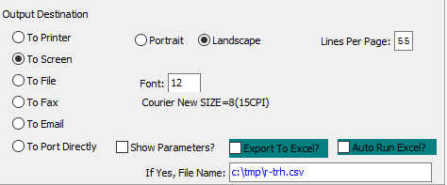

#### Destination Choice

To choose the destination where the document should be printed, please make sure that desired output destination choice bubble is toggled.

#### Layout Choice

To choose the preferred layout of Landscape vs. Portrait, please make sure the desired option choice bubbled is toggled.

#### Lines Per Page

Lines per page on the report when printing.

#### Font

Enter the font number to use with this report (Font 11 is default).

#### Show Parameters? – Toggle Box

To show parameters, make sure that the toggle box is ‘ticked’ with a checkmark.

#### Export to Excel? – Toggle Box

To export the printed file to an excel document, make sure that the Export to Excel toggle box is checked.

#### Auto Run Excel? – Toggle Box

To automatically open the new excel document, make sure that the Auto Run Excel toggle box is checked.

## Vendor Price List [MR6]

The raw materials vendor report essentially shows the cost matrix for each vendor for each item with the cost that will be used in purchasing as well as during estimating. The report may be output computer screen, printer, fax, email or directly text file or to an excel format.

The print selection allows limited the report by product category, material type and vendor. Material types include the following:

|  |  |  |  |  |  |  |  |
| --- | --- | --- | --- | --- | --- | --- | --- |
| B | Board | F | Film | I | Inks | P | Paper |
| C | Cases | G | Glue | M | Miscellaneous | W | Window |

The report also provides an option to include inventory that is stocked raw material or just material used for estimating. Finally, a summary and detail version is available.

### Selection Parameters

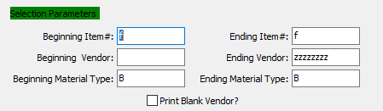

#### Beginning Item # / Ending Item #

Enter the beginning and ending Item Number to run the report for.

#### Beginning Vendor / Ending Vendor

Enter the beginning and ending Vendor to run the report for.

#### Beginning Material Type / Ending Material Type

Enter the beginning and ending Material Type to run the report for.

#### Print Blank Vendor? – Toggle Box

To print blank vendors, make sure that the Print Blank Vendor toggle box is checked.

### Available and Selected Columns

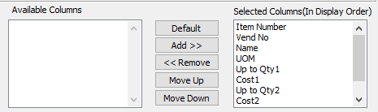

#### Available Columns

The user may choose which columns they wish to have on the report printout. As the user selects their choices, they will appear on the ‘*Selected Columns’* list.

#### Selected Columns (In Display Order)

The columns that the user has chosen from the ‘*Available Columns’* list. The order that these columns are displayed in here is the order in which they will print on the report.

#### Default

Click the ***“Default****”* button to sort the ‘*Selected Columns’* list by the default system parameters.

#### Add >>

Click on the selected item from the ‘*Available Columns’* list to highlight it, then click the ***“Add”*** button to add the selected column to the ‘*Selected Columns’* list.

#### << Remove

Click on the selected item from the ‘*Selected Columns’* list to highlight it, then click the ***“Remove”*** button to remove the selected column to the ‘*Selected Columns’* list.

#### Move Up

Within the ‘*Selected Columns’* list, the user may choose the order they wish the selected columns to print in. In order to change the order of the columns, the user can click on a selection to highlight it. By then clicking the ***“Move Up***” button, the user can change its position on the report.

#### Move Down

Within the ‘*Selected Columns’* list, the user may choose the order they wish the selected columns to print in. In order to change the order of the columns, the user can click on a selection to highlight it. By then clicking the ***“Move Down***” button, the user can change its position on the report.

### Output Destination

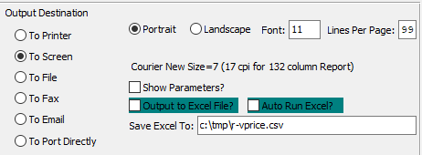

#### Destination Choice

To choose the destination where the document should be printed, please make sure that desired output destination choice bubble is toggled.

#### Layout Choice

To choose the preferred layout of Landscape vs. Portrait, please make sure the desired option choice bubbled is toggled.

#### Lines Per Page

Lines per page on the report when printing.

#### Font

Enter the font number to use with this report (Font 11 is default).

#### Show Parameters? – Toggle Box

To show parameters, make sure that the toggle box is ‘ticked’ with a checkmark.

#### Export to Excel? – Toggle Box

To export the printed file to an excel document, make sure that the Export to Excel toggle box is checked.

#### Auto Run Excel? – Toggle Box

To automatically open the new excel document, make sure that the Auto Run Excel toggle box is checked.

#### If Yes, File Name

If exporting the file to Excel, enter the desired file name.

## Material Receipts History [MR7]

The raw materials vendor report essentially shows the history of receipts by purchase order number. The report may be output computer screen, printer, fax, email or directly text file or to an excel format.

The print selection allows limited the report by date range, items code, material type, vendor and purchase order number. Material types include the following:

|  |  |  |  |  |  |  |  |
| --- | --- | --- | --- | --- | --- | --- | --- |
| B | Board | F | Film | I | Inks | P | Paper |
| C | Cases | G | Glue | M | Miscellaneous | W | Window |

### Selection Parameters

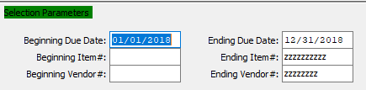

#### Beginning Due Date / Ending Due Date

Enter the beginning and ending Due Date to run the report for.

#### Beginning Item # / Ending Item #

Enter the beginning and ending Item Number to run the report for.

#### Beginning Vendor # / Ending Vendor #

Enter the beginning and ending Vendor Number to run the report for.

### Select/Deselect Material Types

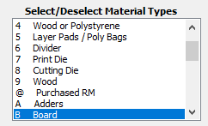

The user may choose multiple Material Types from this list by using the ***“Control – Click”*** method. A selected Material Type will by highlighted within the list, and only highlighted Material Types will be used by the system.

#### SELECT COLUMNS

Click the ***“Select Columns”*** button to bring up the popup window in which the user may select which columns they wish to print to the report, and in what order they will be arranged.

### Available and Selected Columns

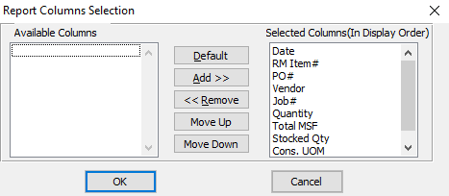

#### Available Columns

The user may choose which columns they wish to have on the report printout. As the user selects their choices, they will appear on the ‘*Selected Columns’* list.

#### Selected Columns (In Display Order)

The columns that the user has chosen from the ‘*Available Columns’* list. The order that these columns are displayed in here is the order in which they will print on the report.

#### Default

Click the ***“Default****”* button to sort the ‘*Selected Columns’* list by the default system parameters.

#### Add >>

Click on the selected item from the ‘*Available Columns’* list to highlight it, then click the ***“Add”*** button to add the selected column to the ‘*Selected Columns’* list.

#### << Remove

Click on the selected item from the ‘*Selected Columns’* list to highlight it, then click the ***“Remove”*** button to remove the selected column to the ‘*Selected Columns’* list.

#### Move Up

Within the ‘*Selected Columns’* list, the user may choose the order they wish the selected columns to print in. In order to change the order of the columns, the user can click on a selection to highlight it. By then clicking the ***“Move Up***” button, the user can change its position on the report.

#### Move Down

Within the ‘*Selected Columns’* list, the user may choose the order they wish the selected columns to print in. In order to change the order of the columns, the user can click on a selection to highlight it. By then clicking the ***“Move Down***” button, the user can change its position on the report.

### Output Destination

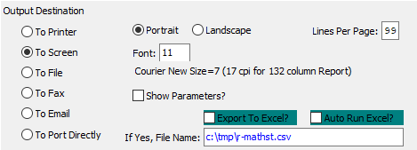

#### Destination Choice

To choose the destination where the document should be printed, please make sure that desired output destination choice bubble is toggled.

#### Layout Choice

To choose the preferred layout of Landscape vs. Portrait, please make sure the desired option choice bubbled is toggled.

#### Lines Per Page

Lines per page on the report when printing.

#### Font

Enter the font number to use with this report (Font 11 is default).

#### Show Parameters? – Toggle Box

To show parameters, make sure that the toggle box is ‘ticked’ with a checkmark.

#### Export to Excel? – Toggle Box

To export the printed file to an excel document, make sure that the Export to Excel toggle box is checked.

#### Auto Run Excel? – Toggle Box

To automatically open the new excel document, make sure that the Auto Run Excel toggle box is checked.

#### If Yes, File Name

If exporting the file to Excel, enter the desired file name.

## Inks by Machine [MR8]

The raw materials inks by machine report is useful for larger companies that must report the environmental protection agency to compare the waste captured closely matches the amount to inks consumed by job and by machine. The report may be output computer screen, printer, fax, email or directly text file or to an excel format.

The print selection allows limited the report by date range, machine range and job number range.

### Selection Parameters

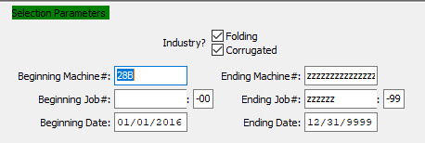

#### Industry? Folding – Toggle Box

To include folding box materials in the report, make sure that the Folding toggle box is checked.

#### Industry? Corrugated – Toggle Box

To include corrugated box materials in the report, make sure that the Corrugated toggle box is checked.

#### Beginning Machine # / Ending Machine #

Enter the beginning and ending Machine Number to run the report for.

#### Beginning Job # / Ending Job #

Enter the beginning and ending Job Number to run the report for.

#### Beginning Job #: 00 / Ending Job #: 00

Enter the beginning and ending Subsequent Job Number to run the report for.

#### Beginning Date / Ending Date

Enter the beginning and ending Date to run the report for.

### Available and Selected Columns

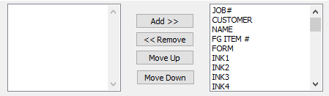

#### Available Columns

The user may choose which columns they wish to have on the report printout. As the user selects their choices, they will appear on the ‘*Selected Columns’* list.

#### Selected Columns (In Display Order)

The columns that the user has chosen from the ‘*Available Columns’* list. The order that these columns are displayed in here is the order in which they will print on the report.

#### Default

Click the ***“Default****”* button to sort the ‘*Selected Columns’* list by the default system parameters.

#### Add >>

Click on the selected item from the ‘*Available Columns’* list to highlight it, then click the ***“Add”*** button to add the selected column to the ‘*Selected Columns’* list.

#### << Remove

Click on the selected item from the ‘*Selected Columns’* list to highlight it, then click the ***“Remove”*** button to remove the selected column to the ‘*Selected Columns’* list.

#### Move Up

Within the ‘*Selected Columns’* list, the user may choose the order they wish the selected columns to print in. In order to change the order of the columns, the user can click on a selection to highlight it. By then clicking the ***“Move Up***” button, the user can change its position on the report.

#### Move Down

Within the ‘*Selected Columns’* list, the user may choose the order they wish the selected columns to print in. In order to change the order of the columns, the user can click on a selection to highlight it. By then clicking the ***“Move Down***” button, the user can change its position on the report.

### Output Destination

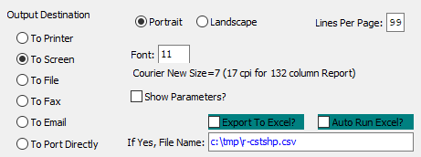

#### Destination Choice

To choose the destination where the document should be printed, please make sure that desired output destination choice bubble is toggled.

#### Layout Choice

To choose the preferred layout of Landscape vs. Portrait, please make sure the desired option choice bubbled is toggled.

#### Show Parameters? – Toggle Box

To show parameters, make sure that the toggle box is ‘ticked’ with a checkmark.

#### Export to Excel? – Toggle Box

To export the printed file to an excel document, make sure that the Export to Excel toggle box is checked.

#### Auto Run Excel? – Toggle Box

To automatically open the new excel document, make sure that the Auto Run Excel toggle box is checked.

#### If Yes, File Name

If exporting the file to Excel, enter the desired file name.

## Roll Stock Lot/Tag Report [MR9]

The raw materials roll stock report shows rolls of paper by tag number by warehouse and bin location. The report may be output computer screen, printer, fax, email or directly text file or to an excel format.

The print selection allows limited the report by item code, product category and warehouse for paper or board material.

### Selection Parameters

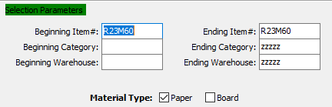

#### Beginning Item # / Ending Item #

Enter the beginning and ending Item Number to run the report for.

#### Beginning Category / Ending Category

Enter the beginning and ending Category to run the report for.

#### Beginning Warehouse / Ending Warehouse

Enter the beginning and ending Warehouse to run the report for.

#### Material Type: Paper – Toggle Box

To include paper roll stock in the report, make sure that the Paper toggle box is checked.

#### Material Type: Board – Toggle Box

To include board roll stock in the report, make sure that the Board toggle box is checked.

### Available and Selected Columns

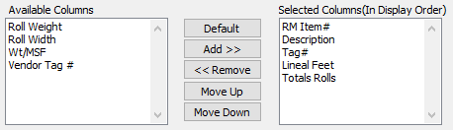

#### Available Columns

The user may choose which columns they wish to have on the report printout. As the user selects their choices, they will appear on the ‘*Selected Columns’* list.

#### Selected Columns (In Display Order)

The columns that the user has chosen from the ‘*Available Columns’* list. The order that these columns are displayed in here is the order in which they will print on the report.

#### Default

Click the ***“Default****”* button to sort the ‘*Selected Columns’* list by the default system parameters.

#### Add >>

Click on the selected item from the ‘*Available Columns’* list to highlight it, then click the ***“Add”*** button to add the selected column to the ‘*Selected Columns’* list.

#### << Remove

Click on the selected item from the ‘*Selected Columns’* list to highlight it, then click the ***“Remove”*** button to remove the selected column to the ‘*Selected Columns’* list.

#### Move Up

Within the ‘*Selected Columns’* list, the user may choose the order they wish the selected columns to print in. In order to change the order of the columns, the user can click on a selection to highlight it. By then clicking the ***“Move Up***” button, the user can change its position on the report.

#### Move Down

Within the ‘*Selected Columns’* list, the user may choose the order they wish the selected columns to print in. In order to change the order of the columns, the user can click on a selection to highlight it. By then clicking the ***“Move Down***” button, the user can change its position on the report.

### Output Destination

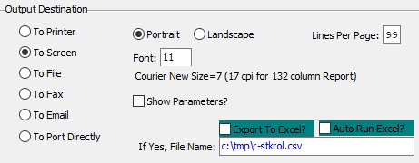

#### Destination Choice

To choose the destination where the document should be printed, please make sure that desired output destination choice bubble is toggled.

#### Layout Choice

To choose the preferred layout of Landscape vs. Portrait, please make sure the desired option choice bubbled is toggled.

#### Lines Per Page

Lines per page on the report when printing.

#### Font

Enter the font number to use with this report (Font 11 is default).

#### Show Parameters? – Toggle Box

To show parameters, make sure that the toggle box is ‘ticked’ with a checkmark.

#### Export to Excel? – Toggle Box

To export the printed file to an excel document, make sure that the Export to Excel toggle box is checked.

#### Auto Run Excel? – Toggle Box

To automatically open the new excel document, make sure that the Auto Run Excel toggle box is checked.

## Roll Stock Consumed Report [MR)]

The raw materials roll stock report shows rolls of paper consumed for any date range. The report may be output computer screen, printer, fax, email or directly text file or to an excel format.

The print selection allows limited the report by item code, product category, date range and warehouse in summary or detail.

### Selection Parameters

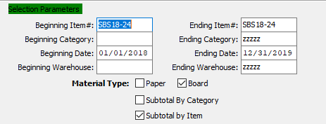

#### Beginning Item # / Ending Item #

Enter the beginning and ending Item Number to run the report for.

#### Beginning Category / Ending Category

Enter the beginning and ending Category to run the report for.

#### Beginning Date / Ending Date

Enter the beginning and ending Date to run the report for.

#### Beginning Warehouse / Ending Warehouse

Enter the beginning and ending Warehouse to run the report for.

#### Material Type: Paper – Toggle Box

To include paper roll stock in the report, make sure that the Paper toggle box is checked.

#### Material Type: Board – Toggle Box

To include board roll stock in the report, make sure that the Board toggle box is checked.

#### Material Type: Subtotal by Category – Toggle Box

To subtotal all inventory by their category, make sure that the Subtotal by Category toggle box is checked.

#### Material Type: Subtotal by Item – Toggle Box

To subtotal all inventory by their item, make sure that the Subtotal by Item toggle box is checked.

### Available and Selected Columns

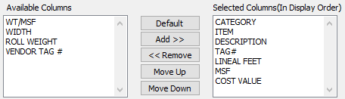

#### Available Columns

The user may choose which columns they wish to have on the report printout. As the user selects their choices, they will appear on the ‘*Selected Columns’* list.

#### Selected Columns (In Display Order)

The columns that the user has chosen from the ‘*Available Columns’* list. The order that these columns are displayed in here is the order in which they will print on the report.

#### Default

Click the ***“Default****”* button to sort the ‘*Selected Columns’* list by the default system parameters.

#### Add >>

Click on the selected item from the ‘*Available Columns’* list to highlight it, then click the ***“Add”*** button to add the selected column to the ‘*Selected Columns’* list.

#### << Remove

Click on the selected item from the ‘*Selected Columns’* list to highlight it, then click the ***“Remove”*** button to remove the selected column to the ‘*Selected Columns’* list.

#### Move Up

Within the ‘*Selected Columns’* list, the user may choose the order they wish the selected columns to print in. In order to change the order of the columns, the user can click on a selection to highlight it. By then clicking the ***“Move Up***” button, the user can change its position on the report.

#### Move Down

Within the ‘*Selected Columns’* list, the user may choose the order they wish the selected columns to print in. In order to change the order of the columns, the user can click on a selection to highlight it. By then clicking the ***“Move Down***” button, the user can change its position on the report.

### Output Destination

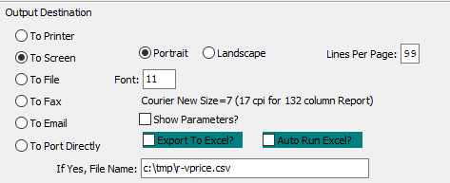

#### Destination Choice

To choose the destination where the document should be printed, please make sure that desired output destination choice bubble is toggled.

#### Layout Choice

To choose the preferred layout of Landscape vs. Portrait, please make sure the desired option choice bubbled is toggled.

#### Lines Per Page

Lines per page on the report when printing.

#### Font

Enter the font number to use with this report (Font 11 is default).

#### Show Parameters? – Toggle Box

To show parameters, make sure that the toggle box is ‘ticked’ with a checkmark.

#### Export to Excel? – Toggle Box

To export the printed file to an excel document, make sure that the Export to Excel toggle box is checked.

#### Auto Run Excel? – Toggle Box

To automatically open the new excel document, make sure that the Auto Run Excel toggle box is checked.

#### If Yes, File Name

If exporting the file to Excel, enter the desired file name.

## Transaction by TON/MSF [MR!]

The raw materials roll stock report shows rolls of paper consumed for any date range. The report may be output computer screen, printer, fax, email or directly text file or to an excel format.

The print selection allows limited the report by item code, product category, date range and warehouse in summary or detail.

### Selection Parameters

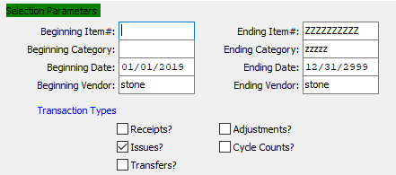

#### Beginning Item # / Ending Item #

Enter the beginning and ending Item Number to run the report for.

#### Beginning Category / Ending Category

Enter the beginning and ending Category to run the report for.

#### Beginning Date / Ending Date

Enter the beginning and ending Date to run the report for.

#### Beginning Vendor / Ending Vendor

Enter the beginning and ending Vendor to run the report for.

#### Transaction Type: Receipts? – Toggle Box

To include Receipt transactions in the report, make sure that the Receipts toggle box is checked.

#### Transaction Type: Issues? – Toggle Box

To include Issue transactions in the report, make sure that the Issues toggle box is checked.

#### Transaction Type: Transfers? – Toggle Box

To include Transfer transactions in the report, make sure that the Transfers toggle box is checked.

#### Transaction Type: Adjustments? – Toggle Box

To include Adjustment transactions in the report, make sure that the Adjustments toggle box is checked.

#### Transaction Type: Cycle Counts? – Toggle Box

To include Cycle Count transactions in the report, make sure that the Cycle Counts toggle box is checked.

### Available and Selected Columns

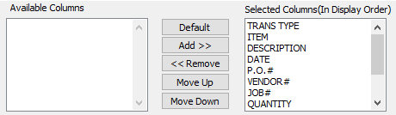

#### Available Columns

The user may choose which columns they wish to have on the report printout. As the user selects their choices, they will appear on the ‘*Selected Columns’* list.

#### Selected Columns (In Display Order)

The columns that the user has chosen from the ‘*Available Columns’* list. The order that these columns are displayed in here is the order in which they will print on the report.

#### Default

Click the ***“Default****”* button to sort the ‘*Selected Columns’* list by the default system parameters.

#### Add >>

Click on the selected item from the ‘*Available Columns’* list to highlight it, then click the ***“Add”*** button to add the selected column to the ‘*Selected Columns’* list.

#### << Remove

Click on the selected item from the ‘*Selected Columns’* list to highlight it, then click the ***“Remove”*** button to remove the selected column to the ‘*Selected Columns’* list.

#### Move Up

Within the ‘*Selected Columns’* list, the user may choose the order they wish the selected columns to print in. In order to change the order of the columns, the user can click on a selection to highlight it. By then clicking the ***“Move Up***” button, the user can change its position on the report.

#### Move Down

Within the ‘*Selected Columns’* list, the user may choose the order they wish the selected columns to print in. In order to change the order of the columns, the user can click on a selection to highlight it. By then clicking the ***“Move Down***” button, the user can change its position on the report.

### Output Destination

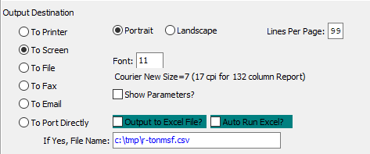

#### Destination Choice

To choose the destination where the document should be printed, please make sure that desired output destination choice bubble is toggled.

#### Layout Choice

To choose the preferred layout of Landscape vs. Portrait, please make sure the desired option choice bubbled is toggled.

#### Lines Per Page

Lines per page on the report when printing.

#### Font

Enter the font number to use with this report (Font 11 is default).

#### Show Parameters? – Toggle Box

To show parameters, make sure that the toggle box is ‘ticked’ with a checkmark.

#### Export to Excel? – Toggle Box

To export the printed file to an excel document, make sure that the Export to Excel toggle box is checked.

#### Auto Run Excel? – Toggle Box

To automatically open the new excel document, make sure that the Auto Run Excel toggle box is checked.

#### If Yes, File Name

If exporting the file to Excel, enter the desired file name.

## Ink/Glue Consumption [MR@]

The raw materials transaction history for ink or glue material can be useful for larger companies that must report the environmental protection agency to compare the waste captured closely matches the amount to inks and glue consumed by job and by machine.

The report may be output computer screen, printer, fax, email or directly text file or to an excel format. The print selection allows limiting the report by item code, product category, date range and job number range.

### Selection Parameters

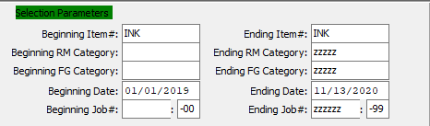

#### Beginning Item # / Ending Item #

Enter the beginning and ending Item Number to run the report for.

#### Beginning RM Category / Ending RM Category

Enter the beginning and ending Raw Material Category to run the report for.

#### Beginning FG Category / Ending FG Category

Enter the beginning and ending Finished Good Category to run the report for.

#### Beginning Date / Ending Date

Enter the beginning and ending Date to run the report for.

#### Beginning Job # / Ending Job #

Enter the beginning and ending Job Number to run the report for.

#### Beginning Job #: 00 / Ending Job #: 00

Enter the beginning and ending Subsequent Job Number to run the report for.

### Select/Deselect Material Types

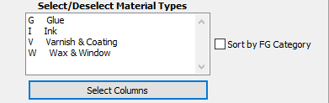

#### Material Types

The user may choose multiple Material Types from this list by using the ***“Control – Click”*** method. A selected Material Type will by highlighted within the list, and only highlighted Material Types will be used by the system.

#### Sort by FG Category – Toggle Box

To sort the report by Finished Good categories, make sure that the Sort by FG Category toggle box is checked.

#### SELECT COLUMNS

Click the ***“Select Columns”*** button to bring up the popup window in which the user may select which columns they wish to print to the report, and in what order they will be arranged.

### Available and Selected Columns

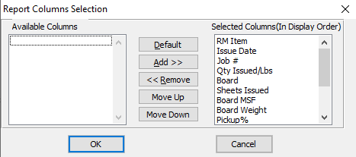

#### Available Columns

The user may choose which columns they wish to have on the report printout. As the user selects their choices, they will appear on the ‘*Selected Columns’* list.

#### Selected Columns (In Display Order)

The columns that the user has chosen from the ‘*Available Columns’* list. The order that these columns are displayed in here is the order in which they will print on the report.

#### Default

Click the ***“Default****”* button to sort the ‘*Selected Columns’* list by the default system parameters.

#### Add >>

Click on the selected item from the ‘*Available Columns’* list to highlight it, then click the ***“Add”*** button to add the selected column to the ‘*Selected Columns’* list.

#### << Remove

Click on the selected item from the ‘*Selected Columns’* list to highlight it, then click the ***“Remove”*** button to remove the selected column to the ‘*Selected Columns’* list.

#### Move Up

Within the ‘*Selected Columns’* list, the user may choose the order they wish the selected columns to print in. In order to change the order of the columns, the user can click on a selection to highlight it. By then clicking the ***“Move Up***” button, the user can change its position on the report.

#### Move Down

Within the ‘*Selected Columns’* list, the user may choose the order they wish the selected columns to print in. In order to change the order of the columns, the user can click on a selection to highlight it. By then clicking the ***“Move Down***” button, the user can change its position on the report.

### Output Destination

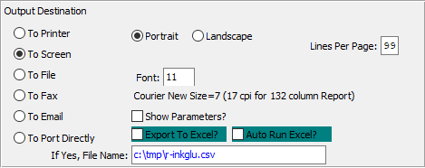

#### Destination Choice

To choose the destination where the document should be printed, please make sure that desired output destination choice bubble is toggled.

#### Layout Choice

To choose the preferred layout of Landscape vs. Portrait, please make sure the desired option choice bubbled is toggled.

#### Lines Per Page

Lines per page on the report when printing.

#### Font

Enter the font number to use with this report (Font 11 is default).

#### Show Parameters? – Toggle Box

To show parameters, make sure that the toggle box is ‘ticked’ with a checkmark.

#### Export to Excel? – Toggle Box

To export the printed file to an excel document, make sure that the Export to Excel toggle box is checked.

#### Auto Run Excel? – Toggle Box

To automatically open the new excel document, make sure that the Auto Run Excel toggle box is checked.

## Roll Stock Cost [MR#]

The raw materials roll stock report shows how many rolls of paper are on hand as well as on hand and the value of the on-hand inventory by LF and MSF. The report may be output computer screen, printer, fax, email or directly text file or to an excel format.

The print selection allows limited the report by product category for paper or board material.

### Selection Parameters

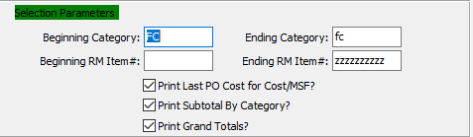

#### Beginning Category / Ending Category

Enter the beginning and ending Category to run the report for.

#### Beginning RM Item # / Ending RM Item #

Enter the beginning and ending Raw Material Item Number to run the report for.

#### Print Last PO Cost for Cost/MSF? – Toggle Box

To print the last purchase order cost for the current report Cost/MSF, make sure that this toggle box is checked.

#### Print Subtotal by Category? – Toggle Box

To print subtotals by category on the report, make sure that the Print Subtotal by Category toggle box is checked.

#### Print Grand Totals? – Toggle Box

To print grand totals on the report, make sure that the Print Grand Totals toggle box is checked.

### Available and Selected Columns

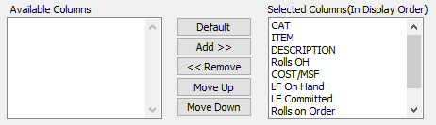

#### Available Columns

The user may choose which columns they wish to have on the report printout. As the user selects their choices, they will appear on the ‘*Selected Columns’* list.

#### Selected Columns (In Display Order)

The columns that the user has chosen from the ‘*Available Columns’* list. The order that these columns are displayed in here is the order in which they will print on the report.

#### Default

Click the ***“Default****”* button to sort the ‘*Selected Columns’* list by the default system parameters.

#### Add >>

Click on the selected item from the ‘*Available Columns’* list to highlight it, then click the ***“Add”*** button to add the selected column to the ‘*Selected Columns’* list.

#### << Remove

Click on the selected item from the ‘*Selected Columns’* list to highlight it, then click the ***“Remove”*** button to remove the selected column to the ‘*Selected Columns’* list.

#### Move Up

Within the ‘*Selected Columns’* list, the user may choose the order they wish the selected columns to print in. In order to change the order of the columns, the user can click on a selection to highlight it. By then clicking the ***“Move Up***” button, the user can change its position on the report.

#### Move Down

Within the ‘*Selected Columns’* list, the user may choose the order they wish the selected columns to print in. In order to change the order of the columns, the user can click on a selection to highlight it. By then clicking the ***“Move Down***” button, the user can change its position on the report.

### Output Destination

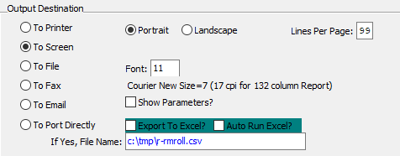

#### Destination Choice

To choose the destination where the document should be printed, please make sure that desired output destination choice bubble is toggled.

#### Layout Choice

To choose the preferred layout of Landscape vs. Portrait, please make sure the desired option choice bubbled is toggled.

#### Show Parameters? – Toggle Box

To show parameters, make sure that the toggle box is ‘ticked’ with a checkmark.

#### Export to Excel? – Toggle Box

To export the printed file to an excel document, make sure that the Export to Excel toggle box is checked.

#### Auto Run Excel? – Toggle Box

To automatically open the new excel document, make sure that the Auto Run Excel toggle box is checked.

## Job Material/Machine Report [MR$]

### Selection Parameters

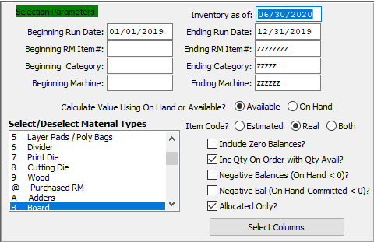

#### Inventory As Of

For Jobs Closed After - (As of) Enter the as of date.

#### Beginning Run Date / Ending Run Date

Enter the beginning and ending Run Date to run the report for.

#### Beginning RM Item # / Ending RM Item #

Enter the beginning and ending Item Number to run the report for.

#### Beginning Category / Ending Category

Enter the beginning and ending Category to run the report for.

#### Beginning Machine / Ending Machine

Enter the beginning and ending Machine to run the report for.

#### Calculate Value Using On-Hand or Available? (Choice)

To choose the preferred calculating method of Available vs. On-Hand, please make sure the desired option choice bubble is toggled.

#### Item Code? (Choice)

To choose the preferred item code option of Estimated vs. Real (Or Both), please make sure the desired option choice bubble is toggled.

#### Include Zero Balances? – Toggle Box

To include inventory that has zero balances, make sure that the Include Zero Balances toggle box is checked.

#### Include Quantity On Order with Quantity Available? – Toggle Box

To include the quantity that is on-order along with the quantity that is on-hand, make sure that this toggle box is checked.

#### Negative Balance (On Hand < 0)? – Toggle Box

To include items that have a negative balance (where the quantity on-hand is less than zero), make sure that this toggle box is checked.

#### Negative Balance (On-Hand Committed < 0)? – Toggle Box

To include items that have a negative balance (where the quantity on-hand that is already committed to an order is less than zero), make sure that this toggle box is checked.

#### Allocated Quantity? – Toggle Box

To show the allocated quantity of an item on the report, make sure that the Allocated Quantity toggle box is checked.

#### SELECT COLUMNS

Click the ***“Select Columns”*** button to bring up the popup window in which the user may select which columns they wish to print to the report, and in what order they will be arranged.

### Select/Deselect Material Types

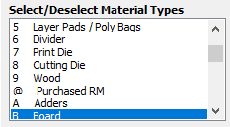

The user may choose multiple Material Types from this list by using the ***“Control – Click”*** method. A selected Material Type will by highlighted within the list, and only highlighted Material Types will be used by the system.

### Available and Selected Columns

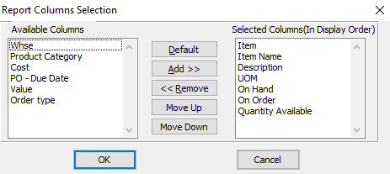

#### Available Columns

The user may choose which columns they wish to have on the report printout. As the user selects their choices, they will appear on the ‘*Selected Columns’* list.

#### Selected Columns (In Display Order)

The columns that the user has chosen from the ‘*Available Columns’* list. The order that these columns are displayed in here is the order in which they will print on the report.

#### Default

Click the ***“Default****”* button to sort the ‘*Selected Columns’* list by the default system parameters.

#### Add >>

Click on the selected item from the ‘*Available Columns’* list to highlight it, then click the ***“Add”*** button to add the selected column to the ‘*Selected Columns’* list.

#### << Remove

Click on the selected item from the ‘*Selected Columns’* list to highlight it, then click the ***“Remove”*** button to remove the selected column to the ‘*Selected Columns’* list.

#### Move Up

Within the ‘*Selected Columns’* list, the user may choose the order they wish the selected columns to print in. In order to change the order of the columns, the user can click on a selection to highlight it. By then clicking the ***“Move Up***” button, the user can change its position on the report.

#### Move Down

Within the ‘*Selected Columns’* list, the user may choose the order they wish the selected columns to print in. In order to change the order of the columns, the user can click on a selection to highlight it. By then clicking the ***“Move Down***” button, the user can change its position on the report.

### Output Destination

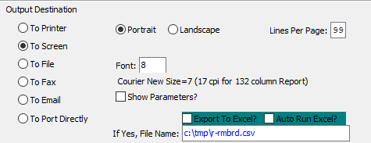

#### Destination Choice

To choose the destination where the document should be printed, please make sure that desired output destination choice bubble is toggled.

#### Layout Choice

To choose the preferred layout of Landscape vs. Portrait, please make sure the desired option choice bubbled is toggled.

#### Lines Per Page

Lines per page on the report when printing.

#### Font

Enter the font number to use with this report (Font 11 is default).

#### Show Parameters? – Toggle Box

To show parameters, make sure that the toggle box is ‘ticked’ with a checkmark.

#### Export to Excel? – Toggle Box

To export the printed file to an excel document, make sure that the Export to Excel toggle box is checked.

#### Auto Run Excel? – Toggle Box

To automatically open the new excel document, make sure that the Auto Run Excel toggle box is checked.

#### If Yes, File Name

If exporting the file to Excel, enter the desired file name.

## Customer Material Usage [MR%]

### Selection Parameters

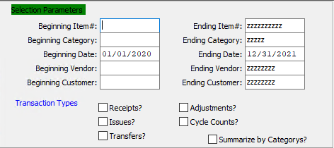

#### Beginning Item # / Ending Item #

Enter the beginning and ending Item Number to run the report for.

#### Beginning Category / Ending Category

Enter the beginning and ending Category to run the report for.

#### Beginning Date / Ending Date

Enter the beginning and ending Date to run the report for.

#### Beginning Vendor / Ending Vendor

Enter the beginning and ending Vendor to run the report for.

#### Beginning Customer / Ending Customer

Enter the beginning and ending Customer to run the report for.

#### Transaction Type: Receipts? – Toggle Box

To include receipt transactions in the report, make sure that the Receipts toggle box is checked.

#### Transaction Type: Issues? – Toggle Box

To include issue transactions in the report, make sure that the Issues toggle box is checked.

#### Transaction Type: Transfers? – Toggle Box

To include transfer transactions in the report, make sure that the Transfers toggle box is checked.

#### Transaction Type: Adjustments? – Toggle Box

To include adjustment transactions in the report, make sure that the Adjustments toggle box is checked.

#### Transaction Type: Cycle Counts? – Toggle Box

To include cycle count transactions in the report, make sure that the Cycle Counts toggle box is checked.

#### Summarize by Categories? – Toggle Box

To summarize items by their categories, make sure that the Summarize by Categories toggle box is checked.

### Available and Selected Columns

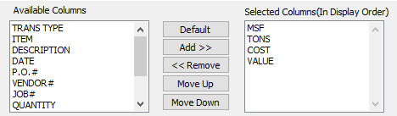

#### Available Columns

The user may choose which columns they wish to have on the report printout. As the user selects their choices, they will appear on the ‘*Selected Columns’* list.

#### Selected Columns (In Display Order)

The columns that the user has chosen from the ‘*Available Columns’* list. The order that these columns are displayed in here is the order in which they will print on the report.

#### Default

Click the ***“Default****”* button to sort the ‘*Selected Columns’* list by the default system parameters.

#### Add >>

Click on the selected item from the ‘*Available Columns’* list to highlight it, then click the ***“Add”*** button to add the selected column to the ‘*Selected Columns’* list.

#### << Remove

Click on the selected item from the ‘*Selected Columns’* list to highlight it, then click the ***“Remove”*** button to remove the selected column to the ‘*Selected Columns’* list.

#### Move Up

Within the ‘*Selected Columns’* list, the user may choose the order they wish the selected columns to print in. In order to change the order of the columns, the user can click on a selection to highlight it. By then clicking the ***“Move Up***” button, the user can change its position on the report.

#### Move Down

Within the ‘*Selected Columns’* list, the user may choose the order they wish the selected columns to print in. In order to change the order of the columns, the user can click on a selection to highlight it. By then clicking the ***“Move Down***” button, the user can change its position on the report.

### Output Destination

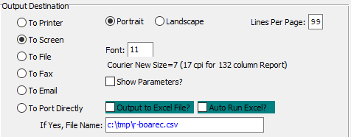

#### Destination Choice

To choose the destination where the document should be printed, please make sure that desired output destination choice bubble is toggled.

#### Layout Choice

To choose the preferred layout of Landscape vs. Portrait, please make sure the desired option choice bubbled is toggled.

#### Lines Per Page

Lines per page on the report when printing.

#### Font

Enter the font number to use with this report (Font 11 is default).

#### Show Parameters? – Toggle Box

To show parameters, make sure that the toggle box is ‘ticked’ with a checkmark.

#### Export to Excel? – Toggle Box

To export the printed file to an excel document, make sure that the Export to Excel toggle box is checked.

#### Auto Run Excel? – Toggle Box

To automatically open the new excel document, make sure that the Auto Run Excel toggle box is checked.

#### If Yes, File Name

If exporting the file to Excel, enter the desired file name.

# **File Maintenance for Raw Goods [MF]**

## Overview

For the Raw Materials File, all estimated and actual materials used in cost estimating must be added to the raw material file. Two screens must be defined for each material, however the data required on the second screen varies depending on whether the item code is ***"E"*** for estimated or ***"R"*** for raw material that is stocked. To Add a material, simply press ***"A"*** for Add and define each field as required. Depending on the material type, different fields are mandatory so that yield factors may be defined for calculating the material requirements in cost estimating and job cost / production control.

To find a material, press ***"P***" for previous item, ***"N"*** for next item or ***"F"*** for find. Once ***"F"*** (Find) is pressed, various fields are highlighted for searching the file. Press the tab key to move to a field, press ***“F1”*** to look up alphabetically, then use the arrow key to select an item to modify. To change or delete and item, first ***"F"*** (Find) an item, then press either ***"C"*** for change or ***"D"*** for delete to modify or delete the item.

Please Note: To add or change information on screen two, press the ***"2"*** key for second screen, then press the ***"C"*** for change. The “BOM” Bill of Material option allows corrugated plants to define the paper medium, liner and medium shrinkage percentages required when producing various board flute grades. @@

%% sys/ref/invtot^^

The consumption totals for Period to Date, Year to Date and Last Year are automatically updated when posting warehouse transactions. The cost and quantity used in the production process are shown in the totals screen.

The Product category file may be defined for each Raw Materials category of items. Many Raw Materials Purchasing Job Costing reports are available by product category.

Material Cost Type/Location Accounts are groupings or classes of material place together for costing purposes. Normally, each product category will have a unique material cost type general ledger accounts, however a category may be divided into unique cost types.

For example, Board may be a product category for inventory reporting, however for costing purposes different board grades such as SBS, CCN, KRAFT, etc. may be divided into unique cost types.

Please Note: The cost type must by entered on the item file. This application allows you to maintain a file of material cost type/locations General ledger accounts for interface to job costing. You can interactively maintain the material cost type / location accounts through add, change and delete modes by pressing the capital Letter in the menu at the bottom of the screen. In this file, the warehouse location must be entered and must be a valid warehouse in the plant / warehouse file. This allows the inventory accounts for a particular material cost type to be tracked by account.

When receiving goods into inventory, the system looks up the matching material cost type/location account record to properly Debit the Raw Material Asset account. When issuing materials to a job, the system looks up the matching material cost type/location account record to properly Credit the Raw Material Asset as well as the Expense and the Purchase Price Variance Accounts.

If you wish to track only one raw material asset GL number, simply create one Material Cost Type and use in all items. If you wish to track by material cost type without regards to location, simply leave the location field blank. If you wish to track inventory assets by location, you must create a material cost type for each location for each material type.

## Folding Carton Materials [MF1]

### Overview

All estimated and actual materials used in cost estimating must be added to the raw material file. Two screens must be defined for each material, however the data required on the second screen varies depending on whether the item code is ***"E"*** for estimated or ***"R"*** for raw material that is stocked.

To Add a material, simply press ***"A"*** for Add and define each field as required. Depending on the material type, different fields are mandatory so that yield factors may be defined for calculating the material requirements in cost estimating and job cost / production control.

To find a material, press ***"P"*** for previous item, ***"N"*** for next item or ***"F"*** for find. Once ***"F"*** (Find) is pressed, various fields are highlighted for searching the file. Press the ***“Tab”*** key to move to a field, press ***“F1”*** to look up alphabetically, then use the arrow key to select an item to modify.

To change or delete and item, first ***"F"*** (Find) an item, then press either ***"C"*** for change or ***"D"*** for delete to modify or delete the item.

Please Note: To add or change information on screen two, press the ***"2"*** key for second screen, then press the ***"C"*** for change.

The “BO<” Bill of Material option allows corrugated plants to define the paper medium, liner and medium shrinkage percentages required when producing various board flute grades.

@@

sys/ref/invtot^^

The consumption totals for Period to Date, Year to Date and Last Year are automatically updated when posting warehouse transactions. The cost and quantity used in the production process are shown in the totals screen.

### Browse Items

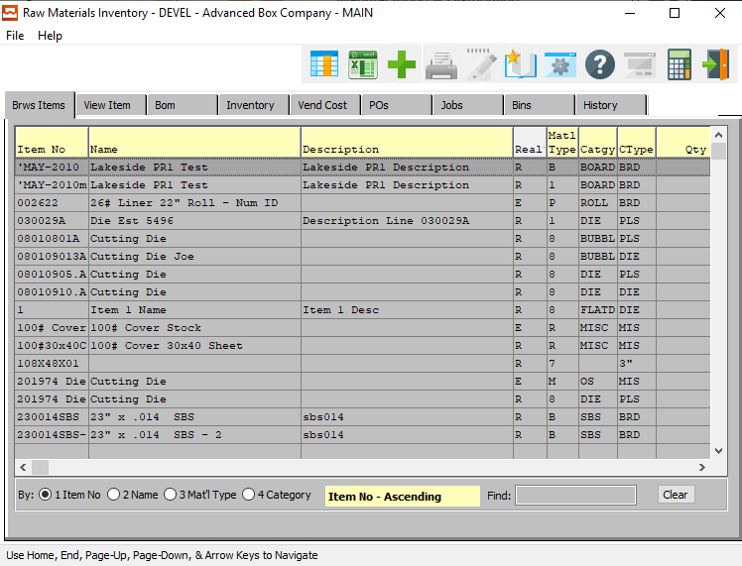

#### ADD

Click the ***“Green + Icon”*** to add a new Raw Material Item.

### View Item

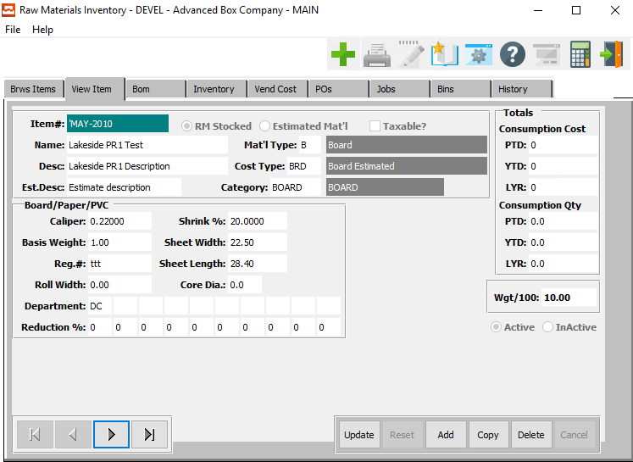

#### UPDATE

To change the currently selected Raw Material Item, simply click the ***“Update***” button at the bottom of the screen.

#### ADD

To add a new Raw Material Item, simply click the ***“Green + Icon”*** button at the top of the Raw Material Inventory screen.

Alternatively, click the ***“Add”*** button at the bottom of the screen.

#### DELETE

To delete the currently selected Raw Material Item, simply press the ***"D"*** key. Alternatively, click the ***“Delete”*** button at the bottom of the screen.

#### NEXT

Press ***"N"*** (Next) to find next Raw Material Item to view or modify. Alternatively, press the ***“Right Arrow”*** on the screen.

#### PREVIOUS

Press ***"P"*** (Previous) to find previous Raw Material Item to view or modify. Alternatively, press the ***“Left Arrow”*** on the screen.

### Add/Update Item

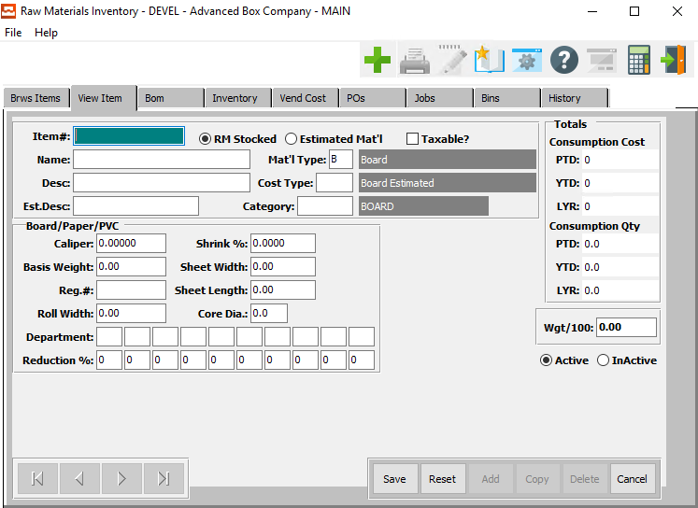

#### SAVE

Click the ***“Save”*** button to save all changes to the current Raw Material Item.

#### RESET

Click the ***“Reset”*** button to reset all fields to their original state.

#### CANCEL

Click the ***“Cancel”*** button to cancel all changes to the Raw Material Item without saving.

### Add/Update Item Field Definitions

#### Item #

Enter a code for this raw material, but be consistent. i.e. C200, C250, C275, etc. so that the items are in order when printed or listed on an inquiry. The code is the primary key for utilizing an alpha numeric search throughout the system. Estimated material as well as actual stocked raw material should be defined with consistent item number codes.

As an example, C200 could be used for an estimated cost of C Flute board so that the system generates an actual sheet size that would be used to calculate the cost based on the total MSF or Tons required. Prior to purchasing the material, we would need to add and item such as C20028x40 which would be a 28 x 40-inch sheet which would a real stocked item number.

#### Material (Choice)

To choose the preferred material type of Stocked Raw Material vs. Estimated Material, please make sure the desired option choice bubble is toggled.

#### Taxable? – Toggle Box

To mark this item as taxable, make sure that the Taxable toggle box is checked.

#### Name

This line transfers to the job ticket, purchase order and desired reports. This line is used for alpha-numeric searches throughout the system.

#### Description

Enter a description of the Raw Materials item for this file.

#### Estimate Description

This is the description used on the cost estimating screen. This field is necessary to minimize characters on the estimate screens and for reporting purposes.

#### Material Type

The material types are maintained by Advanced Software. Only the code is entered in the raw material file. Our system has a formula for each material type so that the total material required for each estimate and production quantity per job is computed by the unit of measure.

Valid Material Types are as Follows:

|  |  |  |  |
| --- | --- | --- | --- |
| B | Board | M | Miscellaneous |
| C | Packing Code | R | Die Rule |
| D | Pallet | S | Stitch |
| G | Glue | T | Tape |
| I | Ink | V | Varnish |
| L | Laminate |  |  |

#### Cost Type

Enter the material cost type for this raw material. General ledger account numbers for the raw material asset account, consumption expense account and purchase price variance account are assigned by material cost types which interface with job costing and the general ledger.

Debit and credits are automatically recorded via receipts for purchases, actual production postings and adjustments. The work-in-process inventory general ledger account numbers are set up in the job cost product line file so that offsetting debits are posted when raw materials are issued to the job.

#### Category

Enter a valid product category from the product category file. Each category is listed by item and the categories are also defined by product line. This file contains categories defined by each company. The description is defined in the file so that only the code is entered in the raw material file. Many inventory, sales and job costing reports are available by product category.

#### Caliper

Caliper dimension for board or paper. Paper will use up to five decimals, whereas the board material will utilize just two decimals. The board caliper is utilized in the machine standards file for creating make ready and run speed standards based on caliper size.

#### Basis Weight

Board (Material Type=B) and Paper (Material Type=P) utilize basis weight or weight per thousand square feet to calculate the total weight of an estimate or order quantity. To calculate the estimated cost of board or paper, the caliper and basis weight must be entered. Only the Item No is entered during estimating.

The basis weight is the multiplier for calculating the total weight of board material required as well as the shipping weight of cartons. The total cost of board is dependent on the item code. For estimated board that is not stocked (item code=E), the standard cost matrix on screen two is used to determine the cost per ton or cost per MSF.

However, if the board used on the estimate is on hand material (item code=R), then the actual (average or last) cost, which is updated by material receipts, is used to compute the cost of board.

#### Registration #

Enter the regular number for paper. This is not used in the board calculations.

#### Roll Width

Enter the board or paper roll width dimension for actual raw material. This field will transfer to the estimate automatically when an actual stocked board is used on an estimate. This field is not used for non-stocked board (item code=E) because the system will calculate the optimum width based on the style formulas then find the best fit roll from the valid roll widths on page two.

#### Shrink %

Enter the take up shrinkage percentage for corrugated medium board when laminating both liner board and medium to a printed sheet. The devisor of this percentage will be divided into the primary boards net sheet length to determine the gross length of this board material. This length together with the primary boards width are used to calculate the weight and cost of this board material.

#### Sheet Width

Enter the board or paper width dimension for actual raw material. This field will transfer to the estimate automatically when an actual stocked board is used on an estimate. This field is not used for non-stocked board (item code=E) because the system will calculate the optimum sheet size based on the style formulas. In addition, if valid roll widths are defined on screen 2, then the system will find the closest roll width equal to or greater than the calculated sheet width.

#### Sheet Length

Enter the board or paper length dimension for actual raw material. This field will transfer to the estimate automatically when an actual stocked board is used on an estimate. This field should not be defined for non-stocked board (item code=E) because the system will calculate the optimum sheet length based on the style formulas.

#### Core Diameter

Enter the core diameter of a roll in this field.

#### Department

The department fields are defined strictly by ASI. However, the departments and sequence priority must be defined by your company. Press the ***“Page Up” / “Page Down”*** or press ***“F1”*** to show valid departments.

For each department defined, a reduction percentage may be defined to slow down the machine run speeds defined in the machine standards file. The percentage entered here will take priority over a percentage defined in the machine file caliper matrix. This percentage will reduce the run speeds found in the machine standard file for each machine in the department defined.

#### Reduction %

Enter the percentage for the department entered above. This percentage will reduce the production run speed found in the machine standards file whenever this raw material item code is entered on an estimate. This field may only be defined for board or paper material. (material type = B).

#### Weight/100

This is the weight per 100 items. It is used to control the weight calculations.

#### Status (Choice)

To choose the preferred Warehouse Status of Active vs. Inactive, please make sure the desired option choice bubble is toggled.

### BOM

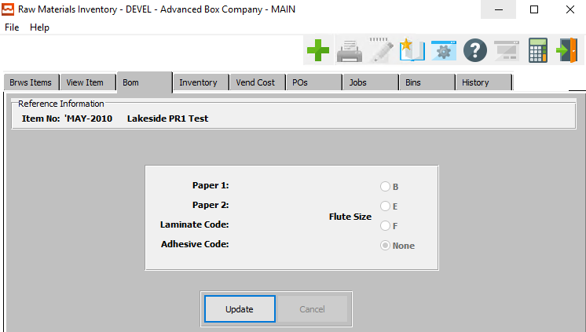

#### UPDATE

To change the currently selected Bill of Materials, simply click the ***“Update***” button at the bottom of the screen.

### Update BOM

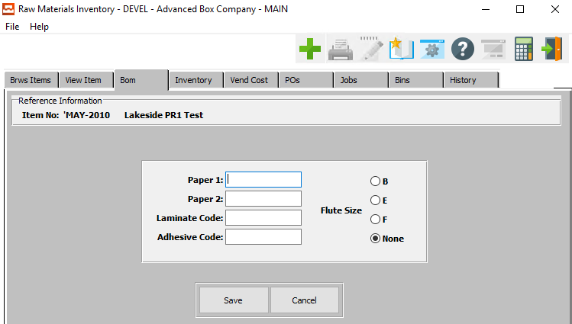

#### SAVE

Click the ***“Save”*** button to save all changes to the current Bill of Material.

#### CANCEL

Click the ***“Cancel”*** button to cancel all changes to the Bill of Material without saving.

### Update BOM Field Definitions

#### Paper 1

Enter the item number for the first kind of paper. Alternatively, press the ***“F1”*** key to choose a number from a list of available items.

#### Paper 2

Enter the item number for the second kind of paper. Alternatively, press the ***“F1”*** key to choose a number from a list of available items.

#### Laminate Code

Enter the item number for the laminate code. Alternatively, press the ***“F1”*** key to choose a number from a list of available items.

#### Adhesive Code

Enter the item number for the adhesive code. Alternatively, press the ***“F1”*** key to choose a number from a list of available items.

#### Flute Size (Choice)

To choose the preferred Flute Size, please make sure the desired option choice bubble is toggled.

### Inventory

The following quantity fields are updated from either warehouse transactions, physical count processing or materials issued through production posting. The weighted average cost is calculated from warehouse transactions receipts or from purchase order receipts which download the cost to accounts payable.

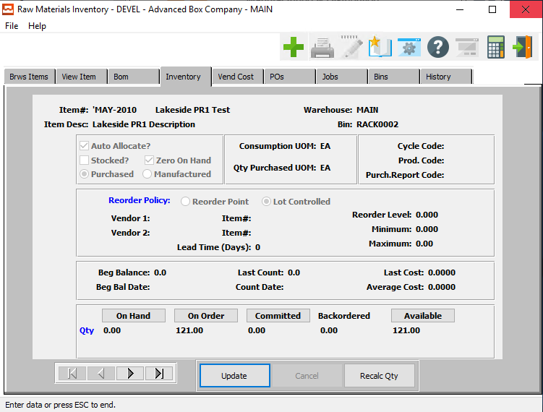

#### UPDATE

To change the currently selected Inventory, simply click the ***“Update***” button at the bottom of the screen.

#### NEXT

Press ***"N"*** (Next) to find next Inventory to view or modify. Alternatively, press the ***“Right Arrow”*** on the screen.

#### PREVIOUS

Press ***"P"*** (Previous) to find previous Inventory to view or modify. Alternatively, press the ***“Left Arrow”*** on the screen.

#### RECALC QTY

Click the ***“Recalc Qty”*** button to recalculate all inventory quantities after making any changes.

### Update Inventory

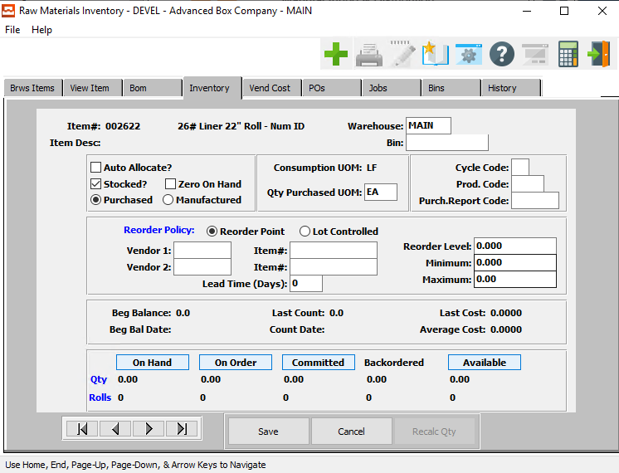

#### SAVE

Click the ***“Save”*** button to save all changes to the current Inventory.

#### CANCEL

Click the ***“Cancel”*** button to cancel all changes to the Inventory without saving.

#### NEXT

Press ***"N"*** (Next) to find next Inventory to view or modify. Alternatively, press the ***“Right Arrow”*** on the screen.

#### PREVIOUS

Press ***"P"*** (Previous) to find previous Inventory to view or modify. Alternatively, press the ***“Left Arrow”*** on the screen.

### Update Inventory Field Definitions

#### Warehouse

This is the primary warehouse location for this item. A separate file will provide inventory control by warehouse and bin location.

#### Bin

This is the primary bin location for this item. The bin file will provide inventory control by warehouse and bin location. Multiple bins as well as pallet/tag numbers can exist for each item within each warehouse.

#### Auto Allocate? – Toggle Box

To automatically allocate the inventory, make sure that the Auto Allocate toggle box is checked.

This field dictates if this item is controlled for automatic allocation and deallocation purposes. Once an order has been entered, this field is used to allocate material which was entered on the estimate.

#### Stocked? – Toggle Box

To mark this as a stocked inventory, make sure that the Stocked toggle box is checked.

This field dictates if this item is stocked in your warehouse. The item must be stocked in order to allocate material.

#### Zero On-Hand – Toggle Box

To mark this item as having zero on-hand quantity, make sure that the Zero On-Hand toggle box is checked.

#### Inventory Type (Choice)

To choose the preferred inventory type of Purchased vs. Manufactured, please make sure the desired option choice bubble is toggled.

#### Qty Purchased UOM

Purchased unit of measure is the unit of measure how this item is purchased. If the Consumption UOM is different, then a conversion for Purchased UOM into Consumption UOM quantities will automatically be calculated when the item is received through the purchasing module.

#### Cycle Code

Enter a user defined code for grouping categories of raw materials. A worksheet will print sorted by cycle count code for taking a physical inventory. Utilizing this method allows counting inventory by logical categories.

#### Production Code

Enter a user defined Production Code used to group items for customizing your own reports.

#### Purchase Report Code

Enter a user defined purchasing report code for purchasing report. For example, C Flute, B Flute, DW, TW to group specific board grades.

#### Reorder Policy (Choice)

Enter "R" for Reorder point or "L" for Lot Controlled. The reorder point method works in conjunction with the allocation process to keep a constant quantity of material on hand. When the quantity on hand falls below the reorder level, the material is listed on the reorder advise report.

The reorder level should be based on the lead time multiplied by the average daily consumption plus a safety stock quantity. The Lot Control method is used for material that is ordered only when we receive an order.

#### Vendor 1

Enter the primary vendor number from the accounts payable vendor file.

#### Vendor 1: Item #

Enter a substitute raw material item number for vendor number one.

#### Vendor 2

Enter a secondary vendor number from the accounts payable vendor file for this material.

#### Vendor 2: Item #

Enter a substitute raw material item number for vendor number two.

#### Reorder Level

Enter the quantity level based on consumption that we must place on a purchase order. Below this quantity will cause this item to appear on the reorder advise reports.

#### Minimum

Enter a minimum quantity to purchase to obtain a reasonable price. An attempt to order a smaller quantity would display a warning message when adding a purchase order.

#### Maximum

Enter a maximum quantity to limit excessive on hand inventory. An attempt to order a larger quantity would display a warning message when adding a purchase order.

#### Lead Time (Days)

Enter the number of days from time of purchase order to delivery of product from vendor. Currently, this is only information.

#### Beginning Balance

Balance at the beginning of each month and is affected when period ending process is run.

#### Beginning Balance Date

This is the beginning balance date for the current period. This is initially set by receipts from the inventory, then is automatically updated by month end procedures.

#### Count Date

The date last physical inventory was posted for this item. This date is updated when posting a physical count.

#### Last Cost

This is the last purchased cost for this item and is automatically updated by the system from purchasing or receipts posting via warehouse transactions or purchase order receipts to inventory.

#### Average Cost

This is the weighted average purchased cost for the quantity on hand of this item and is automatically updated by the system from purchasing or warehouse transactions receipts posted to inventory.

### Inventory: On Hand Inquiry

This is the actual quantity of the item which is currently in stock in the primary location. This quantity is increased by the recording of receipts transactions, and decreased by the filling of a customer orders for the item or by issuing a quantity of the item to the company's manufacturing facility.

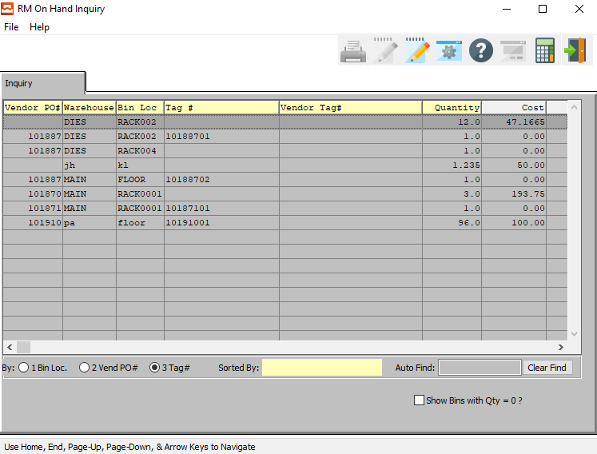

#### Show Bins with Quantity = 0? – Toggle Box

To show empty bins in the selection, make sure that this toggle box is checked.

### Inventory: On Order Inquiry

This is the quantity of the item which is currently on order for all locations. This quantity is increased when purchase orders or shop orders for the item are released, and decreased when orders for the item are received into stock.

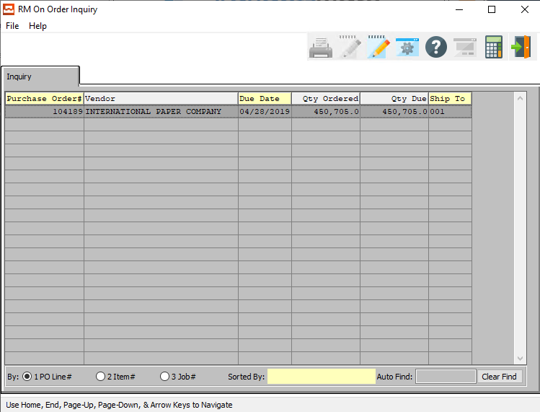

### Inventory: Committed Inquiry

This is the quantity of the item which has already been committed to meet the projected needs of the manufacturing plant. The plant requirements are satisfied by issuing stock from inventory. This decreases the amount issued or shipped. This field cannot be modified in change mode.

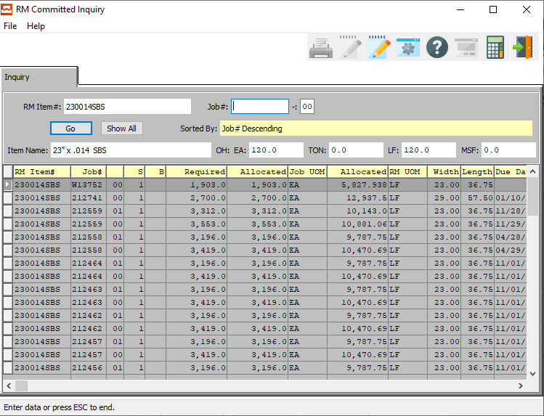

#### Job #

Enter the job number or you can do a ***“F1”*** look-up from list. A partial description may be typed into any field or data may be entered into multiple fields followed by pressing the ***“Go”*** button to sort the fields by the criteria that was entered. Once the data is presented on the screen, the YELLOW column heading may be clicked to sort that specific column in ascending or descending order.

#### Job #: 00

Enter a subsequent job number to search for.

#### Item Name

The item name will transfer from the item file.

### Inventory: Backordered Inquiry

This is a non-modifiable field. It will show the total quantity of an item which is backordered if the item is billed but not shipped.

### Inventory: Available Inquiry

The basic calculation for the available quantity of an item is: Available = On-hand - Committed. You have the option of including the quantity on-order via purchasing in the calculated quantity available; in other words, you can specify that any quantity of the items which are on-order should be considered on-hand for purposes of this report.

If this option is selected (by answering ***"Y"*** to the "SHOULD QUANTITY AVAILABLE INCLUDE ON ORDER?" question on the entry screen), the calculation for the available quantity becomes (Available = On-hand + On-order - Committed). It is normally desirable to include quantity on-order in the calculation of quantity available for this purpose to discover what new purchased orders should be placed.

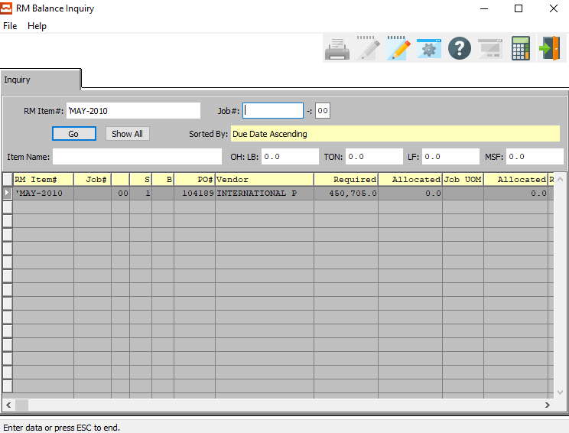

#### Job #

Enter the job number or you can do a ***“F1”*** look-up from list. A partial description may be typed into any field or data may be entered into multiple fields followed by pressing the ***“Go”*** button to sort the fields by the criteria that was entered. Once the data is presented on the screen, the YELLOW column heading may be clicked to sort that specific column in ascending or descending order.

#### Item Name

The item name will transfer from the item file.

### Vend Cost: Browse

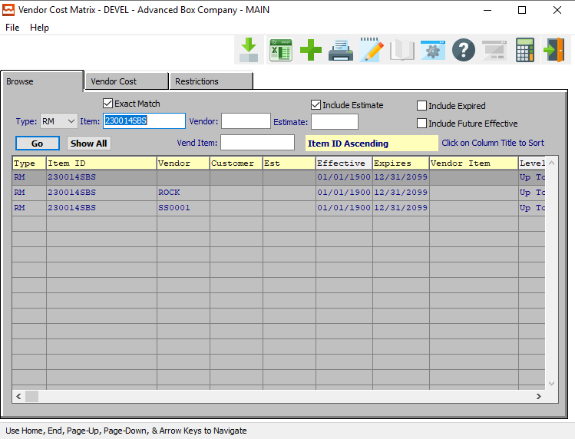

#### ADD

Click the ***“Green + Icon”*** to add a new Vendor Cost Matrix.

### Vend Cost: Browse Field Definitions

#### Exact Match – Toggle Box

To only show search matches that are an exact match to all parameters, make sure that the Exact Match toggle box is checked.

#### Type (Choice)

To choose the preferred Material type of Raw Material vs. Finished Good (Or All), please make sure the desired option is chosen in the drop down menu.

#### Item #

Enter the FG item number or you may use the ***“F1”*** look-up. A partial description may be typed into any field or data may be entered into multiple fields followed by pressing the ***“Go”*** button to sort the fields by the criteria that was entered. Once the data is presented on the screen, the YELLOW column heading may be clicked to sort that specific column in ascending or descending order.

#### Vendor

Enter the vendor number to look-up your customer or you may use the look-up ***“F1”*** key look-up. A partial description may be typed into any field or data may be entered into multiple fields followed by pressing the ***“Go”*** button to sort the fields by the criteria that was entered. Once the data is presented on the screen, the YELLOW column heading may be clicked to sort that specific column in ascending or descending order.

#### Vendor Item

Enter a vendor item number to search for.

#### Include Estimate – Toggle Box

To include estimates in the selection, make sure that the Include Estimate toggle box is checked.

#### Estimate #

Enter the estimate number or you may use the ***“F1”*** look-up. A partial description may be typed into any field or data may be entered into multiple fields followed by pressing the ***“Go”*** button to sort the fields by the criteria that was entered. Once the data is presented on the screen, the YELLOW column heading may be clicked to sort that specific column in ascending or descending order.

#### Include Expired – Toggle Box

To include expired vendor cost matrixes in the search, make sure that the Include Expired toggle box is checked.

#### Include Future Effective – Toggle Box

To include vendor cost matrixes that have not yet begun in the search, make sure that the Include Future Effective toggle box is checked.

### Vend Cost: Vendor Cost

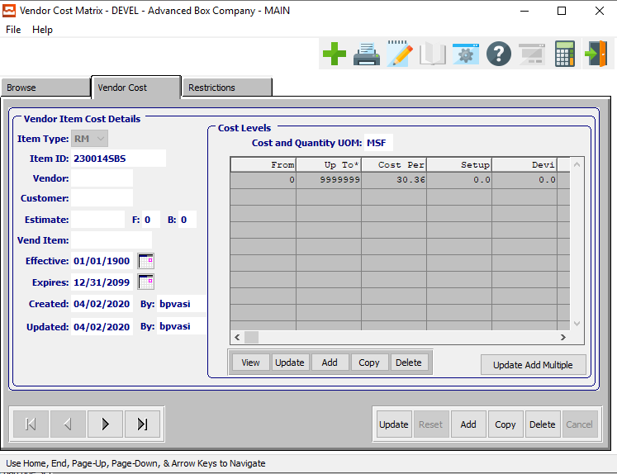

#### UPDATE

To change the currently selected Vendor Cost Matrix, simply click the ***“Update***” button at the bottom of the screen.

#### ADD

To add a new Vendor Cost Matrix, simply click the ***“Green + Icon”*** button at the top of the Vendor Cost screen.

Alternatively, click the ***“Add”*** button at the bottom of the screen.

#### DELETE

To delete the currently selected Vendor Cost Matrix, simply press the ***"D"*** key. Alternatively, click the ***“Delete”*** button at the bottom of the screen.

#### NEXT

Press ***"N"*** (Next) to find next Vendor Cost Matrix to view or modify. Alternatively, press the ***“Right Arrow”*** on the screen.

#### PREVIOUS

Press ***"P"*** (Previous) to find previous Vendor Cost Matrix to view or modify. Alternatively, press the ***“Left Arrow”*** on the screen.

### Add/Update Vendor Cost

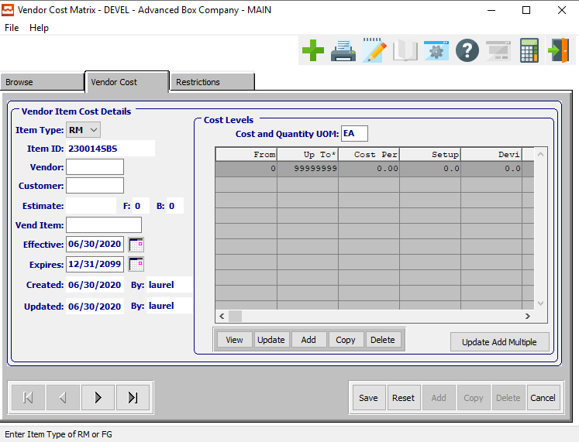

#### SAVE

Click the ***“Save”*** button to save all changes to the current Vendor Cost Matrix.

#### RESET

Click the ***“Reset”*** button to reset all fields to their original state.

#### CANCEL

Click the ***“Cancel”*** button to cancel all changes to the Vendor Cost Matrix without saving.

#### NEXT

Press ***"N"*** (Next) to find next Vendor Cost Matrix to view or modify. Alternatively, press the ***“Right Arrow”*** on the screen.

#### PREVIOUS

Press ***"P"*** (Previous) to find previous Vendor Cost Matrix to view or modify. Alternatively, press the ***“Left Arrow”*** on the screen.

### Add/Update Vendor Cost Field Definitions

#### Item Type (Choice)

To choose the preferred item type of Finished Good vs. Raw Material, please make sure the desired option is chosen from the drop-down menu.

#### Vendor

Enter a valid vendor number. Alternatively, press the ***“F1”*** key to choose a valid number from a list of available vendors.

#### Customer

Enter a valid customer number. Alternatively, press the ***“F1”*** key to choose a valid number from a list of available customers.

#### Estimate

Enter a valid estimate number. Alternatively, press the ***“F1”*** key to choose a valid number from a list of available estimates.

#### Vend Item

Enter a valid vendor item number. Alternatively, press the ***“F1”*** key to choose a valid number from a list of available vendor items.

#### Effective Date

Enter the first date on which this Vendor Cost Matrix will go into effect.

#### Expires Date

Enter the date on which this Vendor Cost Matrix will expire.

#### Created Date

The original date that this Vendor Cost Matrix was created. This is defined by the system and cannot be modified.

#### Created By

The original user that created this Vendor Cost Matrix. This is defined by the system and cannot be modified.

#### Updated Date

The username of the last user to make changes to this Vendor Cost Matrix. This is defined by the system and cannot be modified.

#### Updated By

The date that this Vendor Cost Matrix was last updated. This is defined by the system and cannot be modified.

### Vend Cost: Vendor Cost: Cost Levels

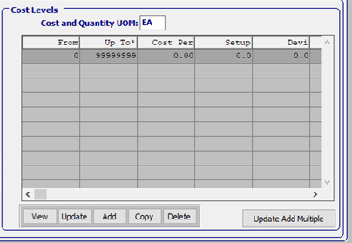

#### VIEW (Cost Level)

Click the ***“View”*** button to view detailed information about the currently selected Cost Level.

#### UPDATE (Cost Level)

To change the currently selected Cost Level, simply click the ***“Update***” button at the bottom of the screen.

#### ADD (Cost Level)

Click the ***“Add”*** button at the bottom of the screen to add a new Cost Level.

#### COPY (Cost Level)

Click the ***“Copy”*** button to copy information from the currently selected Cost Level.

#### DELETE (Cost Level)

To delete the currently selected Cost Level, simply press the ***"D"*** key. Alternatively, click the ***“Delete”*** button at the bottom of the screen.

#### UPDATE ADD MULTIPLE (Cost Level)

Click the ***“Update Add Multiple***” button to add multiple cost levels to this Vendor Cost Matrix.

### Update/Add Cost Levels

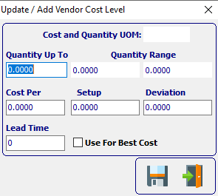

#### SAVE

Click the ***“Floppy Disc Icon”*** to save all changes to the Vendor Cost Level screen.

#### EXIT

Click the ***“Exit Door Icon”*** to exit the Vendor Cost Level popup screen.

### Update/Add Multiple Vendor Cost Levels

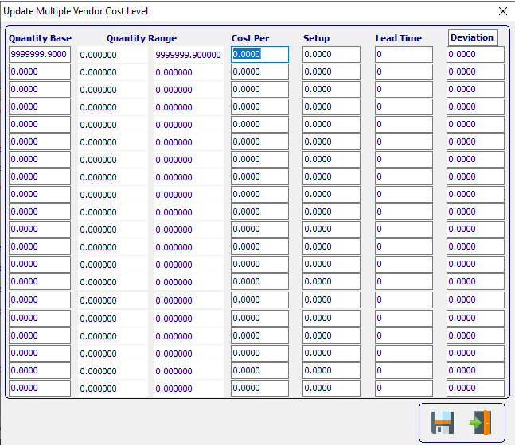

#### SAVE

Click the ***“Floppy Disc Icon”*** to save all changes to the Multiple Vendor Cost Level screen.

#### EXIT

Click the ***“Exit Door Icon”*** to exit the Multiple Vendor Cost Level popup screen.

### Update/Add Cost Levels Field Definitions

#### Cost and Quantity UOM

The sell price unit of measure defaults to M for per thousand, however this may be modified. Each unit of measure will yield a different total selling price.

Valid Units of Measure are:

|  |  |
| --- | --- |
| C | Per Hundred |
| CS | Per Case |
| EA | Per Each |
| L | Per Lot |
| M | Per Thousand |

#### Quantity Up-To

Enter the highest quantity that this item can have.

#### Cost Per

Enter the cost per item.

#### Setup

Enter the set cost for this item.

#### Deviation

Enter the Deviation for this item.

#### Lead Time

Enter the Lead Time for this item.

#### Use for Best Cost – Toggle Box

To use this cost level as the best cost for items, make sure that the Use for Best Cost toggle box is checked.

### Vend Cost: Restrictions

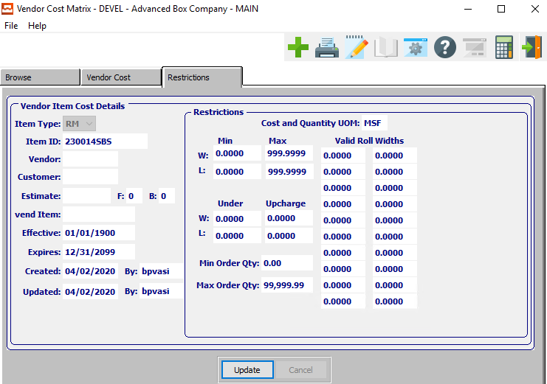

#### UPDATE

To change the currently selected Vendor Restrictions, simply click the ***“Update***” button at the bottom of the screen.

### Update Restrictions

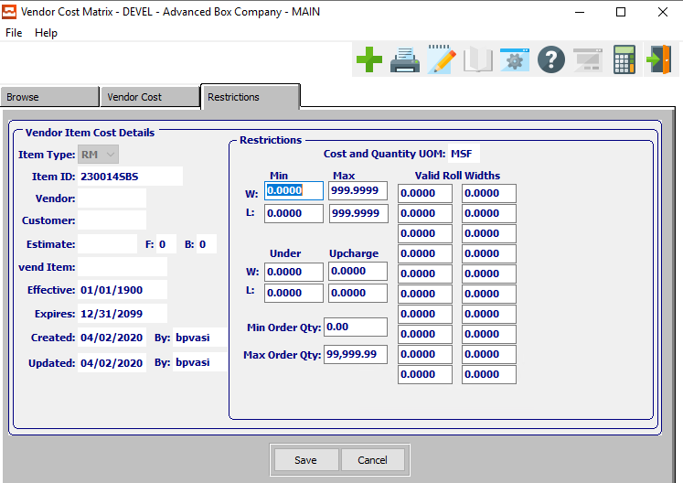

#### SAVE

Click the ***“Save”*** button to save all changes to the current Vendor Restriction.

#### CANCEL

Click the ***“Cancel”*** button to cancel all changes to the Vendor Restriction without saving.

### Update Restrictions Field Definitions

#### Cost and Quantity UOM

The sell price unit of measure defaults to M for per thousand, however this may be modified. Each unit of measure will yield a different total selling price.

Valid Units of Measure are:

|  |  |
| --- | --- |
| C | Per Hundred |
| CS | Per Case |
| EA | Per Each |
| L | Per Lot |
| M | Per Thousand |

#### Minimum Width

Enter the minimum width restriction for the item.

#### Maximum Width

Enter the maximum width restriction for the item.

#### Minimum Length

Enter the minimum length restriction for the item.

#### Maximum Length

Enter the maximum length restriction for the item.

#### Undercharge Width

Enter the undercharge width restriction for the item.

#### Upcharge Width

Enter the upcharge width restriction for the item.

#### Undercharge Length

Enter the undercharge length restriction for the item.

#### Upcharge Length

Enter the upcharge length restriction for the item.

#### Minimum Order Quantity

Enter the minimum order quantity restriction for the item.

#### Maximum Order Quantity

Enter the maximum order quantity restriction for the item.

#### Valid Roll Widths

Enter the valid roll width restriction for the item.

### POs

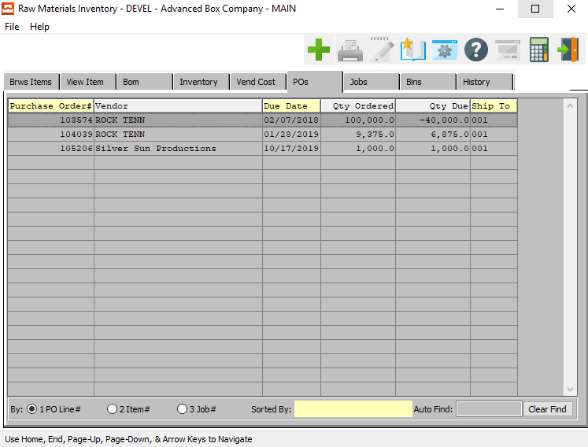

### Jobs

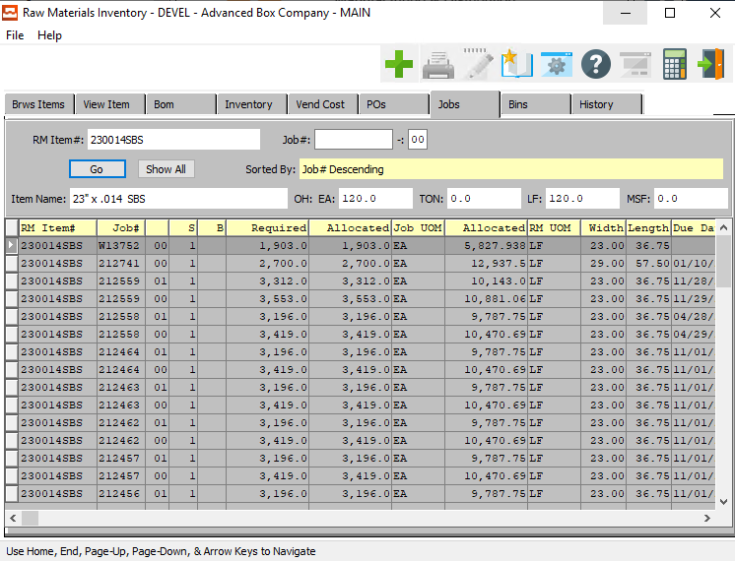

### Jobs Field Definitions

#### Job #

Enter the job number or you can do a ***“F1”*** look-up from list. A partial description may be typed into any field or data may be entered into multiple fields followed by pressing the ***“Go”*** button to sort the fields by the criteria that was entered. Once the data is presented on the screen, the YELLOW column heading may be clicked to sort that specific column in ascending or descending order.

#### Job #: 00

Enter the subsequent job number to search for.

#### Item Name

The item name will transfer from the item file.

### Bins

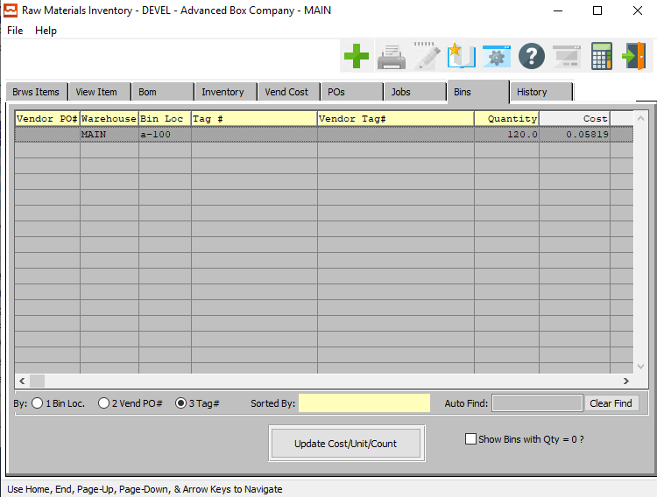

#### UPDATE COST/UNIT/COUNT

Click the ***“Update Cost/Unit/Count”*** button to update this Bin after making any changes to this Raw Material item on any other screen.

#### Show Bins with Quantity = 0? – Toggle Box

To show empty bins in the report, make sure that this toggle box is checked.

### History

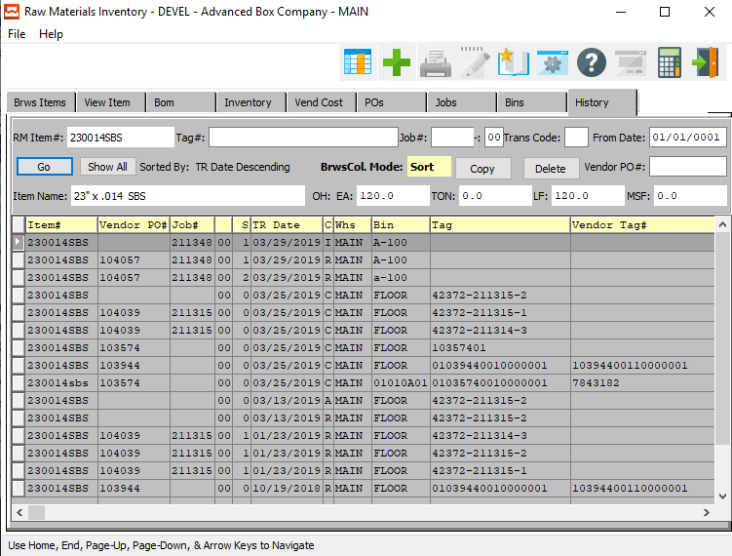

#### COPY

Click the ***“Copy”*** button to copy information from the currently selected Inventory History.

#### DELETE

To delete the currently selected Inventory History, simply press the ***"D"*** key. Alternatively, click the ***“Delete”*** button at the top of the screen.

### History Field Definitions

#### Tag #

Enter the tag number to search for. Alternatively, press the ***“F1”*** key to search for a valid item number from a list of available items.

#### Job #

Enter the job number or you can do a ***“F1”*** look-up from list. A partial description may be typed into any field or data may be entered into multiple fields followed by pressing the ***“Go”*** button to sort the fields by the criteria that was entered. Once the data is presented on the screen, the YELLOW column heading may be clicked to sort that specific column in ascending or descending order.

#### Job #: 00

Enter the subsequent job number to search for.

#### Trans Code

Enter the trans code to search for.

Valid Codes are as Follows:

|  |  |  |  |
| --- | --- | --- | --- |
| A | Adjustment | R | Receipt |
| C | Physical Count | S | Shipment |
| E | Returns |  |  |

#### From Date

Enter the invoice date for the vendor.

#### Vendor PO #

Enter the PO number for a look-up of a customer or you may use the ***“F1”*** key to find the customer. A partial description may be typed into any field or data may be entered into multiple fields followed by pressing the ***“Go”*** button to sort the fields by the criteria that was entered. Once the data is presented on the screen, the YELLOW column heading may be clicked to sort that specific column in ascending or descending order.

#### Item Name

The Item Name will transfer from the Item File.

## Corrugated/Foam Materials [MF2]

### Overview

The cost of board and paper is determined by the board and paper fields simply by entering a board code on the estimate. Corrugated plants may use up to seven paper codes for each board code entered on an estimate. The gross sheet size is used to determine the cost of all board and paper material for each part of an estimate. All medium paper defined utilizes the shrinkage percentage to calculate the gross length of each medium to determine the cost.

The cost for label laminating is calculated by the cost per MSH (thousand sheets), per MSF or per Ton as valid units of measures. The label material raw material item number and the length and width must be entered during estimating. For label material with item codes defined as ***“E”*** (Estimated), the cost per unit of measure is found in the price matrix and multiplied by consumption quantity required for the estimate quantity. For actual stocked material, the last or average cost is used to compute the total cost.

### Browse Items

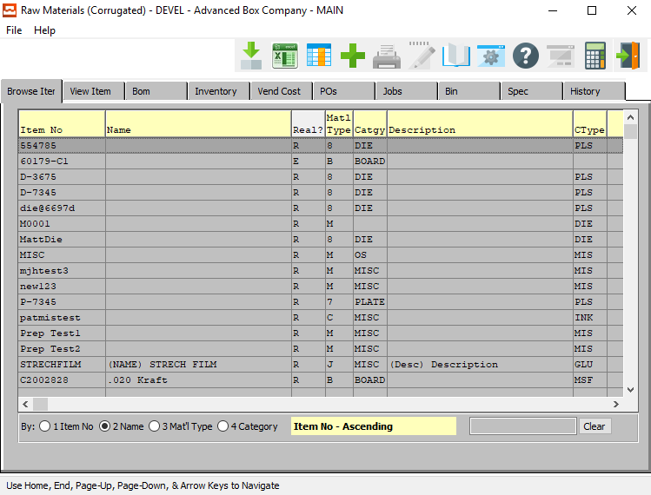

#### ADD

Click the ***“Green + Icon”*** to add a new Raw Material Item.

### View Item

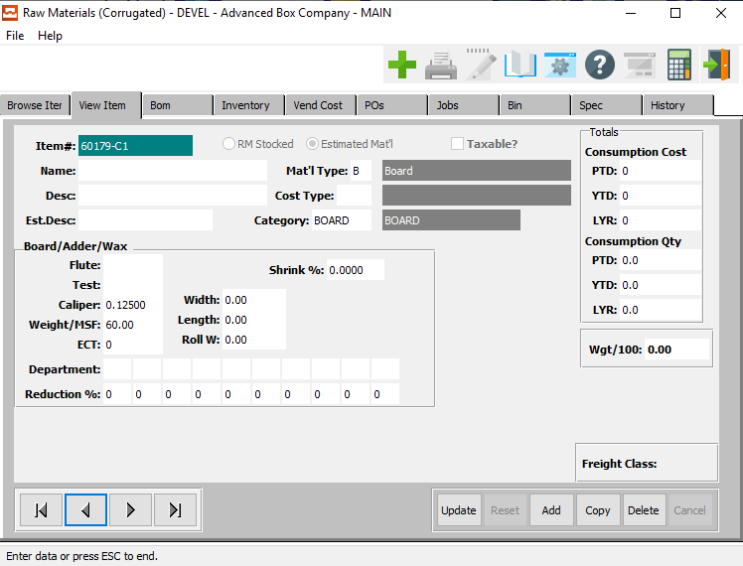

#### UPDATE

To change the currently selected Raw Material Item, simply click the ***“Update***” button at the bottom of the screen.

#### ADD

To add a new Raw Material Item, simply click the ***“Green + Icon”*** button at the top of the Raw Material Inventory screen.

Alternatively, click the ***“Add”*** button at the bottom of the screen.

#### DELETE

To delete the currently selected Raw Material Item, simply press the ***"D"*** key. Alternatively, click the ***“Delete”*** button at the bottom of the screen.

#### NEXT

Press ***"N"*** (Next) to find next Raw Material Item to view or modify. Alternatively, press the ***“Right Arrow”*** on the screen.

#### PREVIOUS

Press ***"P"*** (Previous) to find previous Raw Material Item to view or modify. Alternatively, press the ***“Left Arrow”*** on the screen.

### Add/Update Item

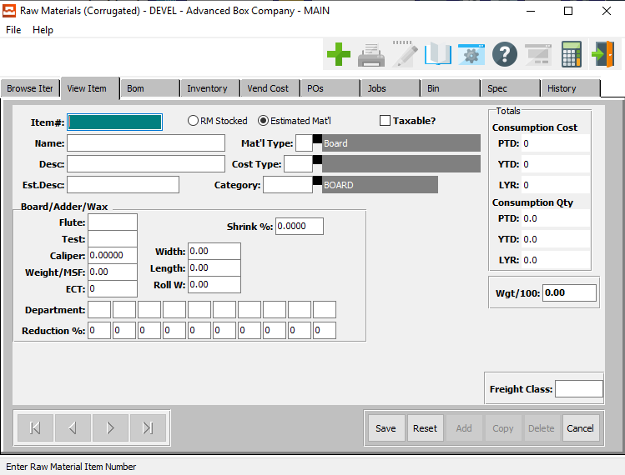

#### SAVE

Click the ***“Save”*** button to save all changes to the current Raw Material Item.

#### RESET

Click the ***“Reset”*** button to reset all fields to their original state.

#### CANCEL

Click the ***“Cancel”*** button to cancel all changes to the Raw Material Item without saving.

### Add/Update Item Field Definitions

#### Item #

Enter a code for this raw material, but be consistent. i.e. C200, C250, C275, etc. so that the items are in order when printed or listed on an inquiry. The code is the primary key for utilizing an alpha numeric search throughout the system. Estimated material as well as actual stocked raw material should be defined with consistent item number codes.

As an example, C200 could be used for an estimated cost of C Flute board so that the system generates an actual sheet size that would be used to calculate the cost based on the total MSF or Tons required. Prior to purchasing the material, we would need to add and item such as C20028x40 which would be a 28 x 40-inch sheet which would a real stocked item number.

#### Material (Choice)

To choose the preferred material type of Stocked Raw Material vs. Estimated Material, please make sure the desired option choice bubble is toggled.

#### Taxable? – Toggle Box

To marl this item as taxable, make sure that the Taxable toggle box is checked.

#### Name

This line transfers to the job ticket, purchase order and desired reports. This line is used for alpha-numeric searches throughout the system.

#### Description

Enter a description of the Raw Materials item for this file.

#### Estimate Description

This is the description used on the cost estimating screen. This field is necessary to minimize characters on the estimate screens and for reporting purposes.

#### Material Type

The material types are maintained by Advanced Software. Only the code is entered in the raw material file. Our system has a formula for each material type so that the total material required for each estimate and production quantity per job is computed by the unit of measure.

Valid Material Types are as Follows:

|  |  |  |  |
| --- | --- | --- | --- |
| B | Board | M | Miscellaneous |
| C | Packing Code | R | Die Rule |
| D | Pallet | S | Stitch |
| G | Glue | T | Tape |
| I | Ink | V | Varnish |
| L | Laminate |  |  |

#### Cost Type

Enter the material cost type for this raw material. General ledger account numbers for the raw material asset account, consumption expense account and purchase price variance account are assigned by material cost types which interface with job costing and the general ledger.

Debit and credits are automatically recorded via receipts for purchases, actual production postings and adjustments. The work-in-process inventory general ledger account numbers are set up in the job cost product line file so that offsetting debits are posted when raw materials are issued to the job.

#### Category

Enter a valid product category from the product category file. Each category is listed by item and the categories are also defined by product line. This file contains categories defined by each company. The description is defined in the file so that only the code is entered in the raw material file. Many inventory, sales and job costing reports are available by product category.

#### Flute

Enter the Flute Code as defined in the Flute File.

#### Test

Enter the test for paperboard.

#### Caliper

Enter the caliper thickness dimension for board or paper. Paper may use up to five decimals, whereas the board material will utilize just three decimals. The board caliper is utilized in the machine standards file for creating make ready and run speed standards based on caliper size.

#### Weight/MSF

Board (Material Type=B) and Paper (Material Type=P) utilize weight per thousand square feet to calculate the total weight of an estimate or order quantity. To calculate the estimated cost of board or paper, the flute, test, caliper and weight per MSF must be entered. Only the Item No is entered during estimating.

The weight per MSF is the multiplier for calculating the total weight of board material required as well as the shipping weight of cartons. The total cost of board is dependent on the item code. For estimated board that is not stocked (item code=E), the standard cost matrix on screen two is used to determine the cost per ton or cost per MSF.

However, if the board used on the estimate is on hand material (item code=R), then the actual (average or last) cost, which is updated by material receipts, is used to compute the cost of board.

#### ECT

Edge Crushed Test. This is a test of the stacking strength.

#### Roll Width

Enter the board or paper roll width dimension for actual raw material. This field will transfer to the estimate automatically when an actual stocked board is used on an estimate. This field is not used for non-stocked board (item code=E) because the system will calculate the optimum width based on the style formulas then find the best fit roll from the valid roll widths on page two.

#### Shrink %

The “BOM” Bill of Material option allows corrugated plants to define the paper medium, liner and medium shrinkage percentages required when producing various board flute grades.

Enter the take up shrinkage percentage for corrugated medium board when producing various flute grades. The devisor of this percentage (1-%) will be divided into the gross sheet length to determine the gross length of the paper medium. This length together with the boards width are used to calculate the weight and cost of the paper material for all medium required to produce the flute grade.

#### Width

Enter the board or paper width dimension for actual raw material. This field will transfer to the estimate automatically when an actual stocked board is used on an estimate. This field is not used for non-stocked board (item code=E) because the system will calculate the optimum sheet size based on the style formulas. In addition, if valid roll widths are defined on screen 2, then the system will find the closest roll width equal to or greater than the calculated sheet width.

#### Length

Enter the board or paper length dimension for actual raw material. This field will transfer to the estimate automatically when an actual stocked board is used on an estimate. This field should not be defined for non-stocked board (item code=E) because the system will calculate the optimum sheet length based on the style formulas.

#### Department

The department fields are defined strictly by ASI. However, the departments and sequence priority must be defined by your company. Press the ***“Page Up” / “Page Down”*** or press ***“F1”*** to show valid departments. For each department defined, a reduction percentage may be defined to slow down the machine run speeds defined in the machine standards file.

The percentage entered here will take priority over a percentage defined in the machine file caliper matrix. This percentage will reduce the run speeds found in the machine standard file for each machine in the department defined.

#### Reduction %

Enter the percentage for the department entered above. This percentage will reduce the production run speed found in the machine standards file whenever this raw material is entered on an estimate. This field may only be defined for board or paper material. (material type = B).

#### Weight/100

This is the weight per 100 items. It is used to control the weight calculations.

### BOM

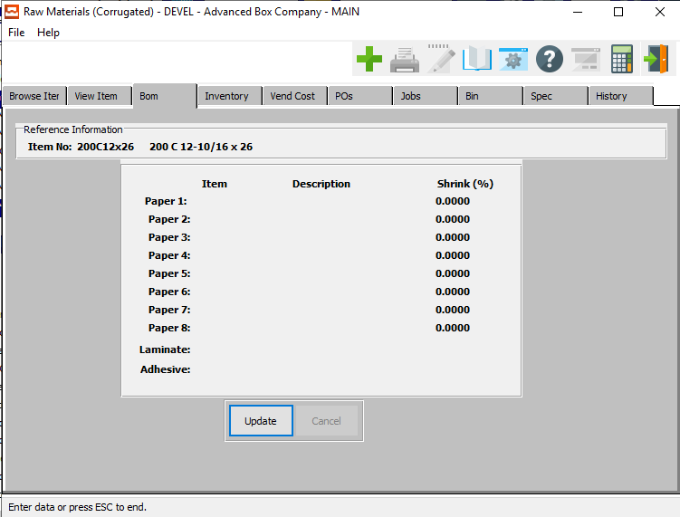

#### UPDATE

To change the currently selected Bill of Materials, simply click the ***“Update***” button at the bottom of the screen.

### Update BOM

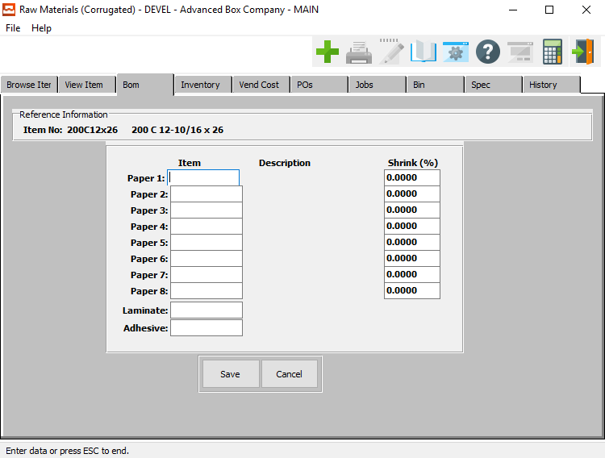

#### SAVE

Click the ***“Save”*** button to save all changes to the current Bill of Material.

#### CANCEL

Click the ***“Cancel”*** button to cancel all changes to the Bill of Material without saving.

### Update BOM Field Definitions

#### Paper 1

Enter the item number for the first kind of paper. Alternatively, press the ***“F1”*** key to choose a number from a list of available items.

#### Shrink %

Enter the shrink percentage.

#### Laminate Code

Enter the item number for the laminate code. Alternatively, press the ***“F1”*** key to choose a number from a list of available items.

#### Adhesive Code

Enter the item number for the adhesive code. Alternatively, press the ***“F1”*** key to choose a number from a list of available items.

### Inventory

The following quantity fields are updated from either warehouse transactions, physical count processing or materials issued through production posting. The weighted average cost is calculated from warehouse transactions receipts or from purchase order receipts which download the cost to accounts payable.

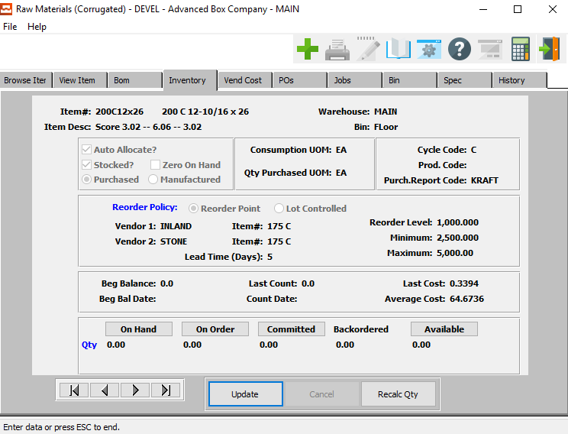

#### UPDATE

To change the currently selected Inventory, simply click the ***“Update***” button at the bottom of the screen.

#### NEXT

Press ***"N"*** (Next) to find next Inventory to view or modify. Alternatively, press the ***“Right Arrow”*** on the screen.

#### PREVIOUS

Press ***"P"*** (Previous) to find previous Inventory to view or modify. Alternatively, press the ***“Left Arrow”*** on the screen.

#### RECALC QTY

Click the ***“Recalc Qty”*** button to recalculate all inventory quantities after making any changes.

### Update Inventory

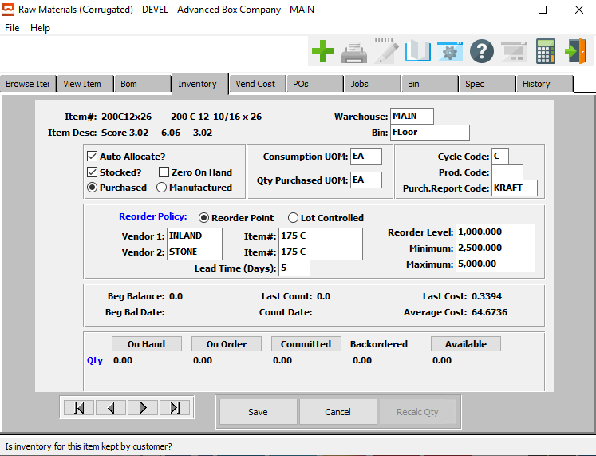

#### SAVE

Click the ***“Save”*** button to save all changes to the current Inventory.

#### CANCEL

Click the ***“Cancel”*** button to cancel all changes to the Inventory without saving.

#### NEXT

Press ***"N"*** (Next) to find next Inventory to view or modify. Alternatively, press the ***“Right Arrow”*** on the screen.

#### PREVIOUS

Press ***"P"*** (Previous) to find previous Inventory to view or modify. Alternatively, press the ***“Left Arrow”*** on the screen.

### Update Inventory Field Definitions

#### Warehouse

This is the primary warehouse location for this item. A separate file will provide inventory control by warehouse and bin location.

#### Bin

This is the primary bin location for this item. The bin file will provide inventory control by warehouse and bin location. Multiple bins as well as pallet/tag numbers can exist for each item within each warehouse.

#### Auto Allocate? – Toggle Box

To automatically allocate the inventory, make sure that the Auto Allocate toggle box is checked.

This field dictates if this item is controlled for automatic allocation and deallocation purposes. Once an order has been entered, this field is used to allocate material which was entered on the estimate.

#### Stocked? – Toggle Box

To mark this as a stocked inventory, make sure that the Stocked toggle box is checked.

This field dictates if this item is stocked in your warehouse. The item must be stocked in order to allocate material.

#### Zero On-Hand – Toggle Box

To mark this item as having zero on-hand quantity, make sure that the Zero On-Hand toggle box is checked.

#### Inventory Type (Choice)

To choose the preferred inventory type of Purchased vs. Manufactured, please make sure the desired option choice bubble is toggled.

#### Consumption UOM

The sell price unit of measure defaults to M for per thousand, however this may be modified. Each unit of measure will yield a different total selling price.

Valid Units of Measure are:

|  |  |
| --- | --- |
| C | Per Hundred |
| CS | Per Case |
| EA | Per Each |
| L | Per Lot |
| M | Per Thousand |

#### Cycle Code

Enter a user defined code for grouping categories of raw materials. A worksheet will print sorted by cycle count code for taking a physical inventory. Utilizing this method allows counting inventory by logical categories.

#### Quantity Purchased UOM

The sell price unit of measure defaults to M for per thousand, however this may be modified. Each unit of measure will yield a different total selling price.

Valid Units of Measure are:

|  |  |
| --- | --- |
| C | Per Hundred |
| CS | Per Case |
| EA | Per Each |
| L | Per Lot |
| M | Per Thousand |

#### Production Code

Enter a user defined Production Code used to group items for customizing your own reports.

#### Purchase Report Code

Enter a user defined purchasing report code for purchasing report. For example, C Flute, B Flute, DW, TW to group specific board grades.

#### Reorder Policy (Choice)

Enter "R" for Reorder point or "L" for Lot Controlled. The reorder point method works in conjunction with the allocation process to keep a constant quantity of material on hand. When the quantity on hand falls below the reorder level, the material is listed on the reorder advise report.

The reorder level should be based on the lead time multiplied by the average daily consumption plus a safety stock quantity. The Lot Control method is used for material that is ordered only when we receive an order.

#### Vendor 1

Enter the primary vendor number from the accounts payable vendor file.

#### Vendor 1: Item #

Enter a substitute raw material item number for vendor number one.

#### Vendor 2

Enter a secondary vendor number from the accounts payable vendor file for this material.

#### Vendor 2: Item #

Enter a substitute raw material item number for vendor number two.

#### Reorder Level

Enter the quantity level based on consumption that we must place on a purchase order. Below this quantity will cause this item to appear on the reorder advise reports.

#### Minimum

Enter a minimum quantity to purchase to obtain a reasonable price. An attempt to order a smaller quantity would display a warning message when adding a purchase order.

#### Maximum

Enter a maximum quantity to limit excessive on hand inventory. An attempt to order a larger quantity would display a warning message when adding a purchase order.

#### Lead Time (Days)

Enter the number of days from time of purchase order to delivery of product from vendor. Currently, this is only information.

### Inventory: On Hand Inquiry

This is the actual quantity of the item which is currently in stock in the primary location. This quantity is increased by the recording of receipts transactions, and decreased by the filling of a customer orders for the item or by issuing a quantity of the item to the company's manufacturing facility.

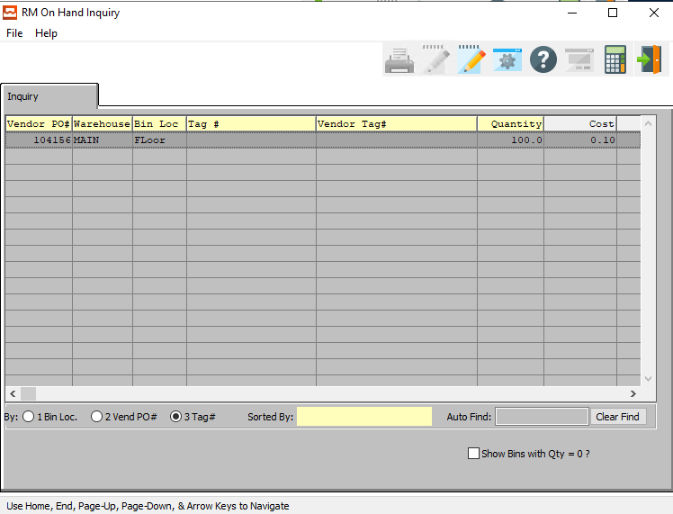

#### Show Bins with Quantity = 0? – Toggle Box

To show empty bins in the selection, make sure that this toggle box is checked.

### Inventory: On Order Inquiry

This is the quantity of the item which is currently on order for all locations. This quantity is increased when purchase orders or shop orders for the item are released, and decreased when orders for the item are received into stock.

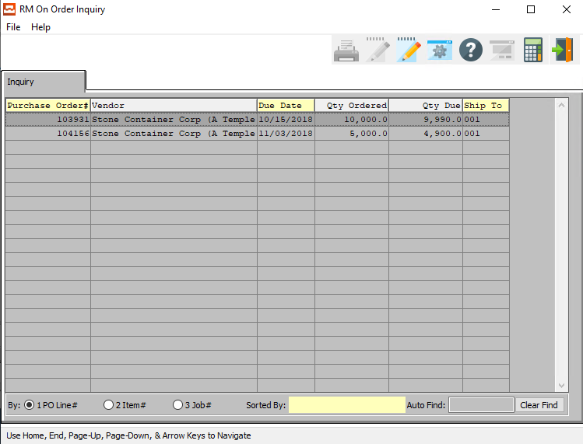

### Inventory: Committed Inquiry

This is the quantity of the item which has already been committed to meet the projected needs of the manufacturing plant. The plant requirements are satisfied by issuing stock from inventory. This decreases the amount issued or shipped. This field cannot be modified in change mode.

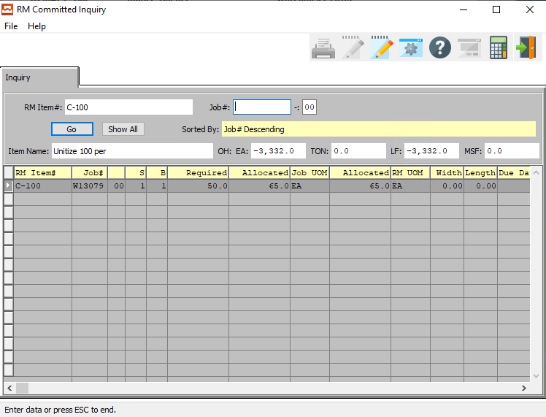

#### Job #

Enter the job number or you can do a ***“F1”*** look-up from list. A partial description may be typed into any field or data may be entered into multiple fields followed by pressing the ***“Go”*** button to sort the fields by the criteria that was entered. Once the data is presented on the screen, the YELLOW column heading may be clicked to sort that specific column in ascending or descending order.

#### Job #: 00

Enter a subsequent job number to search for.

#### Item Name

The item name will transfer from the item file.

### Inventory: Backordered Inquiry

This is a non-modifiable field. It will show the total quantity of an item which is backordered if the item is billed but not shipped.

### Inventory: Available Inquiry

The basic calculation for the available quantity of an item is: Available = On-hand - Committed. You have the option of including the quantity on-order via purchasing in the calculated quantity available; in other words, you can specify that any quantity of the items which are on-order should be considered on-hand for purposes of this report.

If this option is selected (by answering ***"Y"*** to the "SHOULD QUANTITY AVAILABLE INCLUDE ON ORDER?" question on the entry screen), the calculation for the available quantity becomes (Available = On-hand + On-order - Committed). It is normally desirable to include quantity on-order in the calculation of quantity available for this purpose to discover what new purchased orders should be placed.

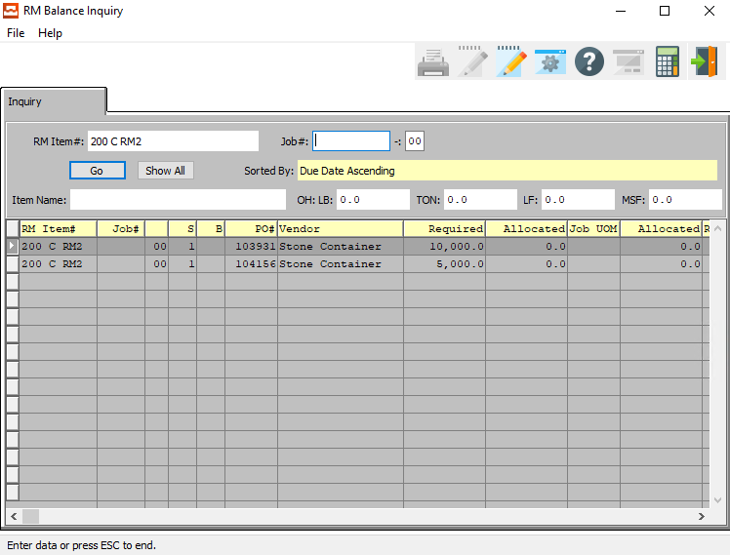

#### Job #

Enter the job number or you can do a ***“F1”*** look-up from list. A partial description may be typed into any field or data may be entered into multiple fields followed by pressing the ***“Go”*** button to sort the fields by the criteria that was entered. Once the data is presented on the screen, the YELLOW column heading may be clicked to sort that specific column in ascending or descending order.

#### Job #: 00

Enter a subsequent job number to search for.

#### Item Name

The item name will transfer from the item file.

### Vend Cost: Browse

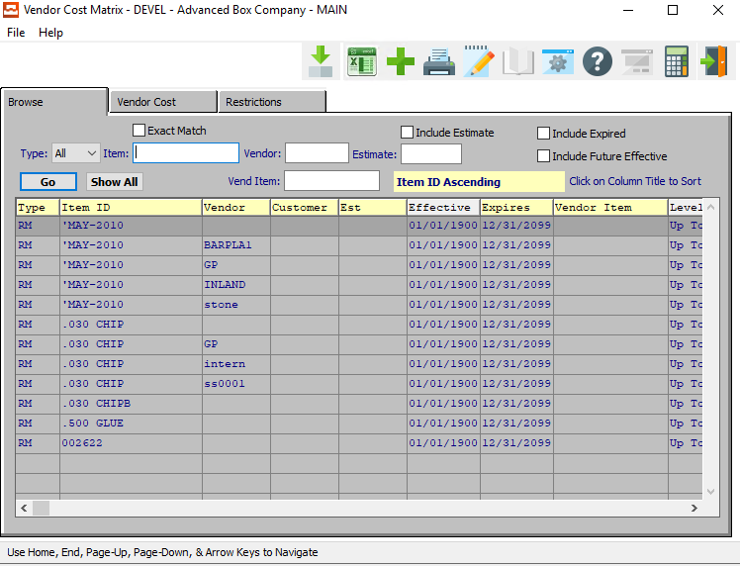

#### ADD

Click the ***“Green + Icon”*** to add a new Vendor Cost Matrix.

### Vend Cost: Browse Field Definitions

#### Exact Match – Toggle Box

To inly show search matches that are an exact match to all parameters, make sure that the Exact Match toggle box is checked.

#### Type (Choice)

To choose the preferred Material type of Raw Material vs. Finished Good (Or All), please make sure the desired option is chosen in the drop-down menu.

#### Item #

Enter the FG item number or you may use the ***“F1”*** look-up. A partial description may be typed into any field or data may be entered into multiple fields followed by pressing the ***“Go”*** button to sort the fields by the criteria that was entered. Once the data is presented on the screen, the YELLOW column heading may be clicked to sort that specific column in ascending or descending order.

#### Vendor

Enter the vendor number to look-up your customer or you may use the look-up ***“F1”*** key look-up. A partial description may be typed into any field or data may be entered into multiple fields followed by pressing the ***“Go”*** button to sort the fields by the criteria that was entered. Once the data is presented on the screen, the YELLOW column heading may be clicked to sort that specific column in ascending or descending order.

#### Vendor Item

Enter a vendor item number to search for.

#### Include Estimate – Toggle Box

To include estimates in the selection, make sure that the Include Estimate toggle box is checked.

#### Estimate #

Enter the estimate number or you may use the ***“F1”*** look-up. A partial description may be typed into any field or data may be entered into multiple fields followed by pressing the ***“Go”*** button to sort the fields by the criteria that was entered. Once the data is presented on the screen, the YELLOW column heading may be clicked to sort that specific column in ascending or descending order.

#### Include Expired – Toggle Box

To include expired vendor cost matrixes in the search, make sure that the Include Expired toggle box is checked.

#### Include Future Effective – Toggle Box

To include vendor cost matrixes that have not yet begun in the search, make sure that the Include Future Effective toggle box is checked.

### Vend Cost: Vendor Cost

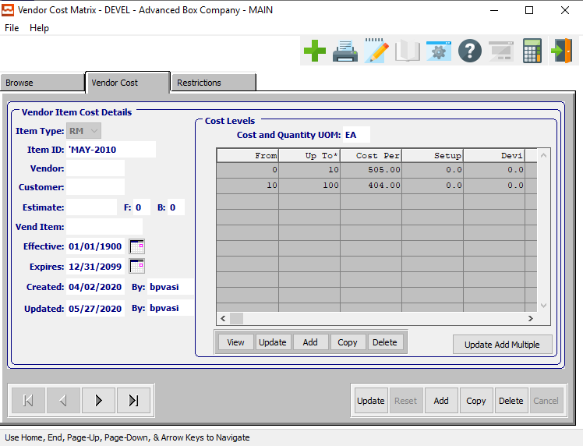

#### UPDATE

To change the currently selected Vendor Cost Matrix, simply click the ***“Update***” button at the bottom of the screen.

#### ADD

To add a new Vendor Cost Matrix, simply click the ***“Green + Icon”*** button at the top of the Vendor Cost Matrix screen.

Alternatively, click the ***“Add”*** button at the bottom of the screen.

#### DELETE

To delete the currently selected Vendor Cost Matrix, simply press the ***"D"*** key. Alternatively, click the ***“Delete”*** button at the bottom of the screen.

#### NEXT

Press ***"N"*** (Next) to find next Vendor Cost Matrix to view or modify. Alternatively, press the ***“Right Arrow”*** on the screen.

#### PREVIOUS

Press ***"P"*** (Previous) to find previous Vendor Cost Matrix to view or modify. Alternatively, press the ***“Left Arrow”*** on the screen.

### Add/Update Vendor Cost

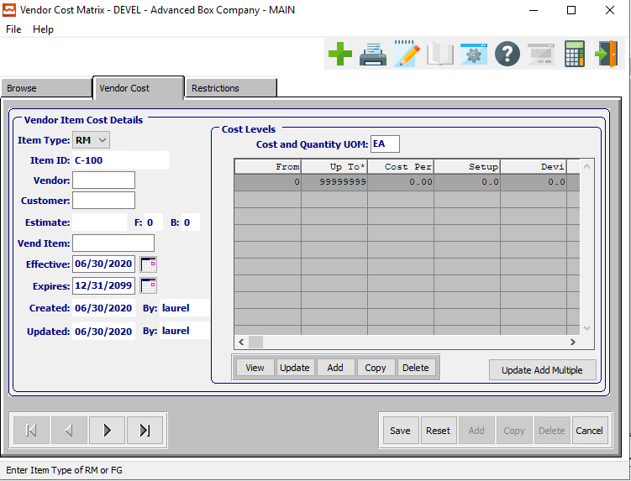

#### SAVE

Click the ***“Save”*** button to save all changes to the current Vendor Cost Matrix.

#### RESET

Click the ***“Reset”*** button to reset all fields to their original state.

#### CANCEL

Click the ***“Cancel”*** button to cancel all changes to the Vendor Cost Matrix without saving.

#### NEXT

Press ***"N"*** (Next) to find next Vendor Cost Matrix to view or modify. Alternatively, press the ***“Right Arrow”*** on the screen.

#### PREVIOUS

Press ***"P"*** (Previous) to find previous Vendor Cost Matrix to view or modify. Alternatively, press the ***“Left Arrow”*** on the screen.

### Add/Update Vendor Cost Field Definitions

#### Item Type (Choice)

To choose the preferred item type of Finished Good vs. Raw Material, please make sure the desired option is chosen from the drop down menu.

#### Vendor

Enter a valid vendor number. Alternatively, press the ***“F1”*** key to choose a valid number from a list of available vendors.

#### Customer

Enter a valid customer number. Alternatively, press the ***“F1”*** key to choose a valid number from a list of available customers.

#### Estimate

Enter a valid estimate number. Alternatively, press the ***“F1”*** key to choose a valid number from a list of available estimates.

#### Vend Item

Enter a valid vendor item number. Alternatively, press the ***“F1”*** key to choose a valid number from a list of available vendor items.

#### Effective Date

Enter the first date on which this Vendor Cost Matrix will go into effect.

#### Expires Date

Enter the date on which this Vendor Cost Matrix will expire.

#### Created Date

The original date that this Vendor Cost Matrix was created. This is defined by the system and cannot be modified.

#### Created By

The original user that created this Vendor Cost Matrix. This is defined by the system and cannot be modified.

#### Updated Date

The username of the last user to make changes to this Vendor Cost Matrix. This is defined by the system and cannot be modified.

#### Updated By

The date that this Vendor Cost Matrix was last updated. This is defined by the system and cannot be modified.

### Vend Cost: Vendor Cost: Cost Levels

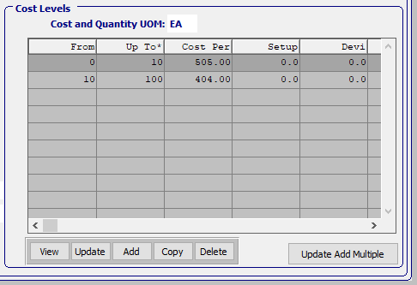

#### VIEW (Cost Level)

Click the ***“View”*** button to view detailed information about the currently selected Cost Level.

#### UPDATE (Cost Level)

To change the currently selected Cost Level, simply click the ***“Update***” button at the bottom of the screen.

#### ADD (Cost Level)

Click the ***“Add”*** button at the bottom of the screen to add a new Cost Level.

#### COPY (Cost Level)

Click the ***“Copy”*** button to copy information from the currently selected Cost Level.

#### DELETE (Cost Level)

To delete the currently selected Cost Level, simply press the ***"D"*** key. Alternatively, click the ***“Delete”*** button at the bottom of the screen.

#### UPDATE ADD MULTIPLE (Cost Level)

Click the ***“Update Add Multiple***” button to add multiple cost levels to this Vendor Cost Matrix.

### Update/Add Cost Levels

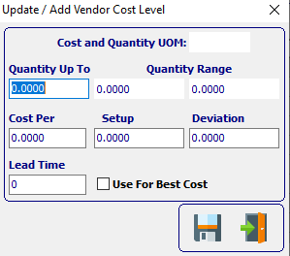

#### SAVE

Click the ***“Floppy Disc Icon”*** to save all changes to the Cost Level screen.

#### EXIT

Click the ***“Exit Door Icon”*** to exit the Cost Level popup screen.

### Update/Add Multiple Vendor Cost Levels



#### SAVE

Click the ***“Floppy Disc Icon”*** to save all changes to the Multiple Vendor Cost Level screen.

#### EXIT

Click the ***“Exit Door Icon”*** to exit the Multiple Vendor Cost Level popup screen.

### Update/Add Cost Levels Field Definitions

#### Cost and Quantity UOM

The sell price unit of measure defaults to M for per thousand, however this may be modified. Each unit of measure will yield a different total selling price.

Valid Units of Measure are:

|  |  |
| --- | --- |
| C | Per Hundred |
| CS | Per Case |
| EA | Per Each |
| L | Per Lot |
| M | Per Thousand |

#### Quantity Up-To

Enter the highest quantity that this item can have.

#### Cost Per

Enter the cost per item.

#### Setup

Enter the set cost for this item.

#### Deviation

Enter the Deviation for this item.

#### Lead Time

Enter the Lead Time for this item.

#### Use for Best Cost – Toggle Box

To use this cost level as the best cost for items, make sure that the Use for Best Cost toggle box is checked.

### Vend Cost: Restrictions

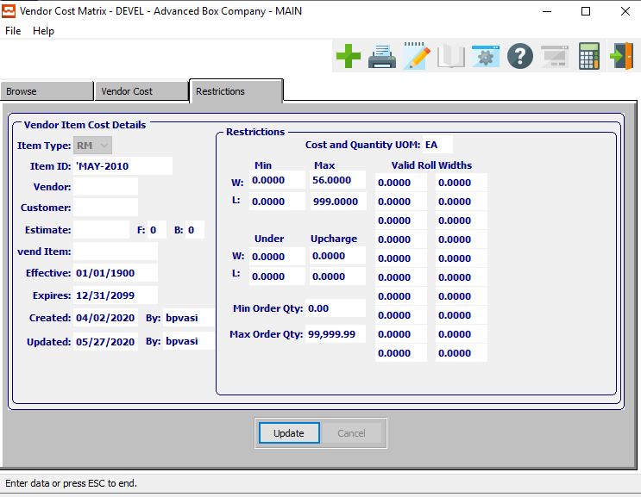

#### UPDATE

To change the currently selected Restriction, simply click the ***“Update***” button at the bottom of the screen.

### Update Restrictions

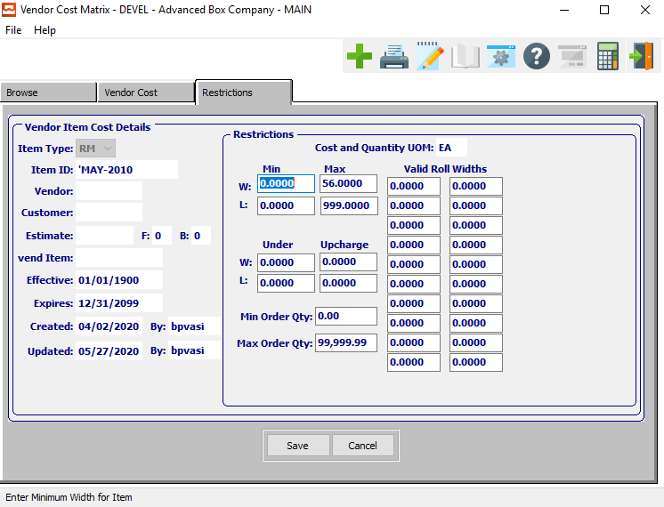

#### SAVE

Click the ***“Save”*** button to save all changes to the current Restriction.

#### CANCEL

Click the ***“Cancel”*** button to cancel all changes to the Restriction without saving.

### Update Restrictions Field Definitions

#### Cost and Quantity UOM

The sell price unit of measure defaults to M for per thousand, however this may be modified. Each unit of measure will yield a different total selling price.

Valid Units of Measure are:

|  |  |
| --- | --- |
| C | Per Hundred |
| CS | Per Case |
| EA | Per Each |
| L | Per Lot |
| M | Per Thousand |

#### Minimum Width

Enter the minimum width restriction for the item.

#### Maximum Width

Enter the maximum width restriction for the item.

#### Minimum Length

Enter the minimum length restriction for the item.

#### Maximum Length

Enter the maximum length restriction for the item.

#### Undercharge Width

Enter the undercharge width restriction for the item.

#### Upcharge Width

Enter the upcharge width restriction for the item.

#### Undercharge Length

Enter the undercharge length restriction for the item.

#### Upcharge Length

Enter the upcharge length restriction for the item.

#### Minimum Order Quantity

Enter the minimum order quantity restriction for the item.

#### Maximum Order Quantity

Enter the maximum order quantity restriction for the item.

#### Valid Roll Widths

Enter the valid roll width restriction for the item.

### POs

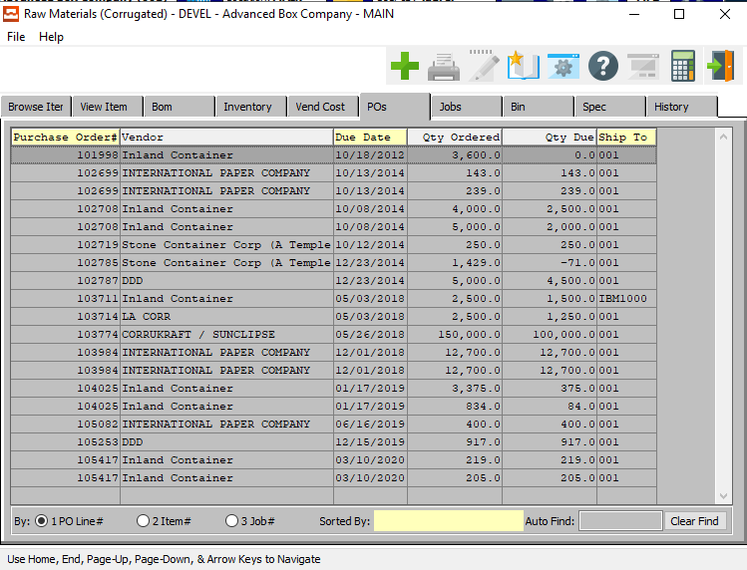

### Jobs

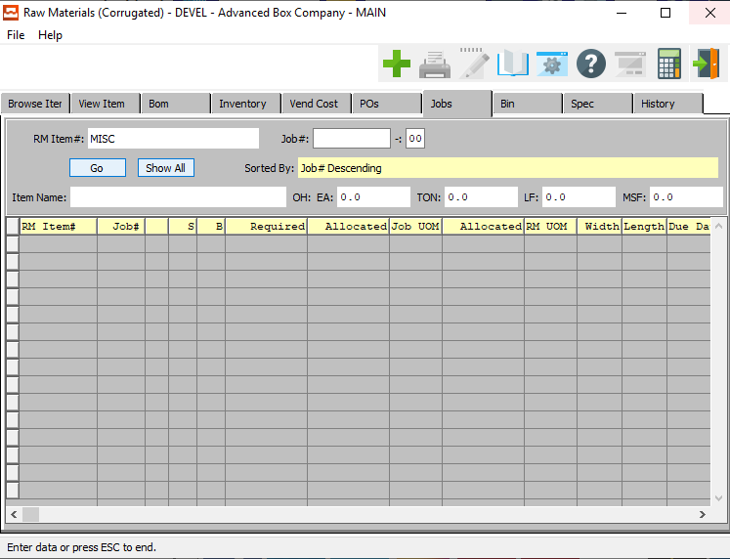

### Jobs Field Definitions

#### Job #

Enter the job number or you can do a ***“F1”*** look-up from list. A partial description may be typed into any field or data may be entered into multiple fields followed by pressing the ***“Go”*** button to sort the fields by the criteria that was entered. Once the data is presented on the screen, the YELLOW column heading may be clicked to sort that specific column in ascending or descending order.

#### Job #: 00

Enter the subsequent job number to search for.

#### Item Name

The item name will transfer from the item file.

### Bins

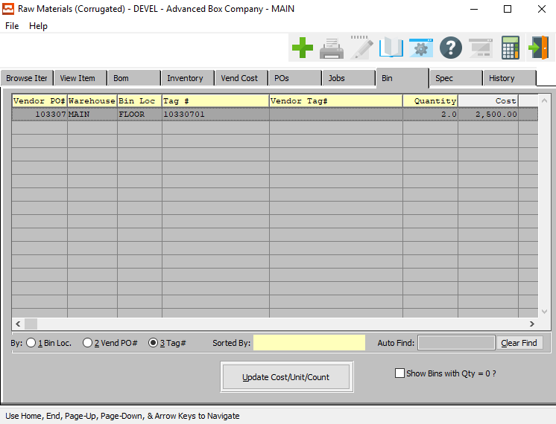

#### UPDATE COST/UNIT/COUNT

Click the ***“Update Cost/Unit/Count”*** button to update this Bin after making any changes to the this Raw Material item on any other screen.

#### Show Bins with Quantity = 0? – Toggle Box

To show empty bins in the selection, make sure that this toggle box is checked.

### Spec

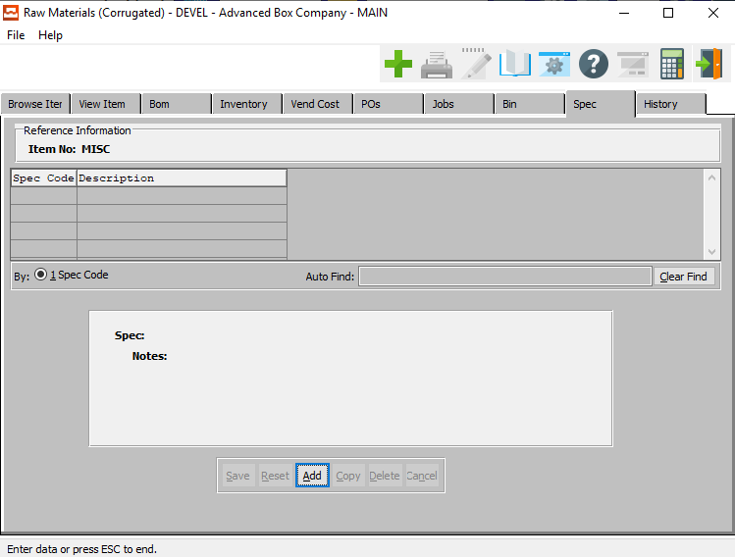

#### ADD

Click the ***“Add”*** button at the bottom of the screen to add a new Spec Code.

### Add Spec

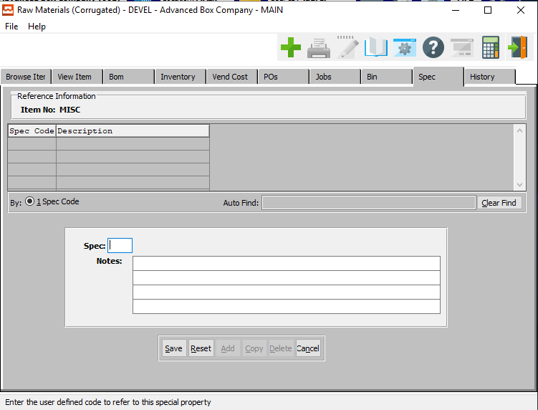

#### SAVE

Click the ***“Save”*** button to save all changes to the current Spec Code.

#### RESET

Click the ***“Reset”*** button to reset all fields to their original state.

#### CANCEL

Click the ***“Cancel”*** button to cancel all changes to the Spec Code without saving.

### Add Spec Field Definitions

#### Spec

Enter a spec code.

#### Notes

Enter any notes about this spec code.

### History

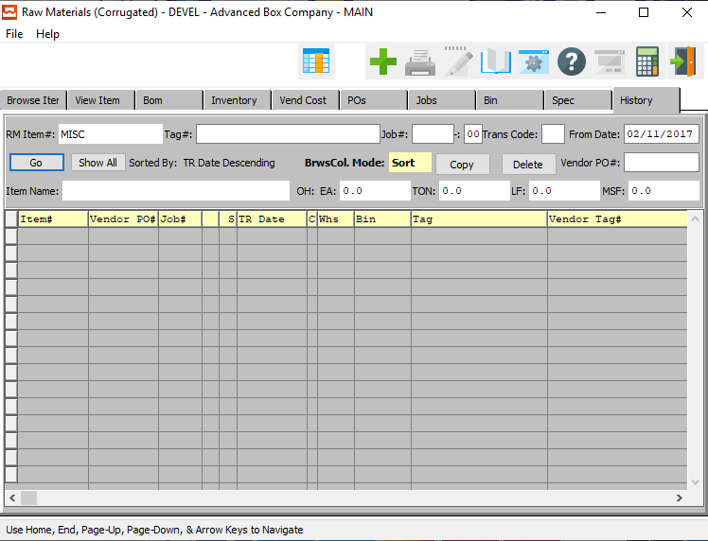

#### COPY

Click the ***“Copy”*** button to copy information from the currently selected Inventory History.

#### DELETE

To delete the currently selected Inventory History, simply press the ***"D"*** key. Alternatively, click the ***“Delete”*** button at the bottom of the screen.

### History Field Definitions

#### Tag #

Enter the tag number to search for. Alternatively, press the ***“F1”*** key to search for a valid item number from a list of available items.

#### Job #

Enter the job number or you can do a ***“F1”*** look-up from list. A partial description may be typed into any field or data may be entered into multiple fields followed by pressing the ***“Go”*** button to sort the fields by the criteria that was entered. Once the data is presented on the screen, the YELLOW column heading may be clicked to sort that specific column in ascending or descending order.

#### Job #: 00

Enter the subsequent job number to search for.

#### Trans Code

Enter the trans code to search for.

Valid Codes are as Follows:

|  |  |  |  |
| --- | --- | --- | --- |
| A | Adjustment | R | Receipt |
| C | Physical Count | S | Shipment |
| E | Returns |  |  |

#### From Date

Enter the invoice date for the vendor.

#### Vendor PO #

Enter the PO number for a look-up of a customer or you may use the ***“F1”*** key to find the customer. A partial description may be typed into any field or data may be entered into multiple fields followed by pressing the ***“Go”*** button to sort the fields by the criteria that was entered. Once the data is presented on the screen, the YELLOW column heading may be clicked to sort that specific column in ascending or descending order.

#### Item Name

The Item Name will transfer from the Item File.

## Raw Materials Categories [MF3]

The product category file may be defined for each raw materials category of items. Many raw materials, purchasing job costing reports are available by product category.

### Browse Category

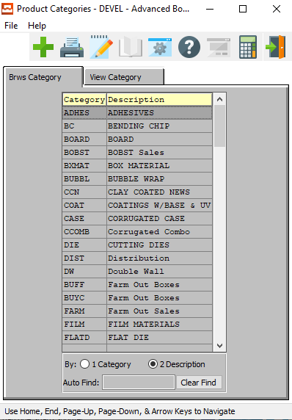

#### ADD

Click the ***“Green + Icon”*** to add a new Product Category.

### View Category

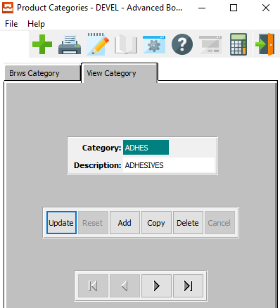

#### UPDATE

To change the currently selected Product Category, simply click the ***“Update***” button at the bottom of the screen.

#### ADD

To add a new Product Category, simply click the ***“Green + Icon”*** button at the top of the Product Category screen.

Alternatively, click the ***“Add”*** button at the bottom of the screen.

#### COPY

Click the ***“Copy”*** button to copy information from the currently selected Product Category.

#### DELETE

To delete the currently selected Product Category, simply press the ***"D"*** key. Alternatively, click the ***“Delete”*** button at the bottom of the screen.

#### NEXT

Press ***"N"*** (Next) to find next Product Category to view or modify. Alternatively, press the ***“Right Arrow”*** on the screen.

#### PREVIOUS

Press ***"P"*** (Previous) to find previous Product Category to view or modify. Alternatively, press the ***“Left Arrow”*** on the screen.

### Add/Update Category

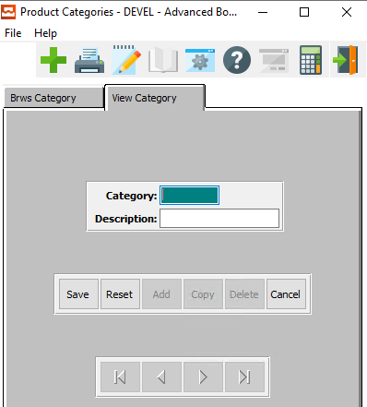

#### SAVE

Click the ***“Save”*** button to save all changes to the current Product Category.

#### RESET

Click the ***“Reset”*** button to reset all fields to their original state.

#### CANCEL

Click the ***“Cancel”*** button to cancel all changes to the Product Category without saving.

### Add/Update Category Field Definitions

#### Category

Enter a user defined product category. This file contains categories defined by each company. The description is defined in the file so that only the code is entered in the raw material item file. Many inventory, purchasing, and job costing reports are available by product category.

#### Description

Enter a user defined description for the product category.

## Material Cost Types [MF4]

### Overview

Material Cost Type/Location Accounts are groupings or classes of material place together for costing purposes. Normally, each product category will have a unique material cost type general ledger accounts, however a category may be divided into unique cost types. For example, Board may be a product category for inventory reporting, however for costing purposes different board grades such as SBS, CCN, KRAFT, etc. may be divided into unique cost types.

Please Note: The cost type must by entered on the item file. This application allows you to maintain a file of material cost type/locations General ledger accounts for interface to job costing. You can interactively maintain the material cost type / location accounts through add, change and delete modes by pressing the capital Letter in the menu at the bottom of the screen.

In this file, the warehouse location must be entered and must be a valid warehouse in the plant / warehouse file. This allows the inventory accounts for a particular material cost type to be tracked by account. When receiving goods into inventory, the system looks up the matching material cost type/location account record to properly Debit the Raw Material Asset account.

When issuing materials to a job, the system looks up the matching material cost type/location account record to properly Credit the Raw Material Asset as well as the Expense and the Purchase Price Variance Accounts. If you wish to track only one raw material asset GL number, simply create one Material Cost Type and use in all items. If you wish to track by material cost type without regards to location, simply leave the location field blank. If you wish to track inventory assets by location, you must create a material cost type for each location for each material type.

### Browse Types

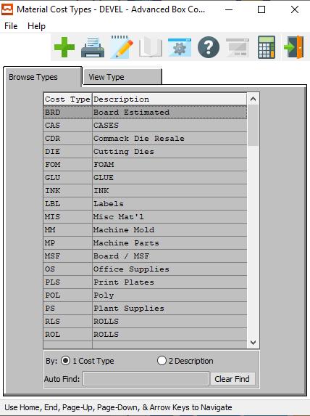

#### ADD

Click the ***“Green + Icon”*** to add a new Material Cost Type.

### View Type

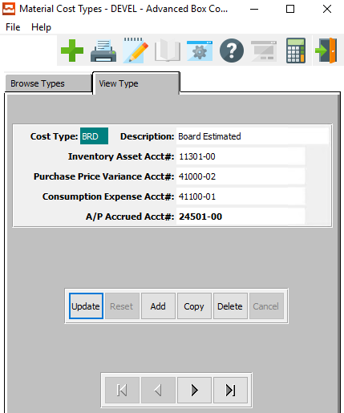

#### UPDATE

To change the currently selected Material Cost Type, simply click the ***“Update***” button at the bottom of the screen.

#### ADD

To add a new Material Cost Type, simply click the ***“Green + Icon”*** button at the top of the Material Cost Type screen.

Alternatively, click the ***“Add”*** button at the bottom of the screen.

#### DELETE

To delete the currently selected Material Cost Type, simply press the ***"D"*** key. Alternatively, click the ***“Delete”*** button at the bottom of the screen.

#### NEXT

Press ***"N"*** (Next) to find next Material Cost Type to view or modify. Alternatively, press the ***“Right Arrow”*** on the screen.

#### PREVIOUS

Press ***"P"*** (Previous) to find previous Material Cost Type to view or modify. Alternatively, press the ***“Left Arrow”*** on the screen.

### Add/Update Type

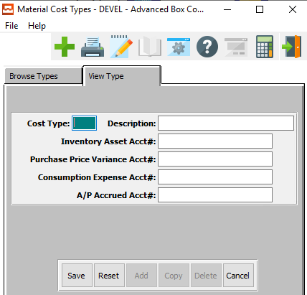

#### SAVE

Click the ***“Save”*** button to save all changes to the current Material Cost Type.

#### RESET

Click the ***“Reset”*** button to reset all fields to their original state.

#### CANCEL

Click the ***“Cancel”*** button to cancel all changes to the Material Cost Type without saving.

### Add/Update Type Field Definitions

#### Cost Type

Enter an ID for this Material Cost Type.

#### Description

Enter a short description for the Cost Type.

#### Inventory Asset Account #

Enter a valid general ledger raw material asset account from the GL chart of accounts file. This will be used when this material type is issued to a job.

#### Purchase Price Variance Account #

Enter a valid general ledger raw material asset account from the GL chart of accounts file. This will be used when this material type is issued to a job.

#### Consumption Expense Account #

Enter a valid general ledger raw material expense account from the GL chart of accounts file. This will be used when this material type is issued to a job.

#### A/P Accrued Account #

Enter the A/P accrued account number. You can use a ***“F1”*** look-up to get a list of accrued accounts.

## Raw Materials Control [MF5]

The control file sets defaults for utilizing the inventory system. Many user defined features particular to your company may be defined in this file. For example, you have the option to value inventory at either last cost or average cost, post inventory costs to general ledger and job costing, default general ledger account numbers, etc.

### R/M Control

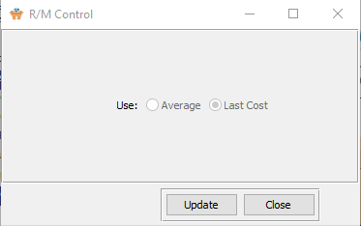

#### UPDATE

To change the Raw Material Control, simply click the ***“Update***” button at the bottom of the screen.

#### CLOSE

Click the ***“Close”*** button to exit the Raw Material Control screen.

### Update Control

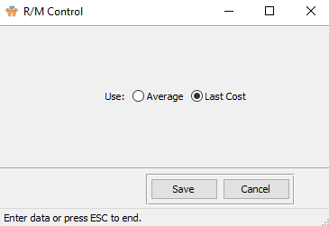

#### SAVE

Click the ***“Save”*** button to save all changes to the Raw Material Control.

#### CANCEL

Click the ***“Cancel”*** button to cancel all changes to the Raw Material Control without saving.

#### Use (Choice)

To choose the preferred Raw Material Control to use between Average vs. Last Cost, please make sure the desired option choice bubble is toggled.

This dictates which cost will be used to calculate the value of inventory when receipts are posted.